13-24)Write a awk program to count number of vowels in a given file

PROGRAM

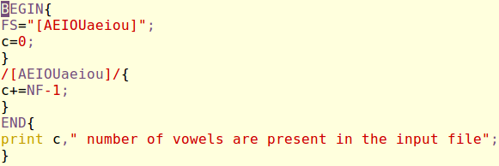

OUTPUT

