13-25)Write a awk program which will find maximum length word and its length in the given input file

PROGRAM

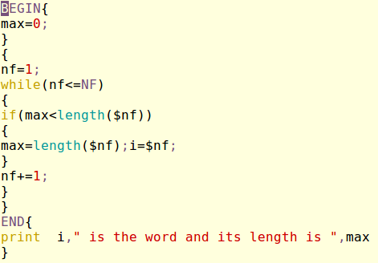

OUTPUT

