13-26) Write a shell script to generate the mathematical tables.

PROGRAM

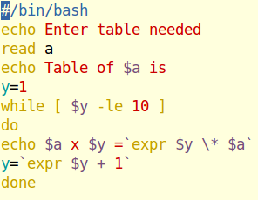

OUTPUT

