13-27) Write a shell script to sort elements of given array by using selection sort.

PROGRAM

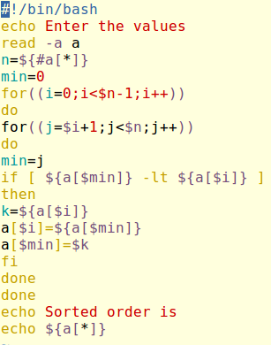

OUTPUT

