13-28) Write a shell script to search given number using binary search.

PROGRAM

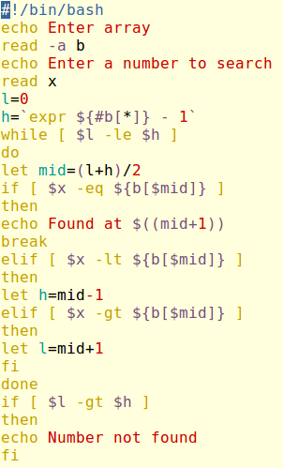

OUTPUT

