13-29) Write a shell script to find number of vowels, consonants, numbers, white spaces and special characters in a given string.

PROGRAM

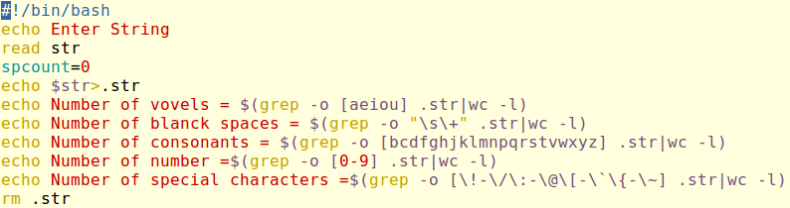

OUTPUT

