13-3) Write a shell script which will display the username and terminal name who login recently in to the Unix system

PROGRAM

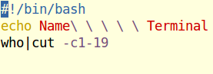

OUTPUT

