13-30)Write a shell script to lock the terminal

PROGRAM

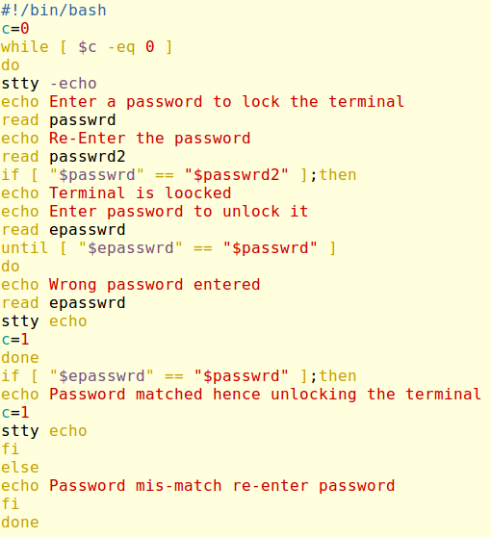

OUTPUT

