13-4) Write a shell script to find no. of files in a directory

PROGRAM

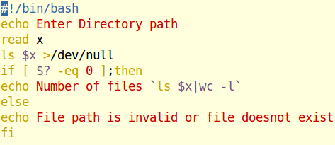

OUTPUT

