13-5) Write a shell script to check whether a given number is perfect or not

PROGRAM

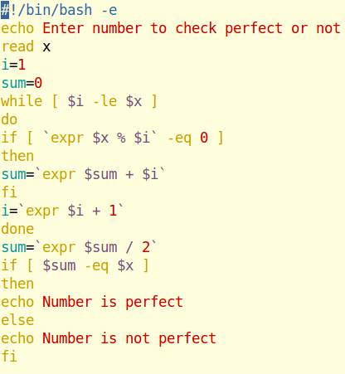

OUTPUT

