13-6) Write a menu driven shell script to copy, edit, rename and delete a file

PROGRAM

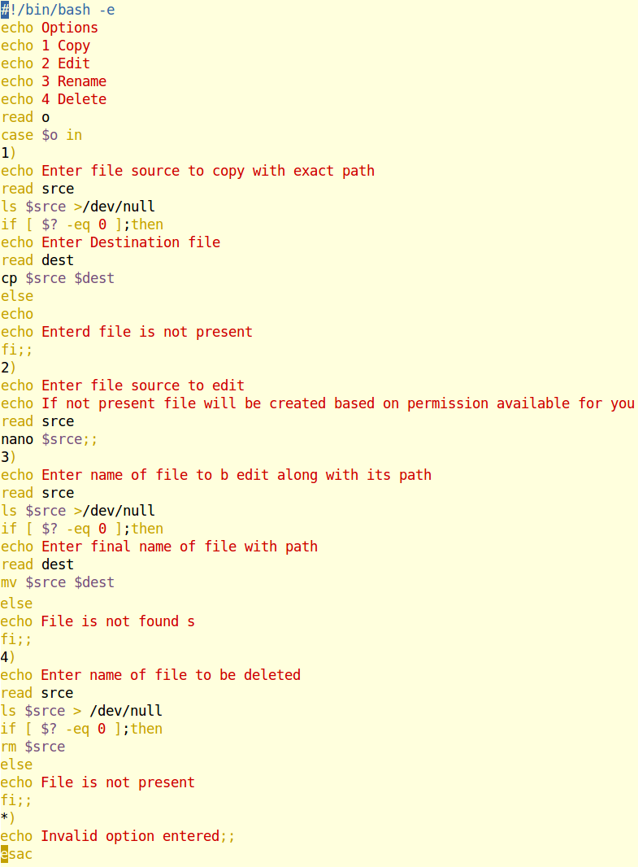

OUTPUT

