13-7)Write a shell script for concatenation of two strings

PROGRAM

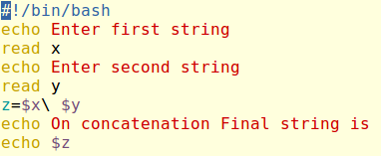

OUTPUT

