13-8) Write a shell script which will display Fibonacci series up to a given number of argument

PROGRAM

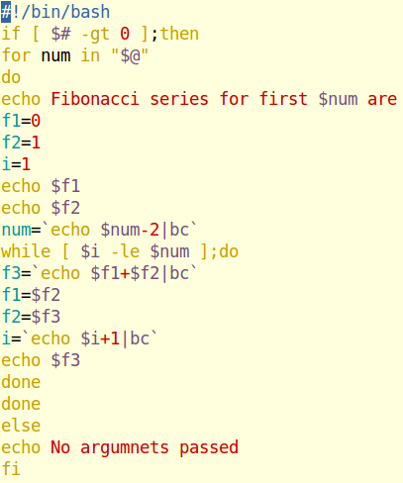

OUTPUT

