13-9) Write a shell script to accept student number, name, marks in 5 subjects. Find total, average and grade. Display the result of student and store in a file called stu.dat Rules: avg>=80 then grade A Avg<80&&Avg>=70 then grade B Avg<70&&Avg>=60 then grade C Avg<60&&Avg>=50 then grade D Avg<50&&Avg>=40 then grade E Else grade F

PROGRAM

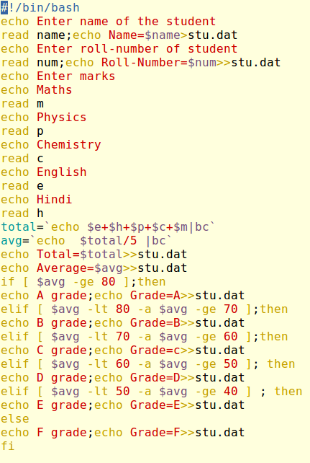

OUTPUT

