3-a)Write a sed command that deletes the first character in each line in a file

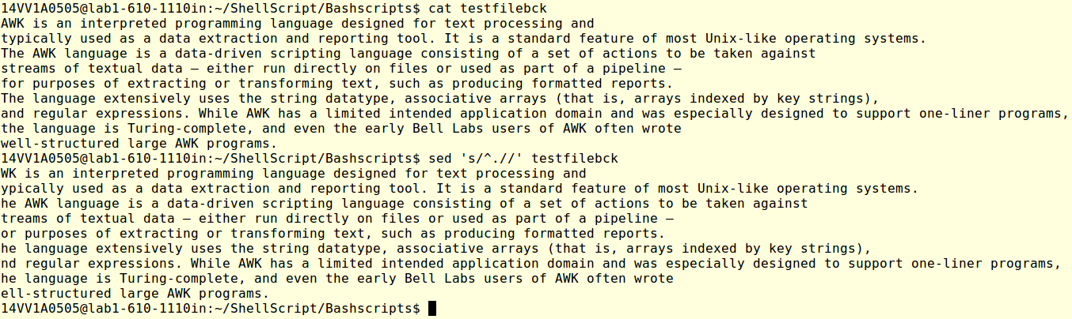

3-b)Write a sed command that deletes the character before the last character in each line in a file

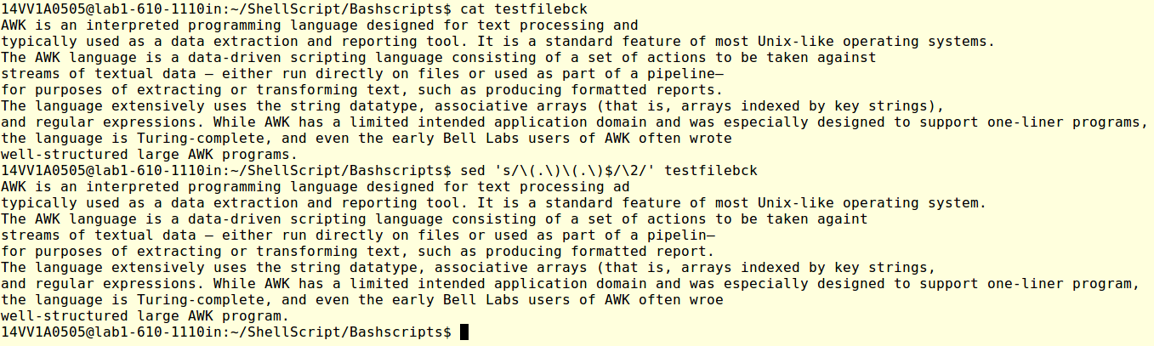

3-c)Write a sed command that swaps the first and second words in each line in a file

