4-a)Pipe your /etc/passwd file to awk, and print out home directories of each user

PROGRAM

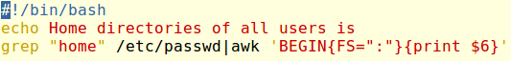

OUTPUT

