4-b)Develop an interactive grep script that asks for a word and a file name and then tells how many lines contains the word

PROGRAM

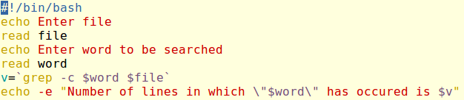

OUTPUT

