4-c,d) Develop an interactive script that asks for a word and a file name and then tells how many lines contains the word using awk

PROGRAM

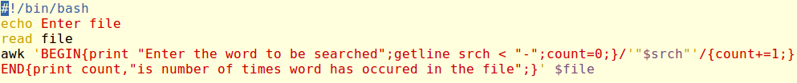

OUTPUT

