5-a) Write a shell script that takes a command-line argument and reports on whether it is directory, a file or something else

#PROGRAM

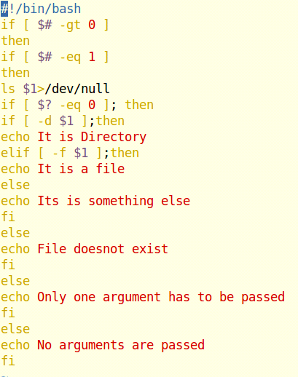

OUTPUT

