5-b)Write a shell-script that accepts one or more filenames as arguments and converts all of them to uppercase provided they exist in the directory

PROGRAM

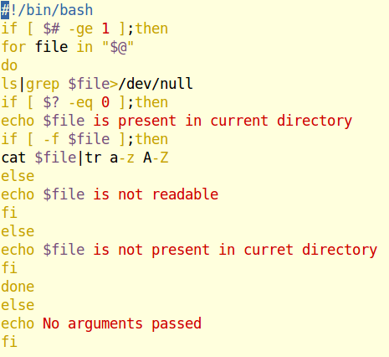

OUTPUT

