5-c)Write a shell script that determines the period for which a specified user is working on the system

PROGRAM

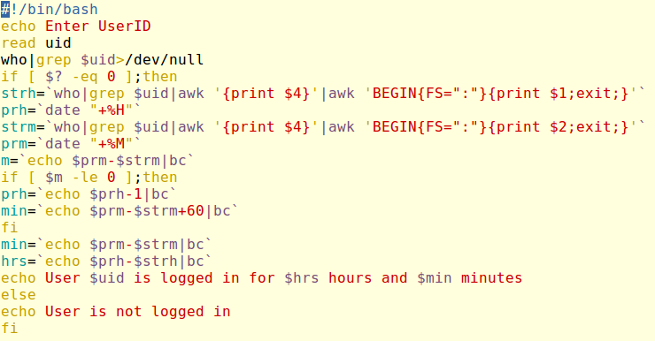

OUTPUT

