6-a)Write a shell-script that accepts a filename starting and ending line numbers as arguments and display all the lines between the given line numbers.

PROGRAM

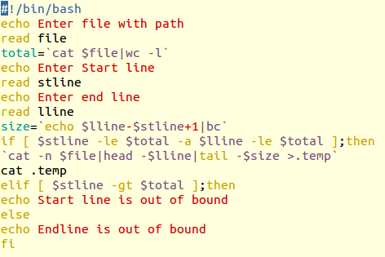

OUTPUT

