6-b)Write a shell-script that deletes all lines containing a specified word in one or more files supplied as arguments to it

PROGRAM

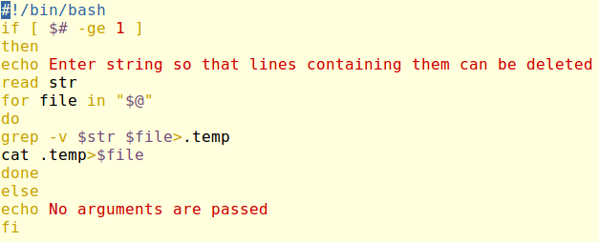

OUTPUT

