7-a)Write a shell-scripts that computes the gross salary of a employee according to the following rules:

i) If basic salary <1500 then HRA=10% of the basic salary and DA=98% of basic salary

ii) If basic salary is >=1500 then HRA=Rs500 and DA=98% of basic salary

Take basic salary is to be taken from keyboard

PROGRAM

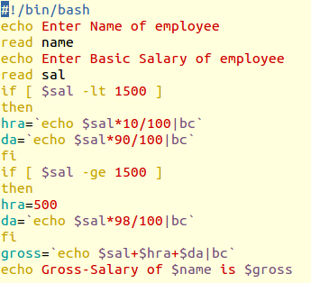

OUTPUT

