7-b)Write a shell script that accepts two integers as its arguments and computers the value of first number raised to the power of the second number.

PROGRAM

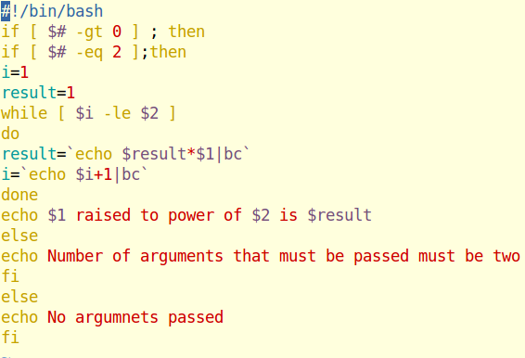

OUTPUT

