8- a)Write an interactive file-handling shell program. Let it offer the user the choice of copying, removing, renaming, or linking files. Once the user has made a choice, have the program ask the user for the necessary information, such as the file name, new name and so on.

PROGRAM

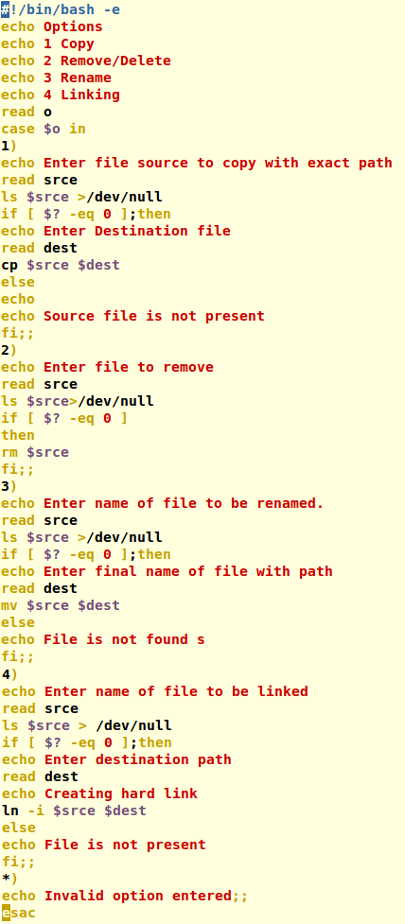

OUTPUT

