8-b)Write shell script that takes a login name as command – line argument and reports when that person logs in.

PROGRAM

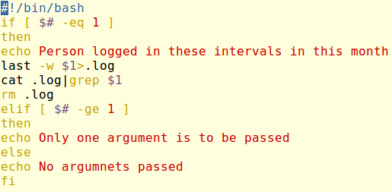

OUTPUT

