9- a)Write a shell script that displays a list of all the files in the current directory to which the user has read, write and execute permissions.

PROGRAM

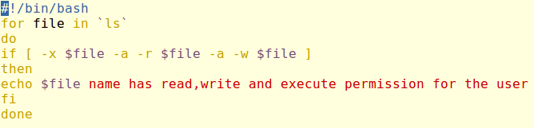

OUTPUT

