9-b) Develop an interactive script that ask for a word and a file name and then tells how many times that word occurred in the file.

PROGRAM

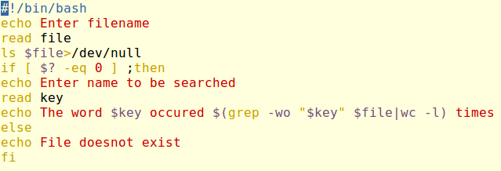

OUTPUT

