9-c)Write a shell script to perform the following string operations: i)To extract a sub-string from a given string. ii)To find the length of a given string.

PROGRAM

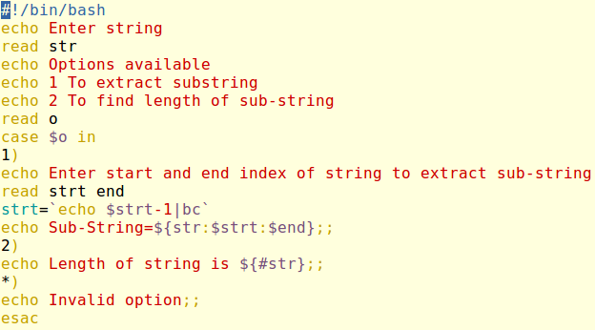

OUTPUT

