This documentation helps to understand how to use a custom API built to interact Microsoft Azure’s Language Understanding Intelligent Service (LUIS). By using this API, one can bypass all necessary steps such as account creation, registering to the service, generating a subscription key and deploying it on the cloud. This API is a wrapper on the LUIS Home Automation intent.

**What is LUIS ?**

So in-order to use the custom API , let us first understand what is LUIS. Language Understanding(LUIS) is a machine learning based service to build natural language into apps, bots and IoT devices. Using this service we can use REST APIs to extract useful information namely ‘intent’, ‘entity’,’phrases’..etc from any sentence.

For LUIS every sentence is an “Utterance”. Based on all its experience, LUIS tries to pry for the “Intent” from the sentence as in what is speaker trying to ‘do’. In addition, it tries to best guess the ‘entity’ from the sentence as to what the ‘intent’ is trying to refer to by giving a score out of 1.

**What does the custom API do?**

Basically all this custom API does is it acts as a wrapper and directly gives access to the LUIS API. Here I have used home automation intent in LUIS service. Similarly one can deploy or add as many intents as required to make the application more intelligent. But for simplification I have used only home automation intent.

**How does the custom API help a user?**

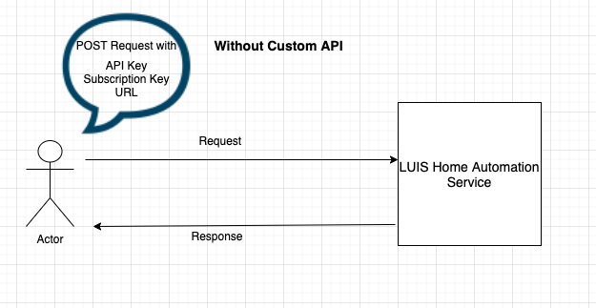

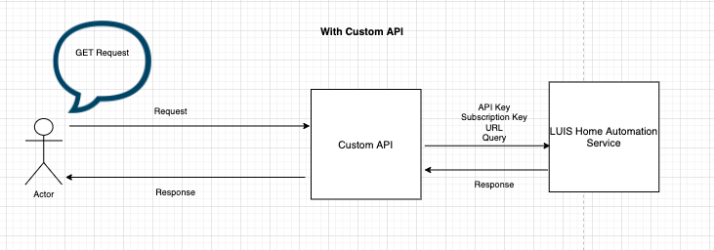

So clearly from above figures we can see how this custom API helps.

**How to use the API?**

The end point of the API is <http://134.209.116.223:3000/api/homeautomation>. User can use Postman or integrated swagger play ground to test the API.

Request Type : A get request.

Response Type: A JSON

An example response is as shown below

{

"query": "turn off lights",

"prediction": {

"topIntent": "HomeAutomation.TurnOff",

"intents": {

"HomeAutomation.TurnOff": {

"score": 0.9966703

},

"HomeAutomation.TurnUp": {

"score": 0.0020204147

},

"HomeAutomation.TurnOn": {

"score": 0.0019510464

},

"HomeAutomation.TurnDown": {

"score": 0.0016985801

},

"HomeAutomation.SetDevice": {

"score": 0.0014676026

},

"None": {

"score": 0.0009998454

},

"HomeAutomation.QueryState": {

"score": 0.0009181465

}

},

"entities": {

"HomeAutomation.DeviceType": [

[

"light"

]

],

"$instance": {

"HomeAutomation.DeviceType": [

{

"type": "HomeAutomation.DeviceType",

"text": "lights",

"startIndex": 9,

"length": 6,

"modelTypeId": 5,

"modelType": "List Entity Extractor",

"recognitionSources": [

"model"

]

}

]

}

}

}

}

**HTTP Codes and its meaning**

1. 200 : Success : This means the request to the API is success and user has got a response from the service
2. 400: Bad Request : These is some problem with the request from the user. Maybe user is trying to do a POST/PUT request but expected is a GET request
3. 500: Internal Server Error: Server is not responding.

Example Screenshot from the Postman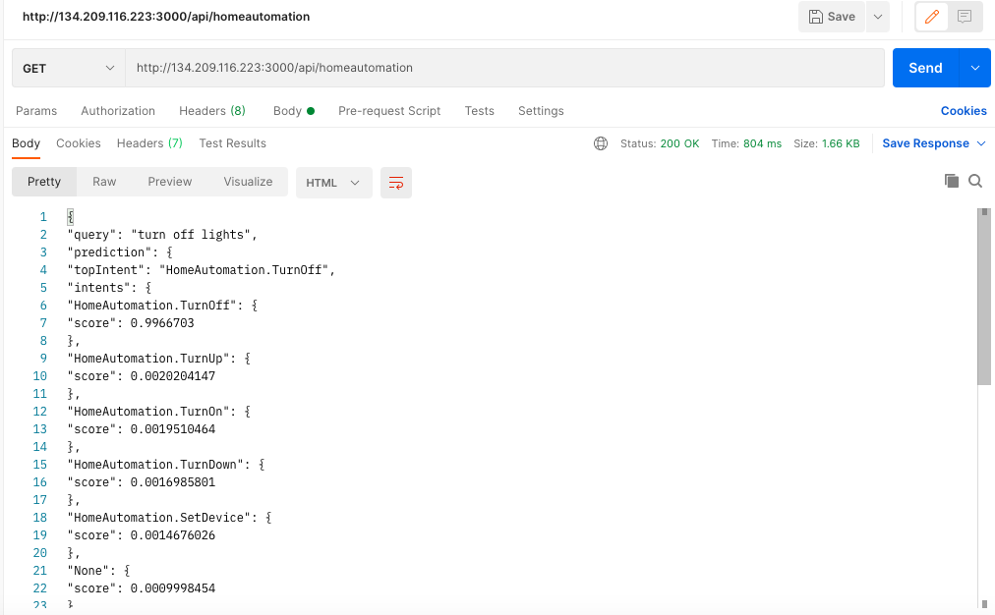

Example screenshot from the Swagger

