EN3160 - Image Processing and Machine Vision
Assignment 2
Fitting and Alignment
Name : Rajakaruna. R. W. M. D. S
Index No : 220498D
GitHub Link :
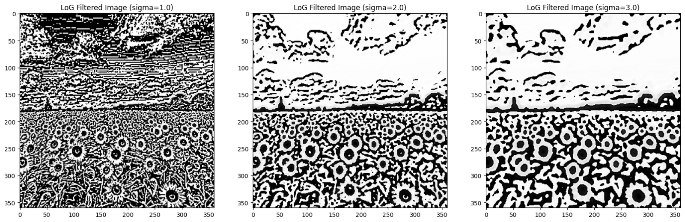
Question 1 : Blob Detection using Laplacian of Gaussians and Scale Space Extreme Detection
In this task, I used the Laplacian of Gaussian (LoG) method with scale-space extrema detection to identify circular blobs in the sunflower field image. The LoG_filter function was applied across different σ values to build a scale-space representation, allowing detection of blobs at multiple sizes. The figure shows the results for σ = 2 and σ = 3, where smaller σ highlights fine details and smaller blobs, while larger σ emphasizes broader and larger blobs, effectively capturing circular features of varying scales across the image.

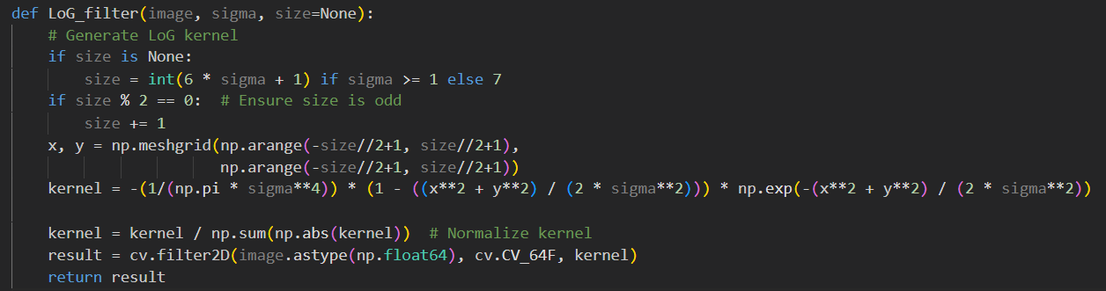

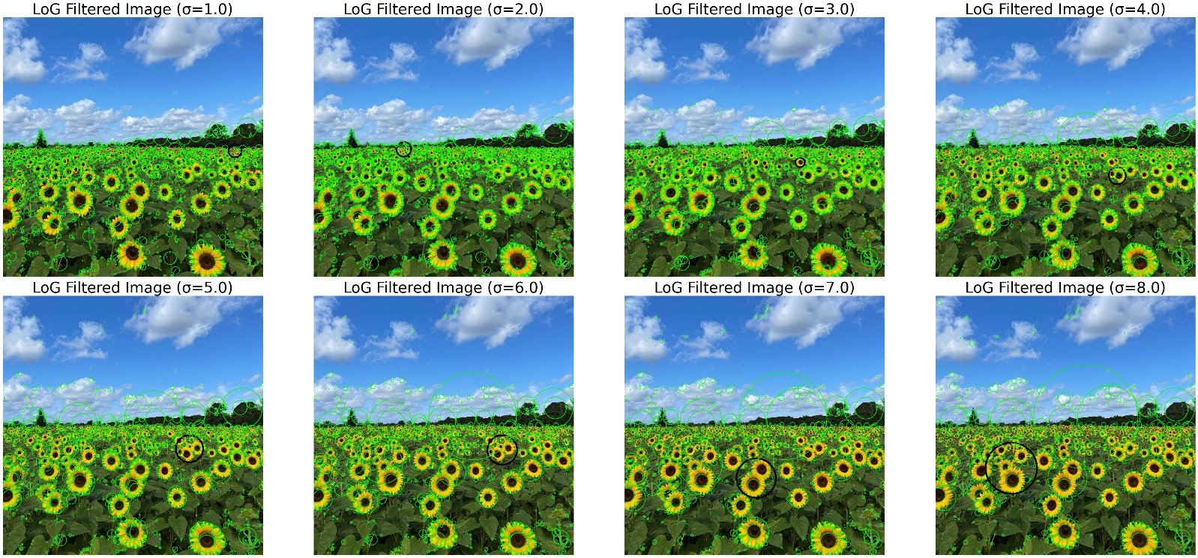

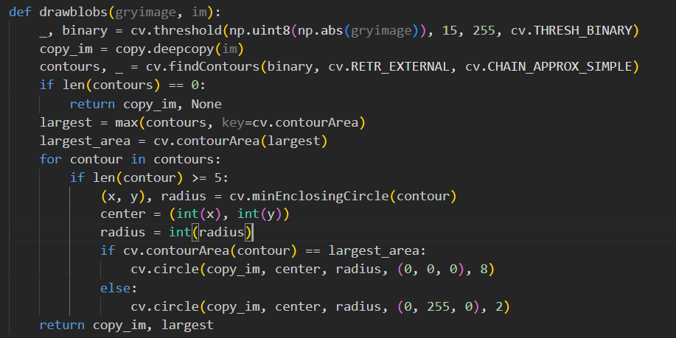



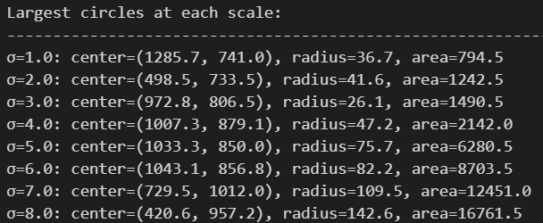
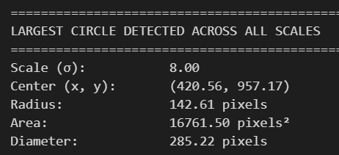

Here I have run this for 8 iterations and get the largest blob when σ = 8.
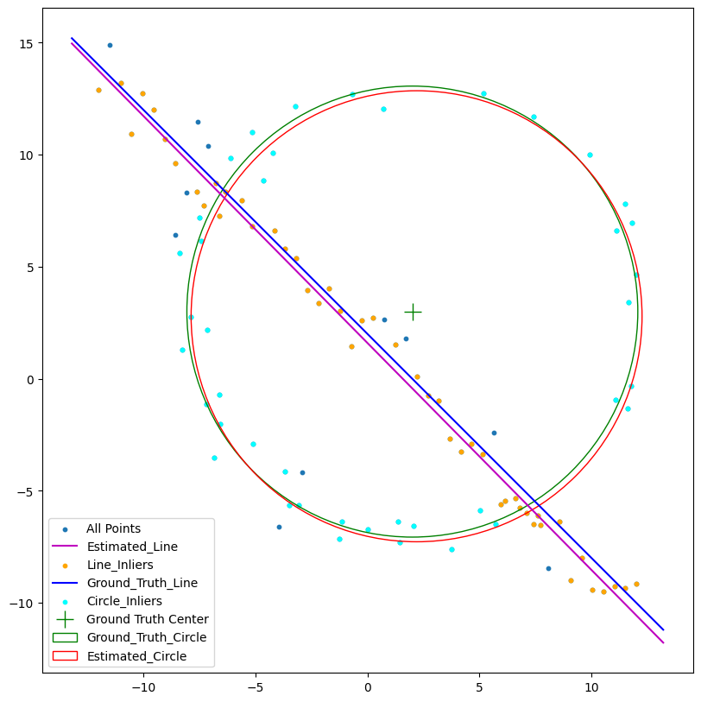
Question 2 : Line and Circle estimation using RANSAC Algorithm
If we choose to detect the circle first without selecting the line, many points may lie close to the line. In such cases, when three random points are selected to fit a circle, they might lie very close to the line instead of forming a true circular boundary. As a result, many more iterations would be required to find the correct points that accurately define the circle.

- Estimated Line
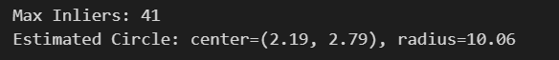

- Estimated Circle
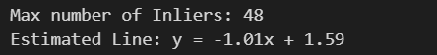

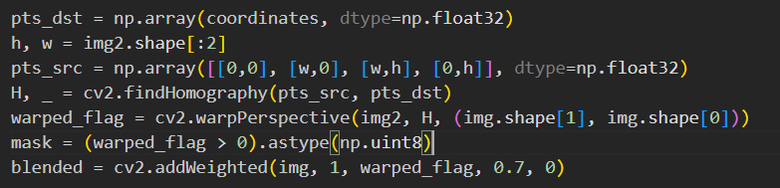
Question 3 : Superimposing an image on another image
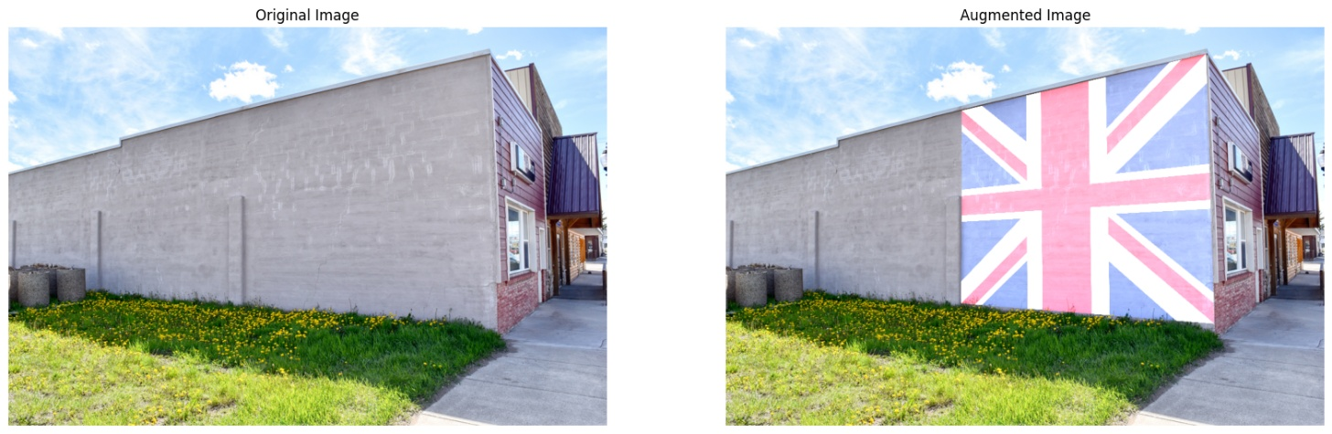

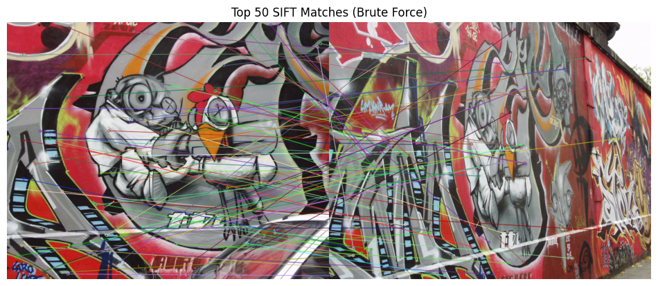
Question 4 : Stitching Graffiti images

