Project Title: Expense Tracker with Budget Alert
Subject: DevOps
Course: B.Sc AI & Data Science
Members :-
- Patel Dhayankumar
- Imran Shaikh

Objective :-
The objective of this project is to build a command-line based expense tracker that helps users manage daily expenses and monitor their monthly budget.

The system allows users to add expenses, categorize them, track totals, and receive alerts when the budget is exceeded.

The project also demonstrates DevOps concepts by using Docker for containerization and Git for version control.

Planning :-
System Flow:
1. User inputs expense details (amount, category, date)
2. Data is stored in a list of dictionaries
3. User can view all expenses
4. System calculates category-wise and total expenses
5. Budget is compared with total expenses
6. Alert is shown if budget is exceeded

Tools Used:
- Python for development
- Git for version control
- Docker for containerization

Source Code :-
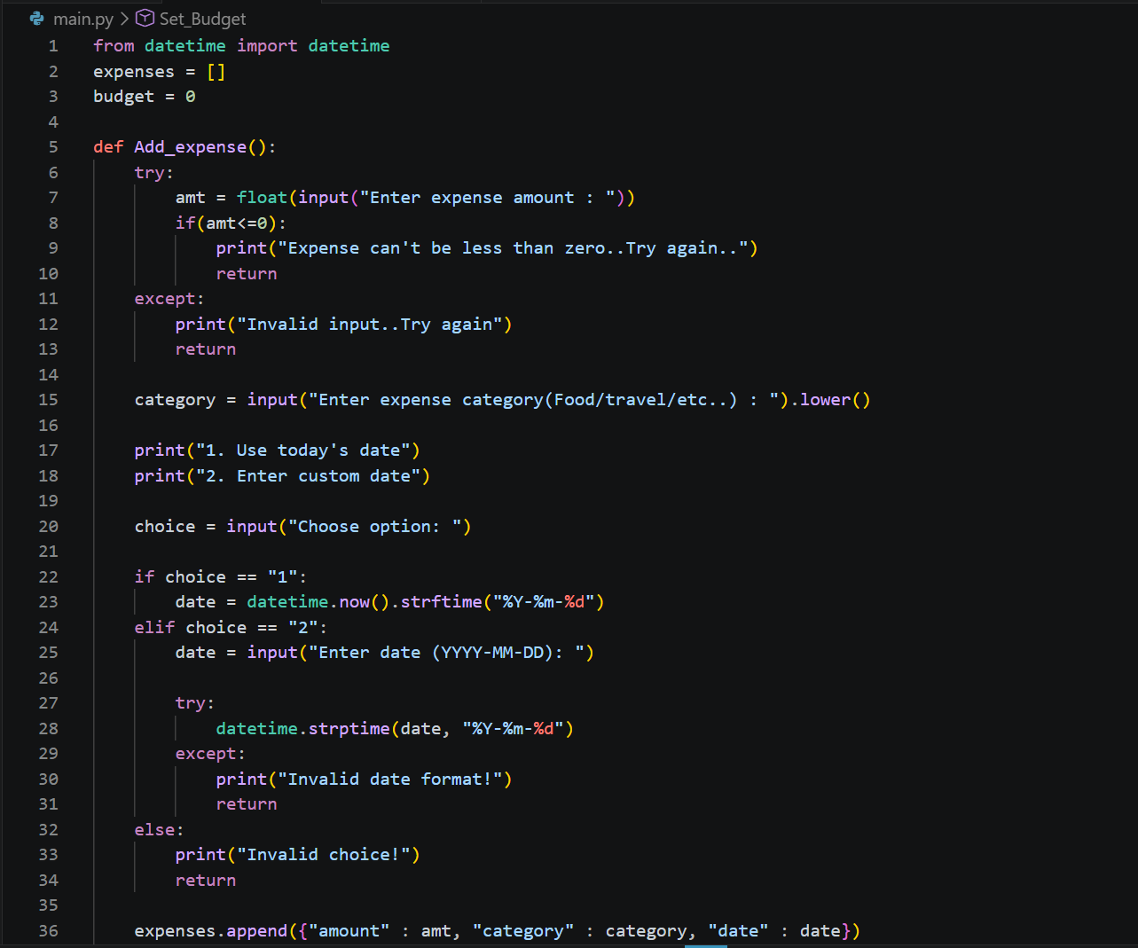
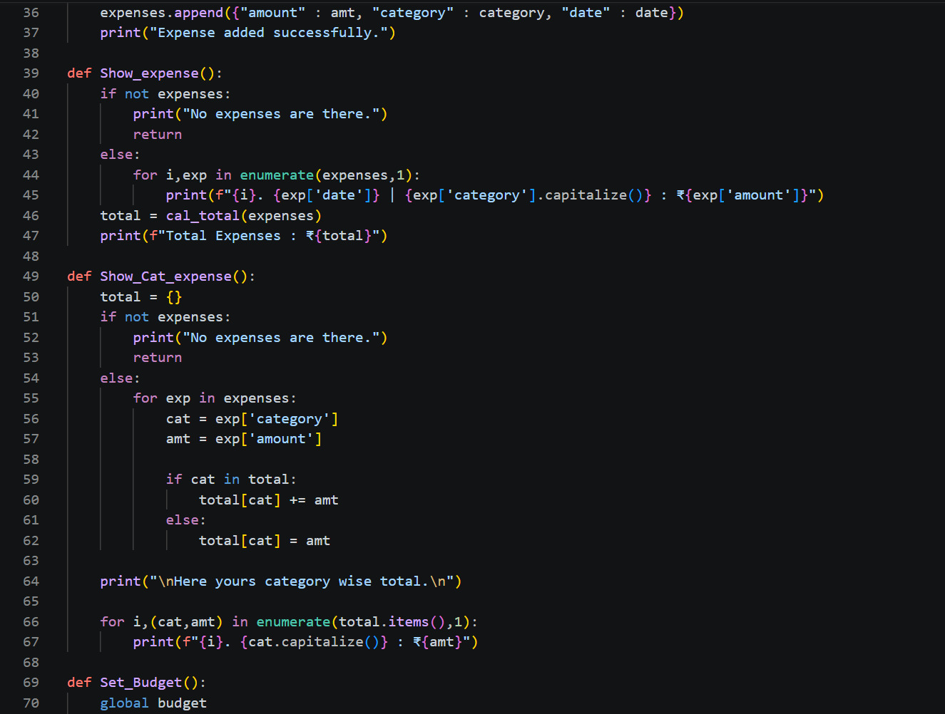
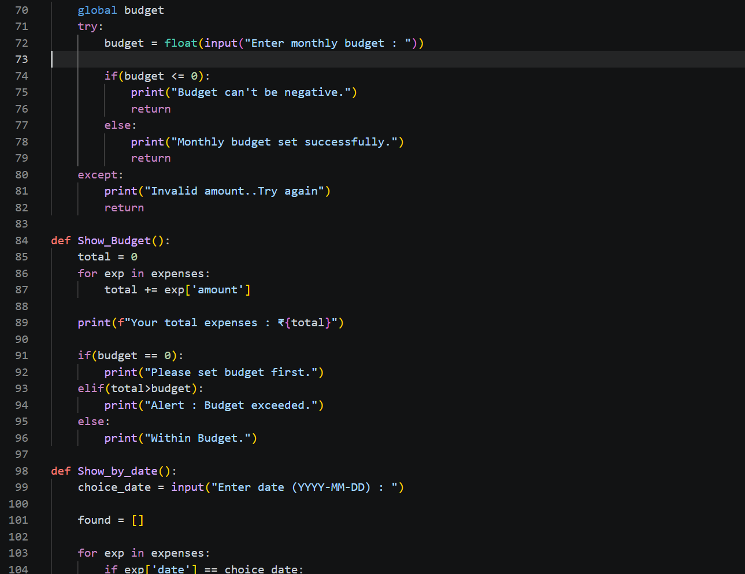
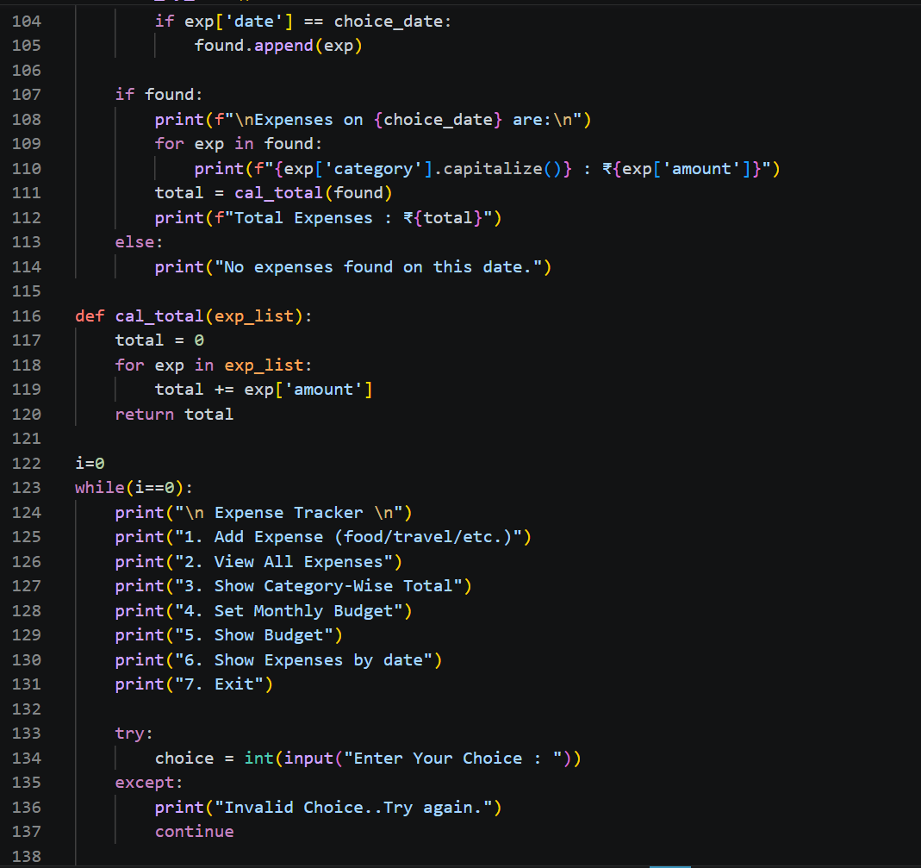
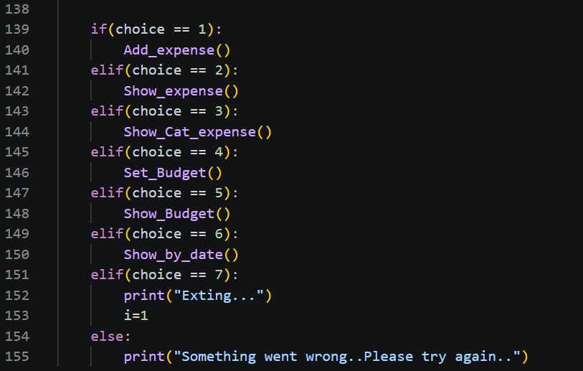

Git Screenshot :-

Build :-

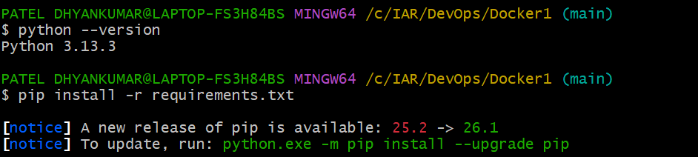
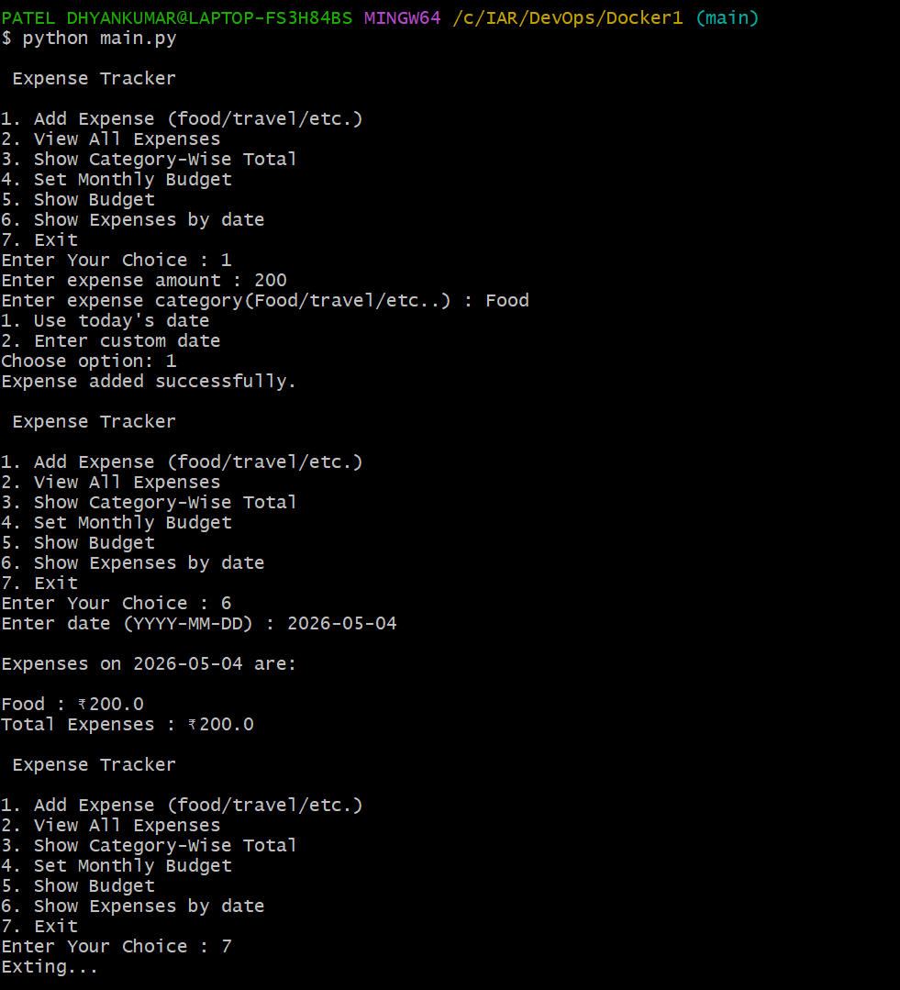

Docker Screenshot :-

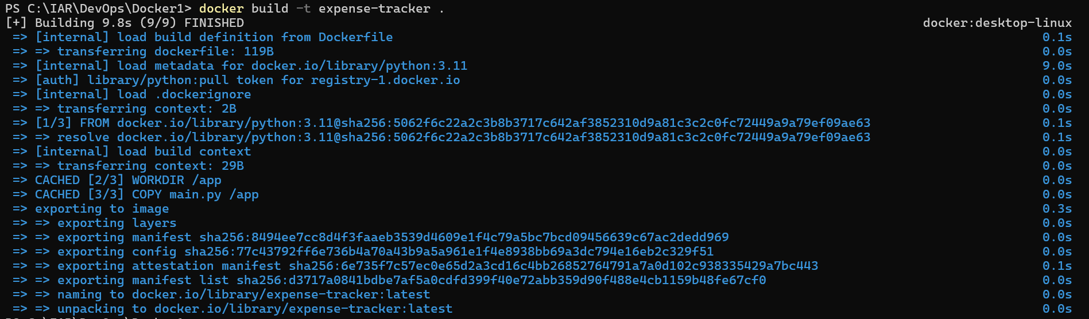
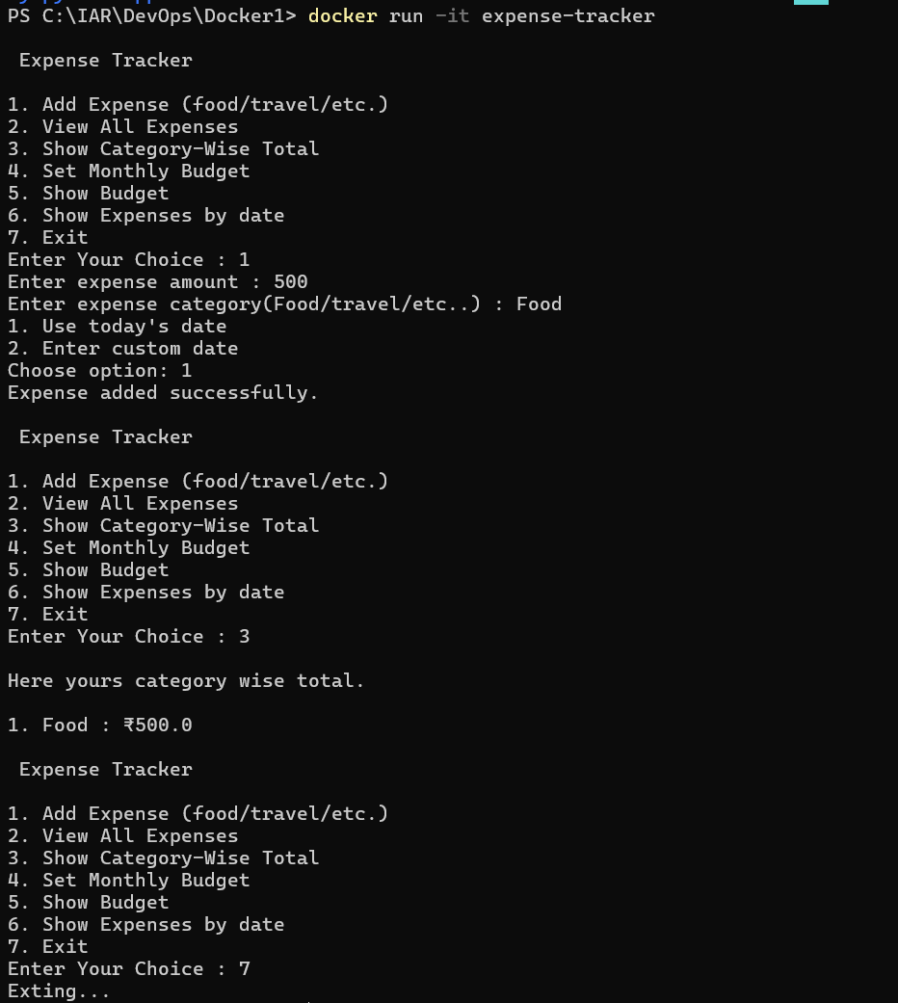

Team Contribution
This project was completed collaboratively by both team members with clearly defined roles:
- Dhayankumar Patel: Responsible for Docker setup, containerization, and managing the Git repository including commits and version control.
- Imran Shaikh : Responsible for application development (coding) and documentation preparation.
- Planning Phase: Both team members actively contributed to system design, feature planning, and overall project structure.
GitHub Repository Link :- https://github.com/DhayanPatel-dev/Devops_Assignment.git

