**Standard Operating Procedure (SOP)**

|  |  |
| --- | --- |
| General Information | |
| Process Title: Organic Food | Department: CSE |
| Contact Info: tdhayanandk@gmail.com | SOP ID: |
| Effective Date:3/7/2024 | EMPLOYEE ID: |

|  |
| --- |
| Process Overview |

**Process Description:**

The process for developing an organic food e-commerce website, providing clear steps and guidelines to ensure a high-quality, user-friendly platform that effectively meets business objectives and customer needs.

No synthetic chemicals: Organic farmers don't use synthetic pesticides, herbicides, or fertilizers. They rely on crop rotation, natural pest control methods, and composted manure to maintain soil health.Minimal processing: Organic foods are typically minimally processed to retain their natural qualities

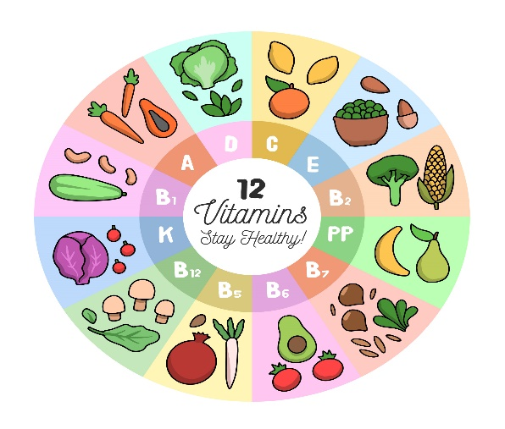

Some minimally processed organic foods may contain things like natural sugars or sea salt for flavor or preservation .There can be variations in processing depending on the specific food product. Processing minimizes human intervention and emphasizes natural methods.

**Purpose & Scope:**

The procedures for handling, processing, and storing organic food products to maintain their organic integrity and ensure compliance with organic standards.

**Scope:**

The scope of Involved in the project, UI/UX Designer, frontend developer, content managers, and security specialists**.**

Then a front-end developer working on an organic food project could be involved in defining the features and functionalities of the front-end user interface (UI) for tasks like:

* An e-commerce platform selling organic products.
* A website for an organic farm showcasing their practices and products.
* An app for consumers to find organic food options near them

**Definitions & Related Documents:**

* **Organic Food:** Food produced without synthetic pesticides, fertilizers, GMOs, antibiotics, and growth hormones.
* **E-Commerce Website:** An online platform that allows customers to buy and sell goods or services over the internet.
* **UI (User Interface):** The part of the website that users interact with directly.
* **UX (User Experience):** The overall experience a user has when interacting with the website.
* **Frontend Development:** The practice of producing HTML, CSS, and JavaScript for a website so that a user can see and interact with them directly.

|  |  |
| --- | --- |
| Resources | |
| WBS | Resources |
| 1.0 | **Frontend:** HTML, CSS, JavaScript, |
| 1.2 | **Version Control:** GitHub |
| 1.3 | **IDE:** Visual Studio Code |