BANK OF BUSSINESS
Software Required:
- Python 3.7
Python Modules Required:
- tkinter
- datetime

HOME PAGE:
When You Opened The Home page will be appeared like this.
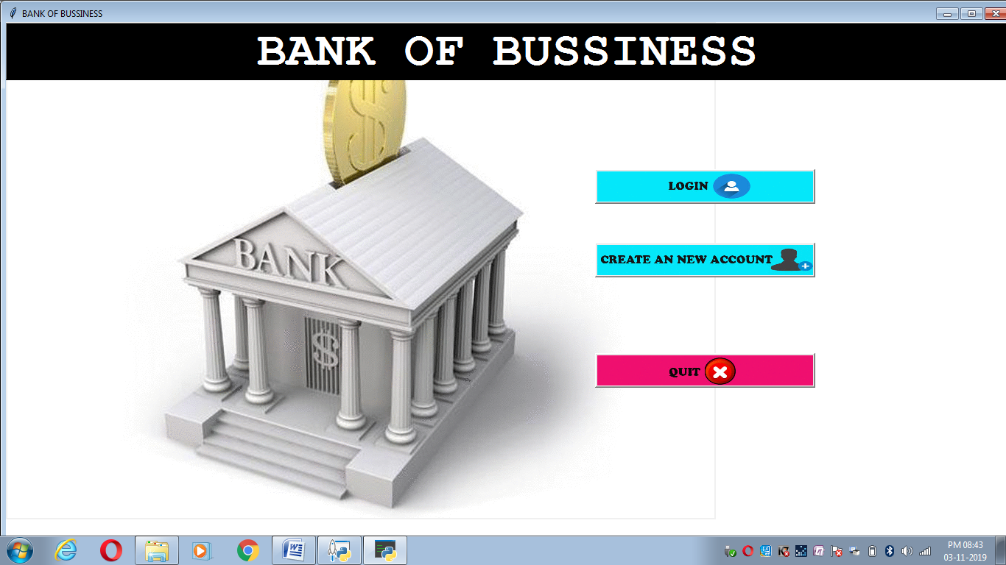
There Will be 3 Buttons Namely, LOGIN BUTTON Which is used for login on to your account which you have created. The second CREATE NEW ACCOUNT button is used for creating account for a new user. The third button is used for QUIT Button which is used for exit the page.
HOW TO CREATE AN ACCOUNT?
You can be create your account by clicking CREATE A NEW ACCOUNT Button in Home Page.
After Clicking It A new Window Will Be Opened.There You Need To Enter 8 Details i.e. NAME and OPENING CREDIT,PIN,AADAR CARD NUMBER,PHONE NUMBER,PAN NUMBER,ACCOUNT TYPE, After filling this give SUBMIT BUTTON.
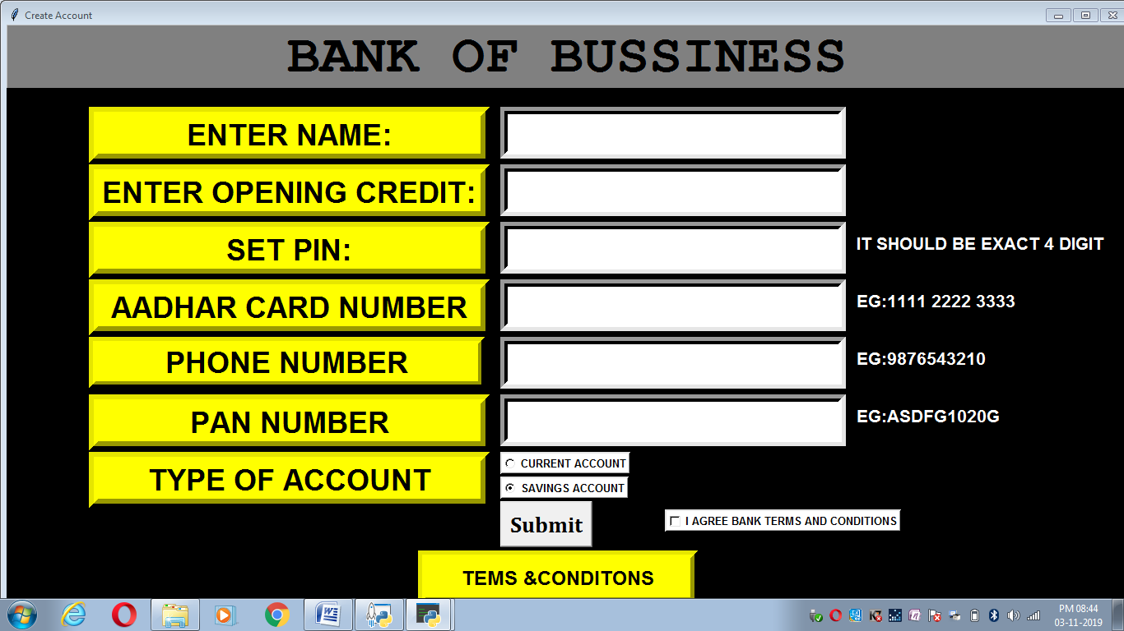
After Giving Submit Button Your Account Number Will Be Displayed. Please Note It
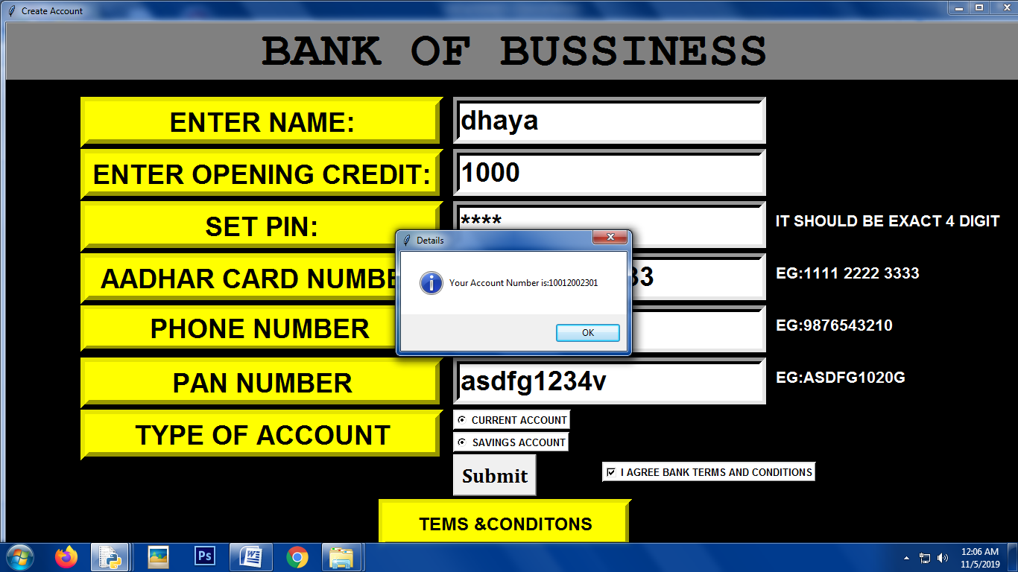

HOW I CAN LOGIN MY ACCOUNT?
After Creating your account you can be Login Your account by clicking LOGIN button. It has three options namely NAME,Account Number, and PIN
HOW I CAN CREDIT IN MY ACCOUNT?
After Login Your Account,The new Window Will Be Opened.
THERE WILL BE 9 BUTTONS NAMELY,CREDIT IN YOUR ACCOUNT,DEBEIT IN YOUR ACCOUNT,CHECK BALANCE,VIEW TRANSACTION.,DEBEIT IN YOUR ACCOUNT,CHECK BALANCE,VIEW TRANSACTION,FUND TRANSFER,EDIT ACCOUNT DETALIS,CHANGE PIN,FUND TRANSFER,HELP

By Clicking CREDIT IN YOUR ACCOUNT button You Can Deposit To the bank. It will Ask How Much Amount You Need To deposit after entering it click CREDIT button(Note:It should be above 100 and multiples of 100)

HOW I CAN DEBIT AMOUNT IN MY ACCOUNT?
After Login the new page will open.THAT NEW PAGE THE BUTTON NAMED DEBIT ON MY ACCOUNT CLICK THAT.NOW YOU CAN ENTER YOUR DEBIT MONEY AND CLICK DEBIT BUTTON

HOW I CAN CHCK MY BALANCE?
YOU CHECK YOUR BALANCE BY CLICKING CHECK BALANCE BUTTON.THE BALANCE WILL BE SHOWN.
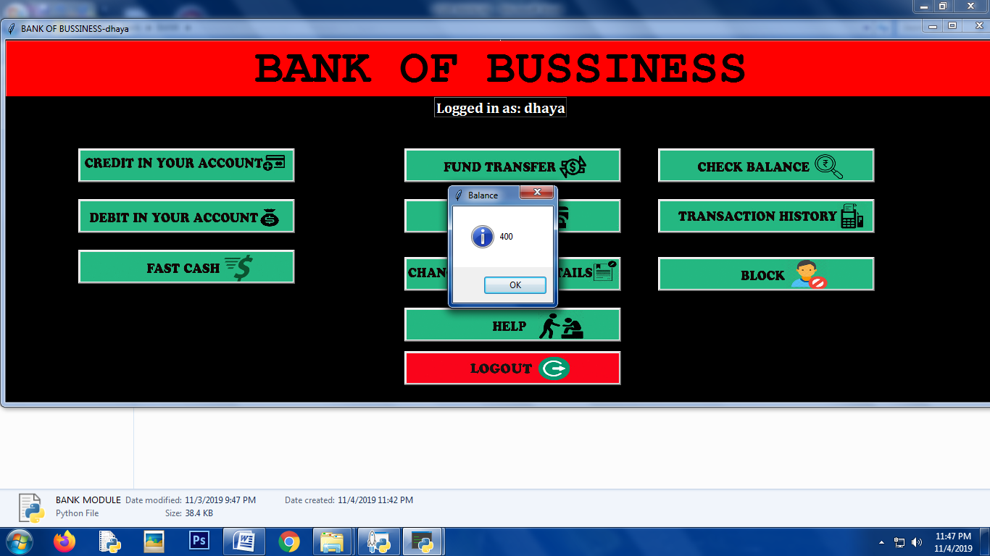
HOW I CAN CHECK MY TRANSACTION HISTORY?
YOU CAN CHECK YOUR TRANSACTION HISTORY BY CLICKING VIEW TRANSACTION HISTORY BUTTON.AFTER CLICKING A NEW WINDOW WILL BE OPENED THERE IT WILL BE DISPLAYED ON WHICH TIME,DATE
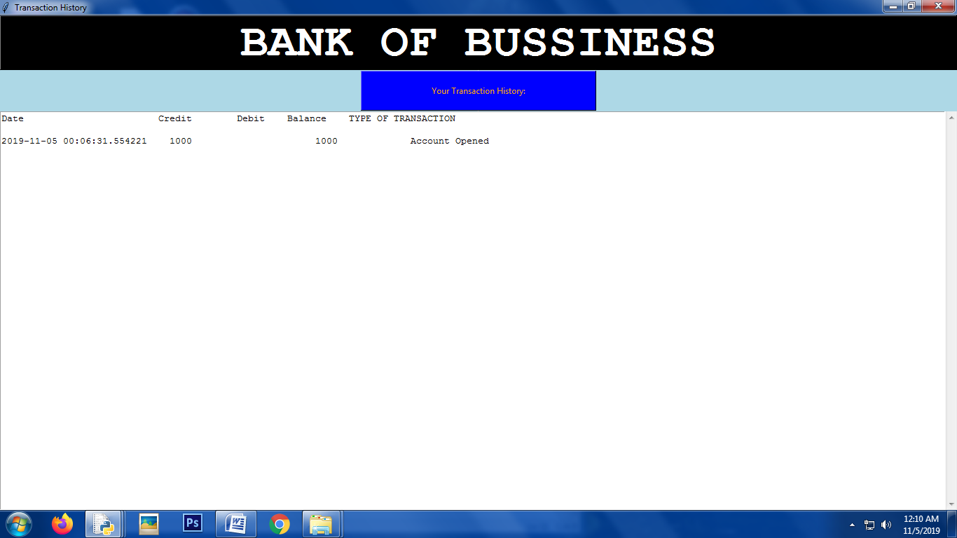

HOW I CAN DO FAST WIDHRAW?
After Loginin,The New Window Will Opened. There The Fast Cash Button Will Be There By Clicking That We can Be Withdraw By clicking One Button.There Only 4 button,500,1000,5000,10000 By Clicking That Button You Can Be Withraw
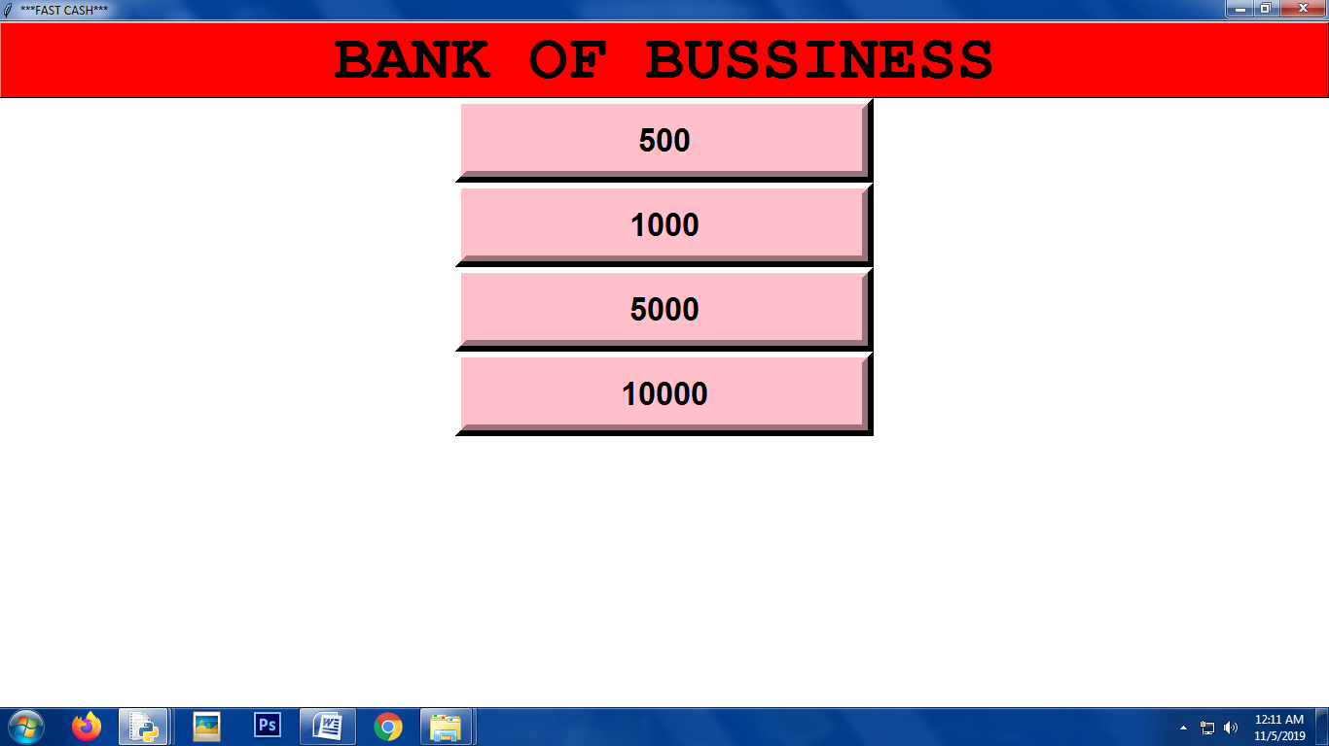
HOW I CAN CHANGE MY DETAILS?
After login in,
There Will Be Button Named [Edit Account Details. click on that. The New Window Will Opened. It will be more options. Once you have Updated all
details you give Update......it will be updated....
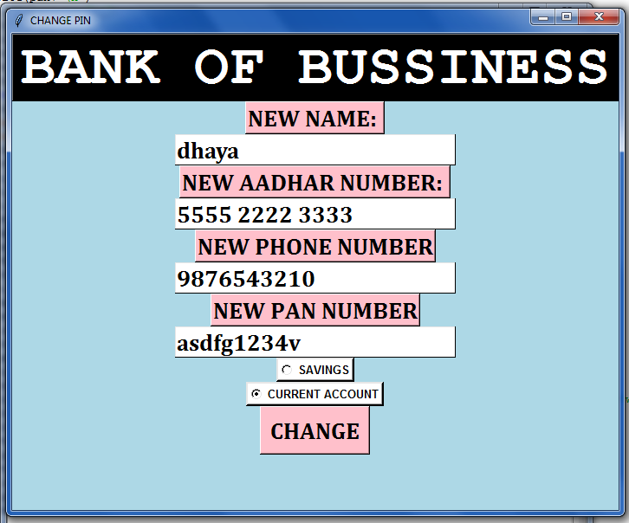

HOW I CAN TRANSFER MY MONEY TO ANOTHER ACCOUNT?
After login,There Will be a Button named Change Pin BUTTON a new window will be Opened....there it will be 2 buttons...
2 Buttons Namely New Pin Re-Type Pin . You need to type your new pin in first button and
for conform you need to type again in the Pin in Second button and give CHANGE........

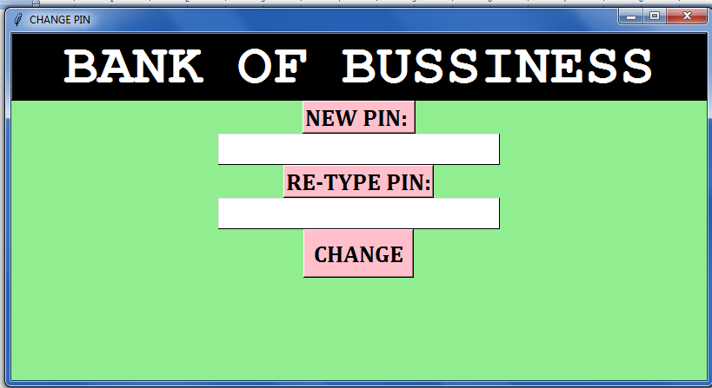

HOW I CAN BLOCK MY ACCOUNT?
After Login There Will Be Button Named Block My Account Button. Click That A new Window Will Be Opened Like This
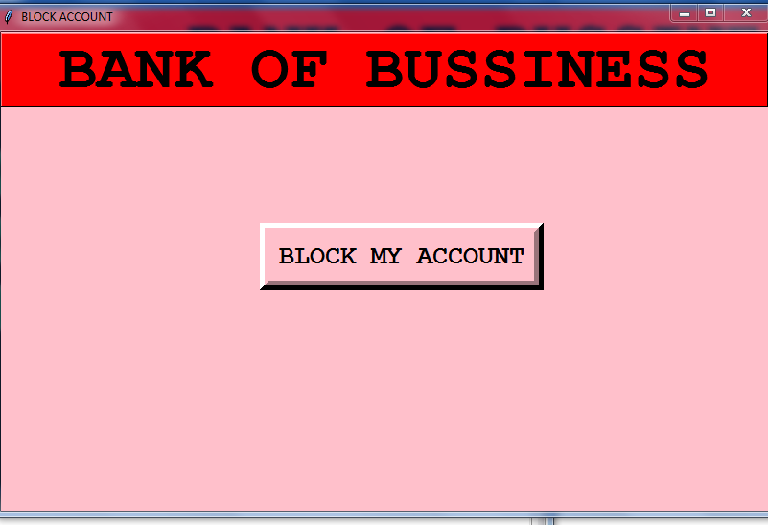
By Clicking Block My Account Button You Can Block Your Account.If You Need To Unblock You Need To Contact Bank

HOW I CAN LOGOUT MY ACCOUT?
After Login,
The Center Last The Button Named Logout Button Will Be There. You Click On That.You Will Be Logouted SucessFully….

