MNIST Quantization aware training (QAT)

Confusion Matrix

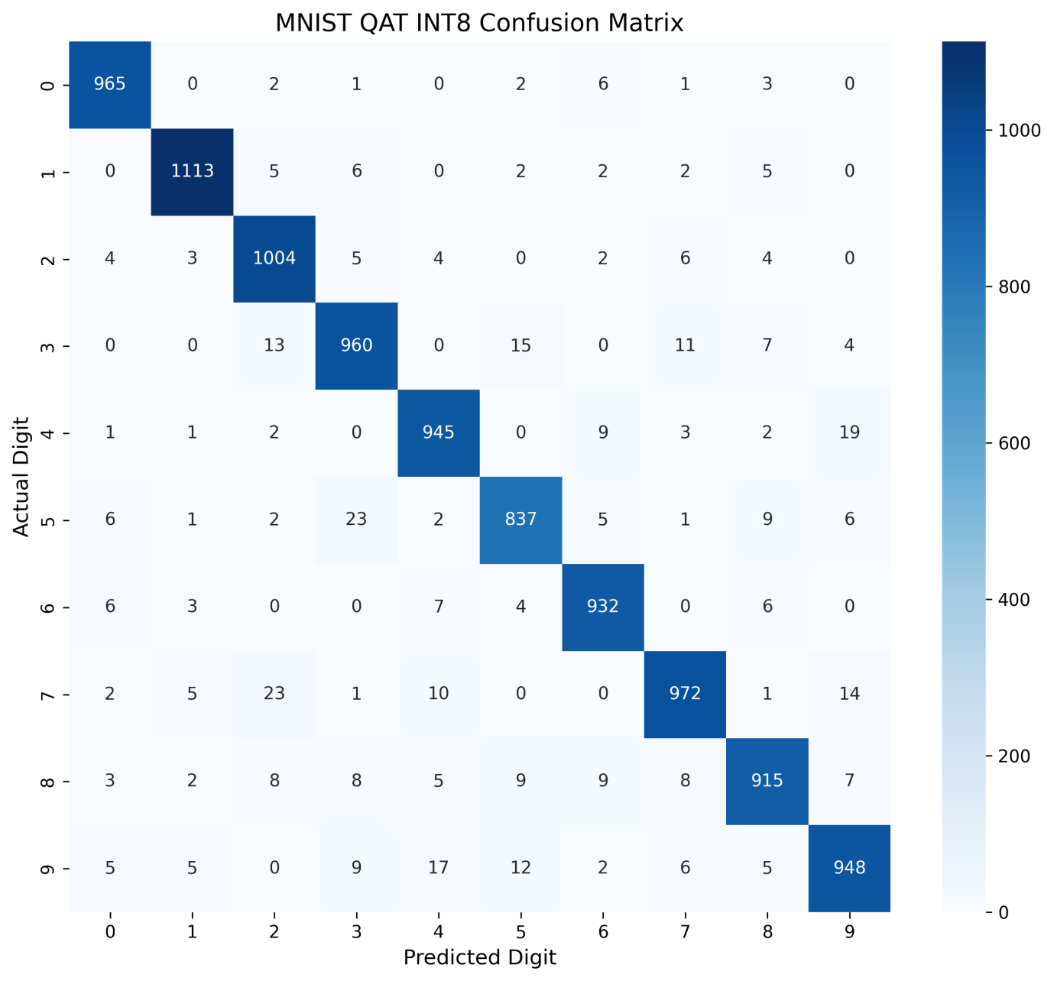

Training accuracy = how well your model classifies the same MNIST images it was trained on.
For example:
60,000 training images.
60,000 training images
↓
Neural Network
↓
58,000 correct
↓
Training accuracy = 96.67%
It tells you how well the model learned the training data.

Test accuracy
Test accuracy = how well the trained model classifies new MNIST images that it never saw during training.
MNIST has 10,000 test images.
10,000 unseen images
↓
Trained Network
↓
9,673 correct
↓
Test accuracy = 96.73%

Floating Point training VS QAT

TEST accuracy
Floating- Point accuracy : 96.73%
QAT / INT8 Accuracy : 95.90%
Accuracy Difference : 0.83 percentage points

Exact INT8 MATLAB REFERENCE Accuracy : 95.91%
QAT vs Exact : 0.01 percentage points

==============================================
PER-DIGIT INT8 ACCURACY
==============================================
Digit 0: 98.47%
Digit 1: 98.06%
Digit 2: 97.29%
Digit 3: 95.05%
Digit 4: 96.23%
Digit 5: 93.83%
Digit 6: 97.29%
Digit 7: 94.55%
Digit 8: 93.94%
Digit 9: 93.95%

Verilog functional waveform
fw[7:0] = layer wise output
mm[3:0] = final classified output
st[4:0]= FSM current state indicator
Compared with matlab
Output layer output for input 7

From Matlab workspace

0 7 0 39 0 0 0 76 0 34

Compared with fw signal in waveform

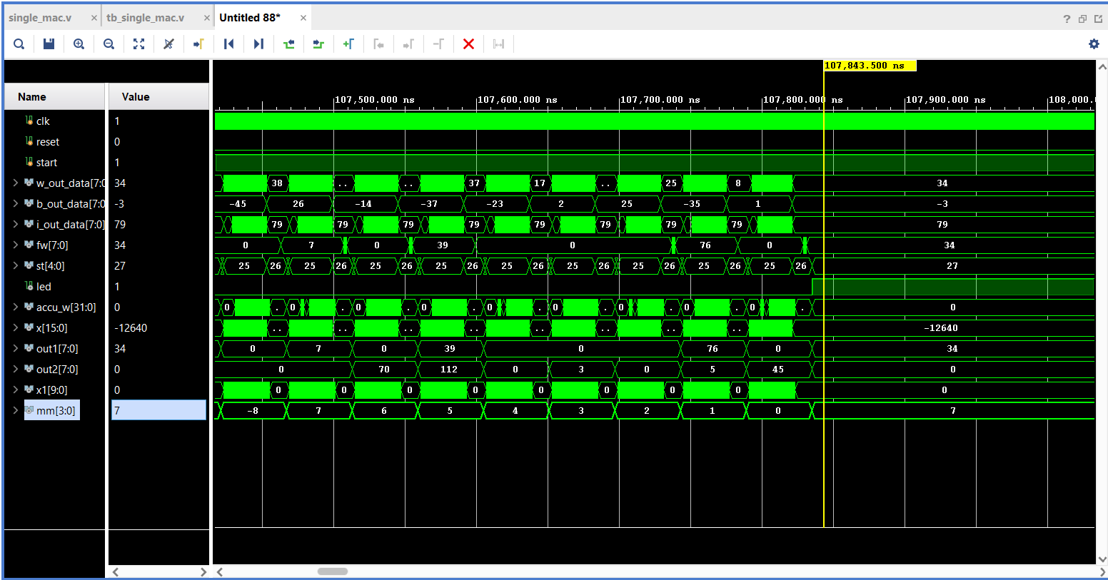

mm signal in waveform is correctly 7 for input 7

