**Lab Report :Linux**

1)

To oblige with the directives from Mr. Penny Johnson, CTO of the company, steps were taken to safeguard the access to the "noida.txt" project file on a Linux machine. This differed from my usual workflow as it included making a new user account "pjohnson," moving the file to a designated project directory, and implementing File Access Control List (FACL) measures. Mr. Johnson was the only user to benefit from the VIP passes that FACL granted him and denied other applicants. To verify the access to the plan and maintain the project file confidential, testing was successful for Mr. Johnson.

Output 1:

Mr. Johnson was the only user to benefit from the VIP passes that FACL granted him and denied other applicants and verified the access to the plan and maintain the project file confidential, testing was successful for Mr. Johnson.

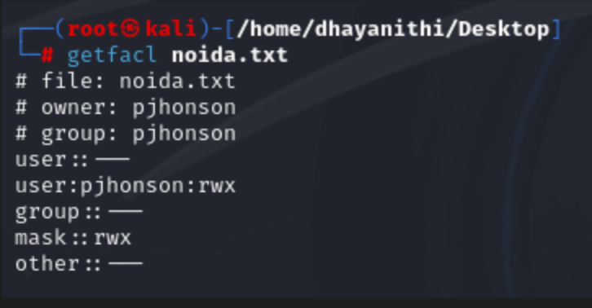

Output 2: Demonstrated that Mr. Penny has access and that any other user cannot access the file.

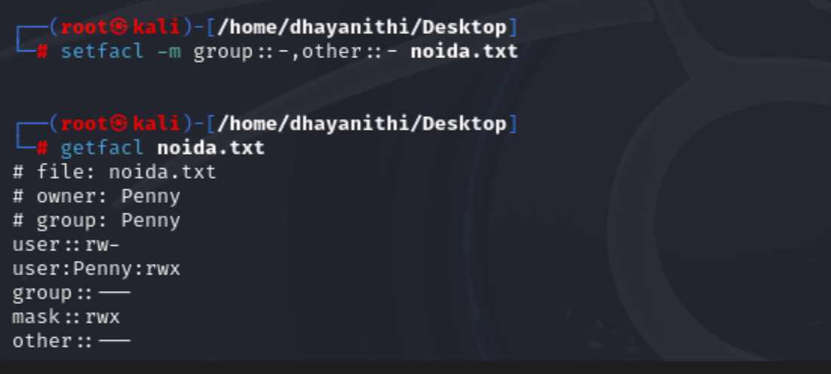

You are a part of the IT Security team at the census department, the government of India. Three representatives were chosen from three states namely Goa, Delhi, and Gujarat who need to have access to specific files. Those files are attached herewith. Following is the activity to be performed.

Output:

In response to the government's need for controlled file access, users "stefi," "aravind," and "jignesh" were created with the password "india," alongside the group "citizen."

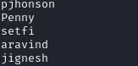 

Files from "government.zip" were extracted, and permissions were adjusted for Gujarat to grant full access to "jignesh" and read/execute access to "aravind."

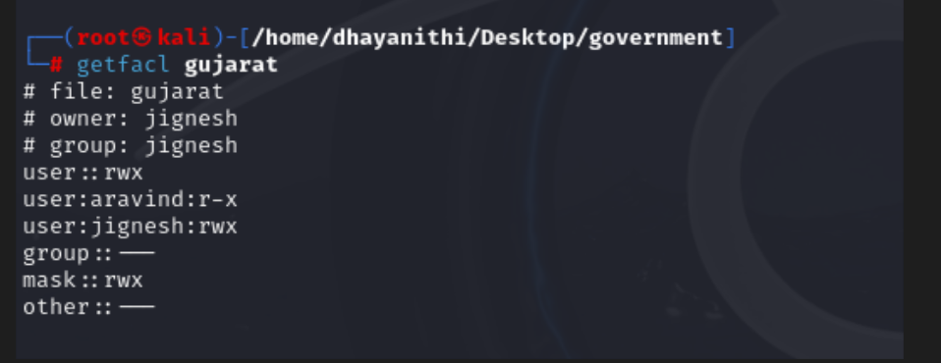

Delhi's permissions were recursively modified to deny access for "stefi."

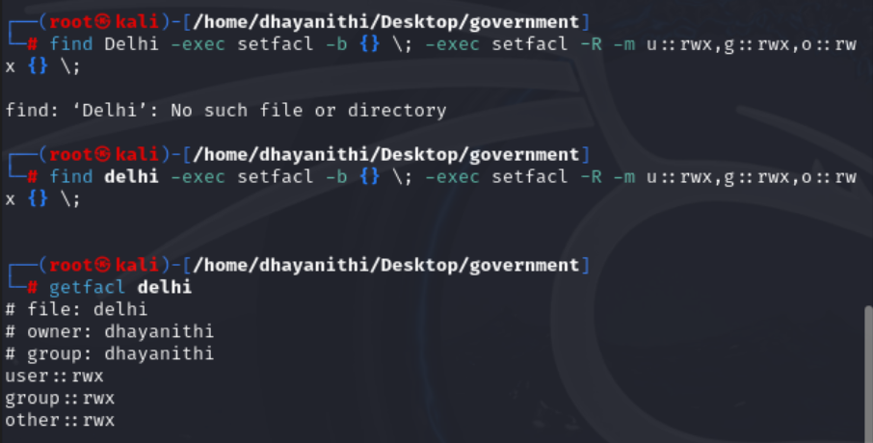

Full rights were granted to the "citizen" group for Goa, and specific permissions were set for "goa\anjuna.txt" .Full rights were granted to the "citizen" group for Goa, and specific permissions were

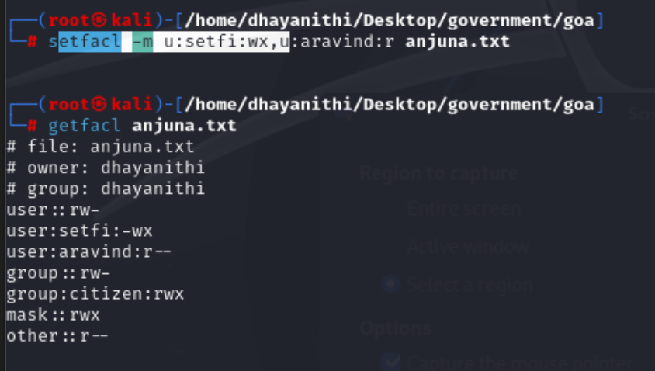

Full rights were granted to the "citizen" group for Goa, and specific permissions were "goa\candolim.txt." Verification checks ensured access integrity and screenchots have been uploaded

