**Information Gathering on Websites Using Linux**

Lab 1: Nmap: Finding the IP address, OS details, port details, and service details of a target machine.

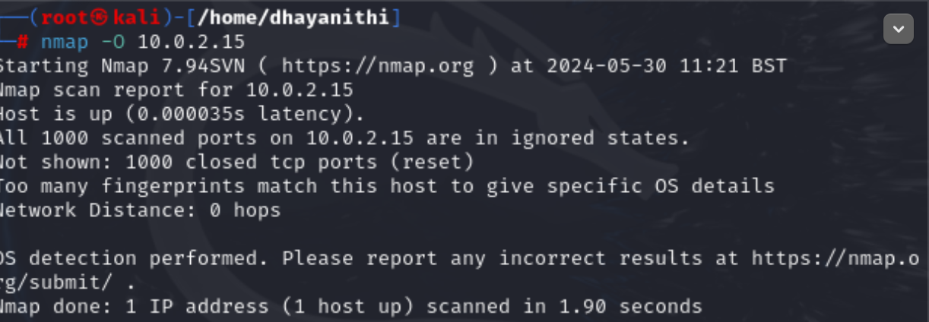

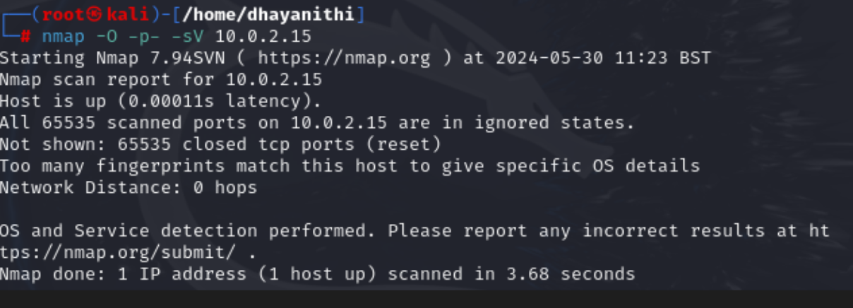

Lab 2: Macchanger:

Experiment with changing your MAC address to understand how it can help in maintaining anonymity or bypassing certain security measures.

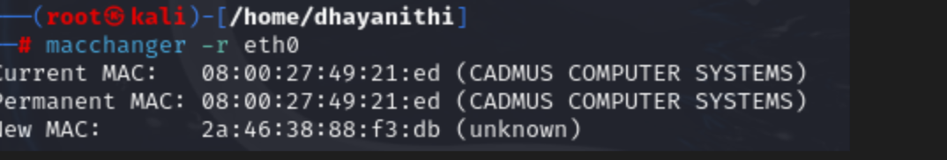

Lab 3: Netstat: Netstat in Windows to enumerate ports and display the routing table of a machine.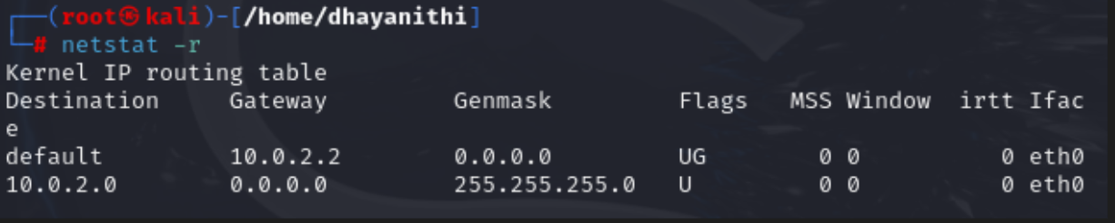

Lab 4: Wireshark: Identify different protocols, find the protocol through which data is passed, and analyze TCP streams to find actual data being transmitte

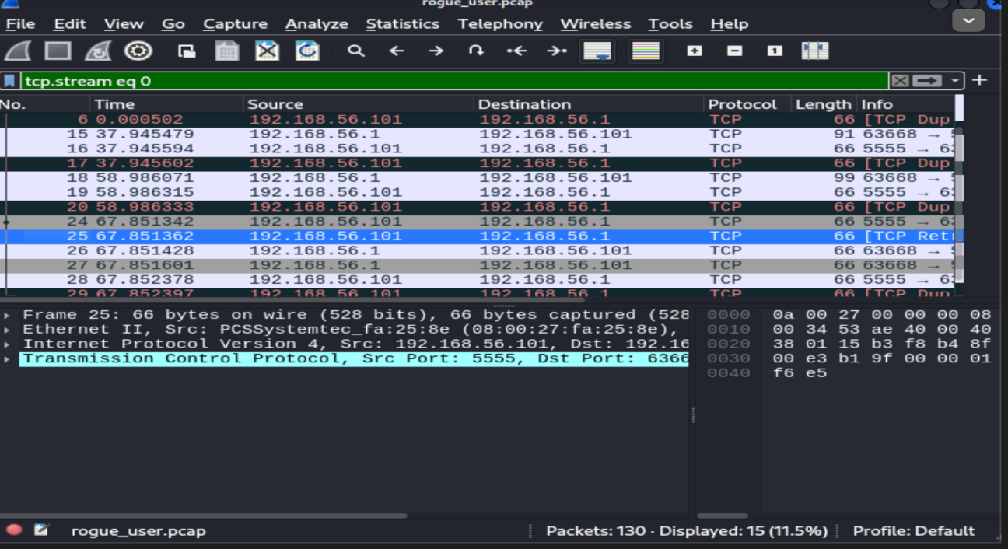

The data transfered has been captured using Wireshark.

