

**Coffee Shop Web Server and DNS Server With Ubuntu**

GROUP 8

Names : Annisa Angelita Putri

Dhayu Wiragusti

Muhammad Rizky

Class : 2 ISA 2

**CEP CCIT**

**FACULTY OF ENGINEERING UNIVERSITY OF INDONESIA**

**2023**

# **PREFACE**

Thank you, the author wishes to God the Almighty for His blessings and grace, we can complete this project task both in the form of presentation and paper in a timely manner.

The author also delivers him gratitude to Mr. Tri Agus Riyadi, S.Kom, M.Kom faculty and other faculty for all guidance to complete it. Thank you to fellow students who have supported, and also thank you to fellow workers in the education at CCIT-FTUI. The Project paper entitled “Coffee Shop Web Server and DNS Server With Ubuntu” the author submits as a requirement for the Project assignment in 2023.

Finally, the authors hope this paper can be useful for all and also gain a better insight into the operating system. The author realizes that it is still imperfect. Therefore, the authors really expect all suggestions and criticisms from readers who are constructive in order for the perfection of this paper. Hopefully, this paper can provide many benefits for the readers.

# **TABLE OF CONTENTS**

**PREFACE i**

**TABLE OF CONTENTS ii**

**TABLE OF FIGURES iii**

**CHAPTER I INTRODUCTION 1**

I.1 Background 1

I.2 Writing Objective 2

I.3 Problem Domain 2

I.4 Writing Methodology 2

I.5 Writing Framework 2

**CHAPTER II 3**

II.1 Software 3

**CHAPTER III PROBLEM AND SYSTEM ANALYST 6**

III.1 Procedure 6

III.2 Prototype 13

III.3 Implementation 13

III.3.1 Advantage 14

III.3.2 Disadvantage 14

**CHAPTER IV CONCLUSION AND SUGGESTION 15**

IV.1 Conclusion 15

IV.2 Suggestion 15

**BIBLIOGRAPHY 16**

# **TABLE OF FIGURES**

**Figure 2.1 VirtualBox 3**

**Figure 2.2 Ubuntu 4**

**Figure 2.3 Visual Studio Code 4**

**Figure 2.4 XAMPP Apache 5**

**Figure 3.1 DNS Server Network Manager 6**

**Figure 3.2 DNS Server Configuration Named 6**

**Figure 3.3 Instalation Configuration 7**

**Figure 3.4 DNS Server Configuration 7**

**Figure 3.5 DNS Server Configuration Option 8**

**Figure 3.6 DNS Server Configuration Resolv 8**

**Figure 3.7 DNS Server Testing Nslookup 9**

**Figure 3.8 DNS Server Testing Information 9**

**Figure 3.9 DNS Server Testing in Windows 10**

**Figure 3.10 Web Server Build Directory 10**

**Figure 3.11 Web Server Create Server 11**

**Figure 3.12 Web Server Hosts 11**

**Figure 3.13 Web Server Reload Apache2 12**

**Figure 3.14 Web Server Installing ssl Configuration 12**

**Figure 3.15 Prototype 13**

# **CHAPTER I**

# **INTRODUCTION**

## I.1 Background

At this time, a lot of OS developed. An operating system or OS is a software or software whose job is to be responsible for managing and controlling the work of hardware or hardware and running software or applications in a computer system. The operating system plays a role in coordinating all connected devices on the gadget at the same time, such as internal storage, mouse, speakers, and CPU. In this case the operating system acts as a bridge that connects hardware and software. A computer operating system is needed for its performance to run properly. Every computer requires an operating system to run or use.

There are three computer operating systems that are commonly used, namely Microsoft Windows, Mac OS X, and Linux. Currently, modern operating systems use a graphical user interface (called a GUI). But in this project, we will discuss more deeply about making a web server on Linux. In simple terms,

Linux is an operating system or Operating System (OS), just like Windows OS, MacOS, iOS, Android, and so on. Like any other operating system, Linux's function is as a container for bridging communication or user commands on the relationship between software and hardware in a device. With such a function, Linux will receive and translate user commands in the software, then sent to the hardware to produce an action output.

In today's modern era, the use of the website has become a common thing for various interests, not only for the industry, but also for individuals. Creating a website or blog is very easy and even free, but apart from that there is technology that is the backbone for these websites to run, namely a web server. This time I will discuss a little about web servers and how to build them.

A web server is a server that is responsible for receiving HTTP requests from web clients and giving back HTTP responses (HTTP is a protocol), the response given is in the form of a web page as well as its content in the form of text or script. One of the widely used web servers is the Apache web server. Apache is open source and of course free.

## I.2. Writing Objective

The purpose of writing this paper is to explain the components needed to create a Web Server and DNS server on Ubuntu.

## I.3 Problem Domain

The problem area of this paper is how to make a web server and DNS server using ubuntu.

## I.4 Writing Methodology

This research used a descriptive technique in which the data was collected from a trustworthy literature study.

## I.5 Writing Framework

**Chapter 1:** Introduction to the paper, background, the purpose of writing, problem domain, writing methodology, and writing outline.

**Chapter 2:** Describes what software is used.

**Chapter 3:** Describe the procedures and implementation of the project.

**Chapter 3:** Conclusions and suggestions of this paper.

**CHAPTER II**

## II.1. Software

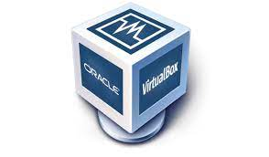

**Figure 2.1 VirtualBox**

**(https://shorturl.at/hvzAV)**

VirtualBox is virtualization software for installing an operating system. The term virtualization product changes or transforms something into a real form or a simulated form of a real form. For example, if a person has the Windows operating system installed on their computer, that person can also run other operating systems on the Windows operating system. If you want to try and practice installing an operating system, you don't need to reinstall your PC/laptop.

Installing the operating system in VirtualBox does not affect the main operating system. Another advantage is being able to install multiple operating systems for free without disconnecting from the main hard drive. Save money by eliminating the need to buy new hardware or computers to use/install multiple operating systems. And the last advantage is being able to test and simulate operating system installations without losing the existing system.

VirtualBox can simulate as many different operating systems as you want and can run them concurrently. Constraints are the resources of the main device itself. If the primary device only has 4GB of RAM, there is no way to simulate a virtual machine with more than 4GB of RAM. The same is true for other resources such as video memory and memory (although the dynamic memory feature can be used).



**Figure 2.2 Ubuntu Server**

**(**[**https://shorturl.at/ehrtH**](https://shorturl.at/ehrtH)**)**

Linux is a family of operating systems based on the Linux kernel, where the kernel is the core part of an operating system. The kernel enables communication between hardware and software components. Meanwhile, Ubuntu is a Linux distribution based on Debian. Ubuntu is well-suited for cloud computing, servers, desktops, and other internet of things (IoT) devices.



**Figure 2.3 Visual Studio Code**

**(**[**https://shorturl.at/frvx1**](https://shorturl.at/frvx1)**)**

Visual Studio Code is a code editor application made by Microsoft that can be run on all desktop devices for free. The complete range of features and extensions make this code editor the top choice for developers. Visual Studio Code even supports almost all operating systems such as Windows, Mac OS, Linux, and so on. Visual Studio is software that is used to write syntax when creating an application. There are at least four types of Visual Studio that you should know about, including IDE, App Center, Azure DevOps, and Visual Studio Code.



**Figure 2.4 Apache XAMPP**

**(**[**https://rb.gy/fytw7**](https://rb.gy/fytw7)**)**

XAMPP is a web server software used to develop and design websites on a local server. This application is also often referred to as localhost XAMPP because of its function as a local server maker on computer devices. This application is open source and can be operated on various operating systems, such as Windows, Mac OS, and Linux. In this application there are various programs needed to build and design websites. Some of the programs in question include Apache, MySQL/MariaDB, PHP, and Perl.

# **CHAPTER III**

# **PROBLEM AND SYSTEM ANALYST**

## III.1. Procedure

Steps to create a coffee shop web server and web DNS on Ubuntu

1. Download and install Virtual Box as an application to try out an operating system other than the main operating system.

2. Download Ubuntu on Virtual Box.

3. Configuring Web Server and DNS Server on Ubuntu terminal.

4. After that, set the DNS Server following the steps below.

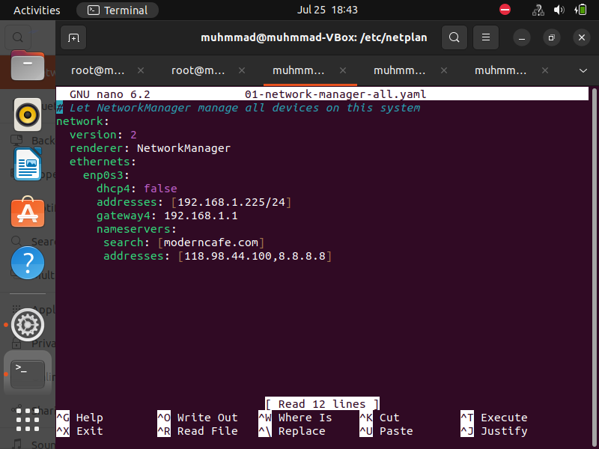

**Figure 3.1 DNS Server Network Manager**

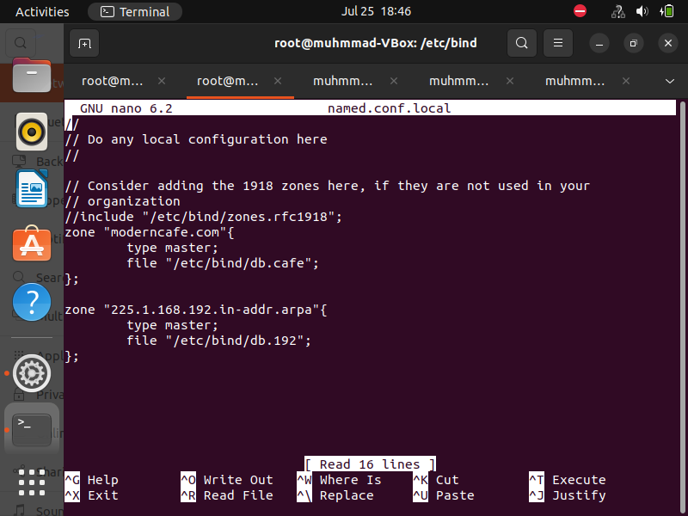

**Figure 3.2 Server Configuration Named**

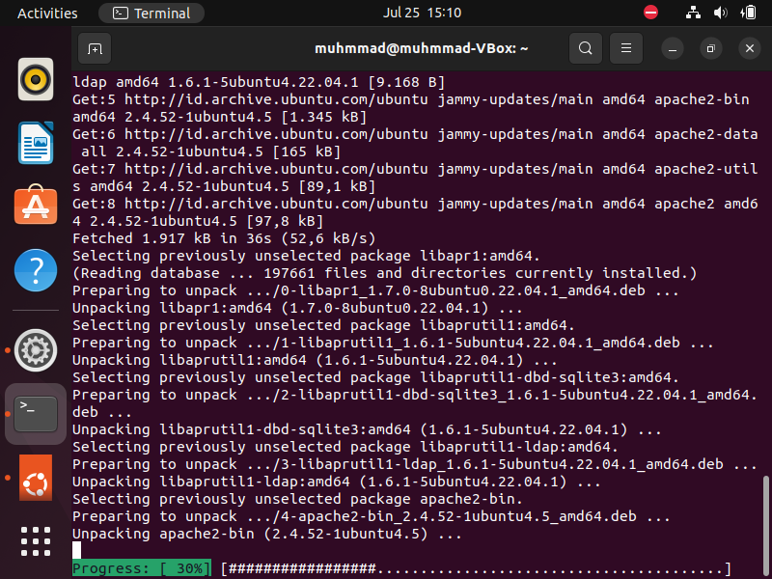

**Figure 3.3 Instalation Configuration**

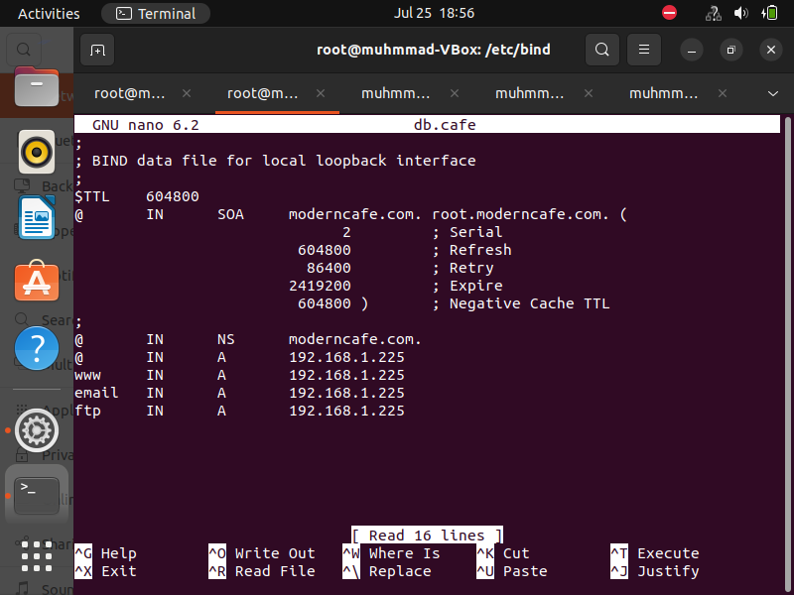

**Figure 3.4 DNS Server Configuration db.domain**

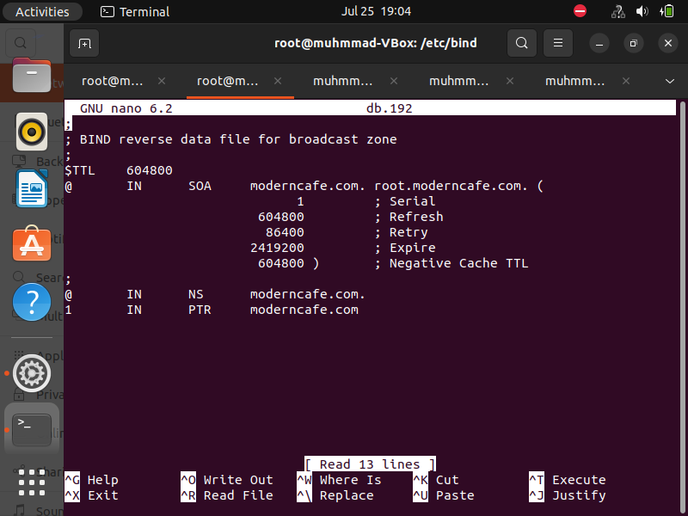

**Figure 3.5 DNS Server Configuration db.port**

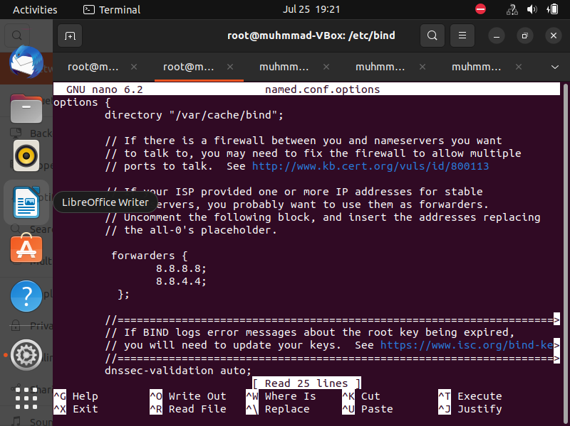

**Figure 3.6 DNS Server Configuration Option**

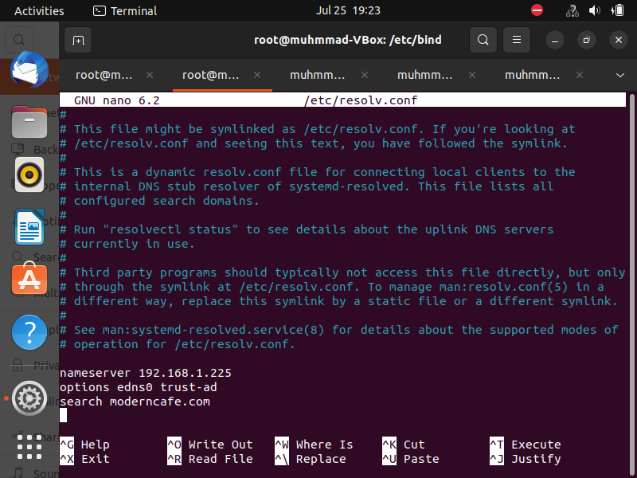

**Figure 3.7 DNS Server Configuration Resolv**

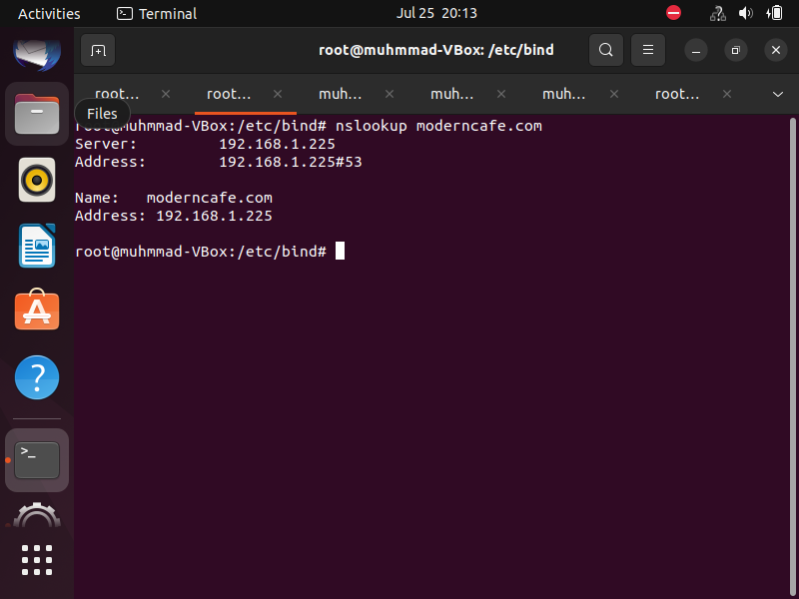

**Figure 3.8 DNS Server Testing Nslookup**

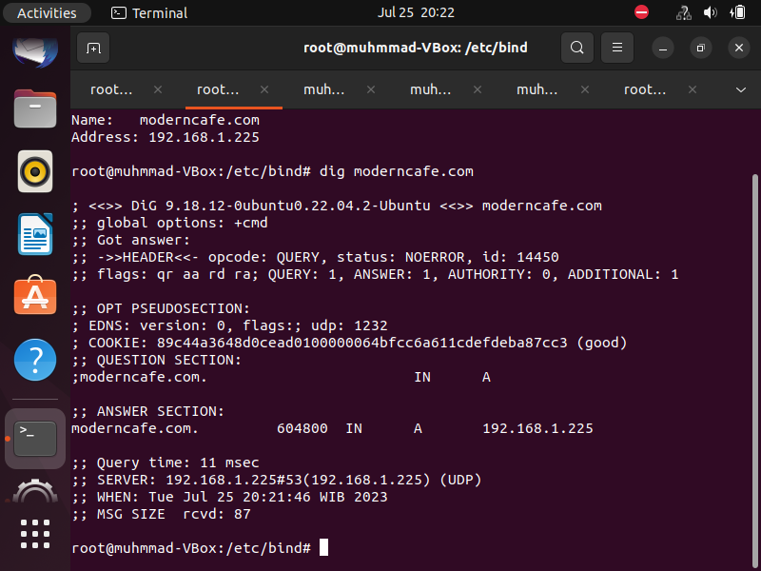

**Figure 3.9 DNS Server Testing Information**

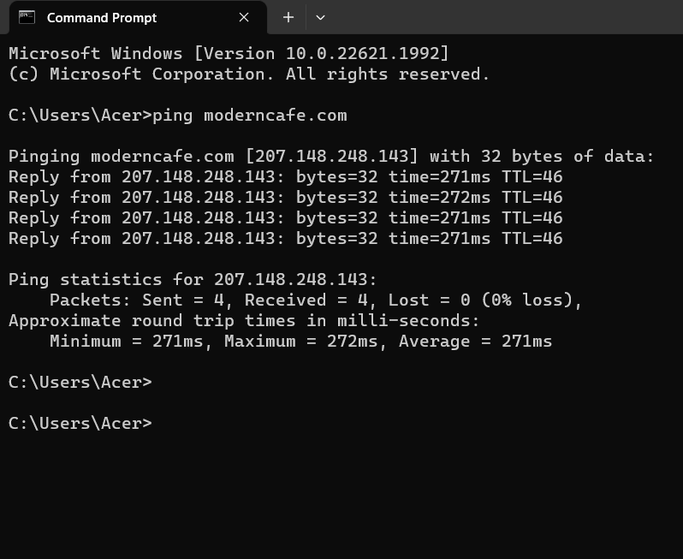

**Figure 3.10 DNS Server Testing in Windows**

5. Then web server settings like the steps below.

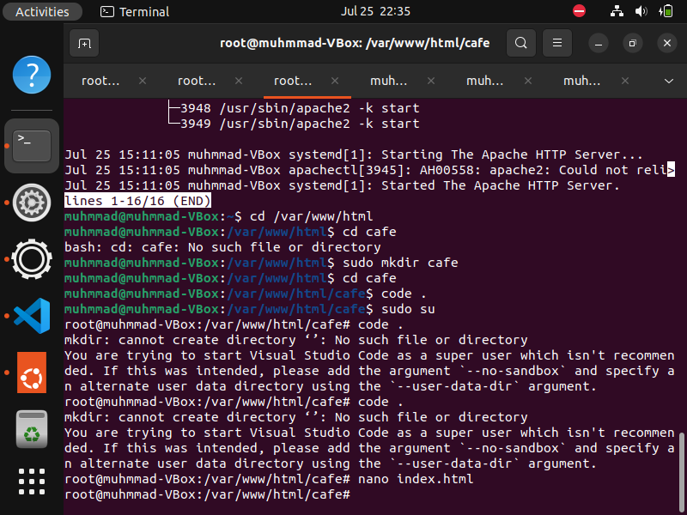

**Figure 3.11 Web Server Build Directory**

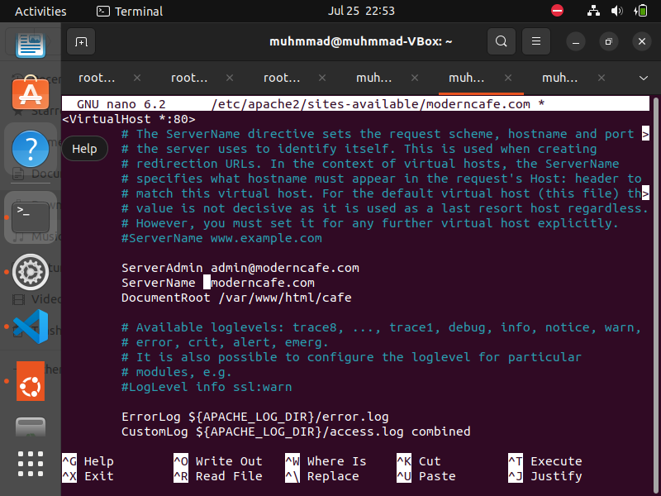

**Figure 3.12 Web Server Create Server**

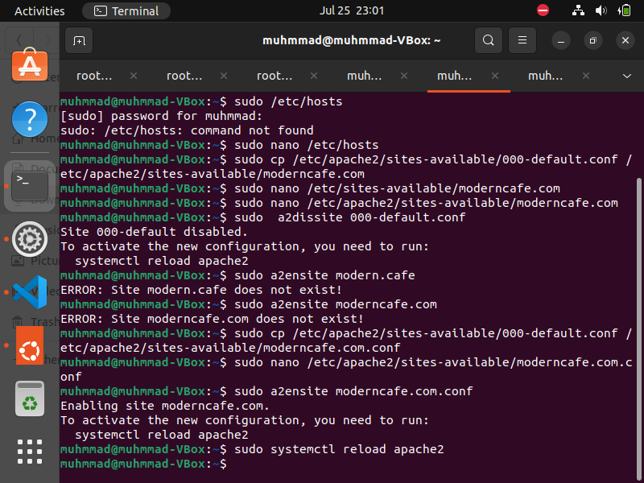

**Figure 3.13 Web Server Reload Apache2**

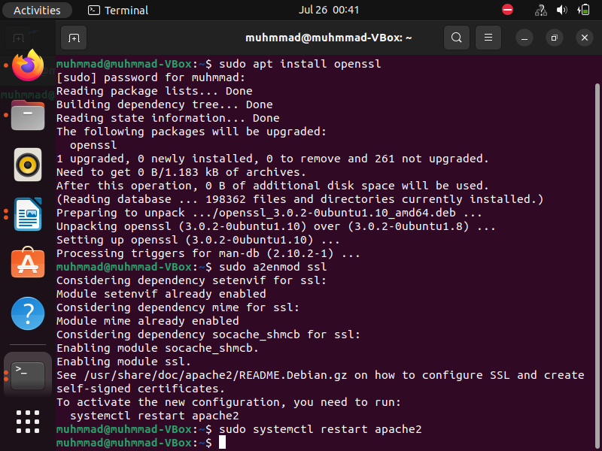

**Figure 3.14 Web Server Installing ssl Configuration**

## III.2. Prototype

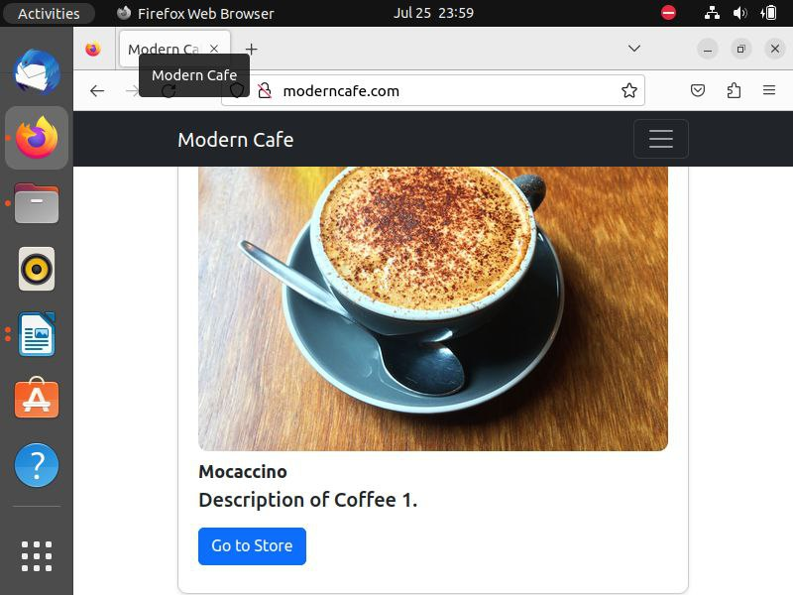

**Figure 3.15 Prototype**

## III.3. Implementation in Daily Life

The implementation of setting up a web server and DNS server on Ubuntu can have several real-world applications. For instance, if you're running a small business, you can host your own website on a local server, providing information about your business and services to potential customers. This can save costs on web hosting services and give you more control over your online presence.

Similarly, if you're a developer, setting up your own web server can be beneficial for testing and development purposes. You can test your applications in a controlled environment before deploying them to a live server.

Creating a DNS server can also be beneficial for businesses. It allows you to manage the domain names of your business network, making it easier for users to access different servers and services. For instance, instead of remembering an IP address for a server, users can just type in a domain name.

In the education sector, understanding how to set up a web and DNS server can be a valuable skill for IT students. It can enhance their understanding of how the internet works and provide hands-on experience with server management.

### **III.3.1 Advantages**

1. Cost-effective: Using open-source software like Ubuntu and VirtualBox reduces costs compared to proprietary alternatives.
2. Flexibility: This setup allows you to easily create, modify, and replicate server environments for different projects or testing scenarios.
3. Safety: Virtual machines provide a layer of isolation from the host system, reducing the risk of damaging your main operating system during testing or if the server is compromised.

### **III.3.2 Disadvantages**

* 1. Performance: Running a server within a virtual machine can lead to lower performance compared to running the server directly on the hardware.
  2. Complexity: Setting up a server and DNS on Ubuntu requires a certain level of technical knowledge and can be complex for beginners.

**CHAPTER IV**

# **CONCLUSION AND SUGGESTION**

## IV.1 Conclusion

## Creating a web server and a DNS server on Ubuntu is a practical skill in today's tech-driven world. It gives you control over your web presence and network management, and can be a cost-effective solution for small businesses and individual developers. Although the process can be complex, the availability of comprehensive guides and community support makes it achievable even for those new to server management.

## IV.2 Suggestion

## For individuals or businesses considering setting up their web server and DNS server on Ubuntu, it's important to ensure that proper security measures are implemented to protect the server from potential threats. Regular updates and patches should be applied to keep the server secure.

## Also, before setting up the servers, it's advisable to have a clear understanding of the process and the potential issues that may arise. Make use of online resources, tutorials, and community forums to gain as much knowledge as possible. Lastly, always have a backup plan in place to prevent data lossin case of any server failure.

.

# **BIBLIOGRAPHY**

Faradilla. (2023, February 21). *Ubuntu*. Retrieved from hostinger: https://www.hostinger.co.id/tutorial/ubuntu-adalah

Huda, N. (2022, November 2022). *Visual Studio Code*. Retrieved from dewa web: https://www.dewaweb.com/blog/mengenal-visual-studio-code/

Indra. (2022, Agustus 31). *Virtual Box*. Retrieved from idmetafora: https://idmetafora.com/news/read/809/Pengertian-Sejarah-Fungsi-Dan-Manfaat-Virtual-Box.html

Rifka, A. (2022, February 18). *Operating System*. Retrieved from Liputan 6: https://www.liputan6.com/hot/read/4890871/6-macam-os-pada-komputer-pahami-pengertian-dan-fungsinya

*XAMPP*. (2022, September 2022). Retrieved from UMA: http://lp2mp.uma.ac.id/pengertian-xampp-fungsi-dan-cara-kerjanya/