Product catalog system project

Code Screenshot

1. Controller layer

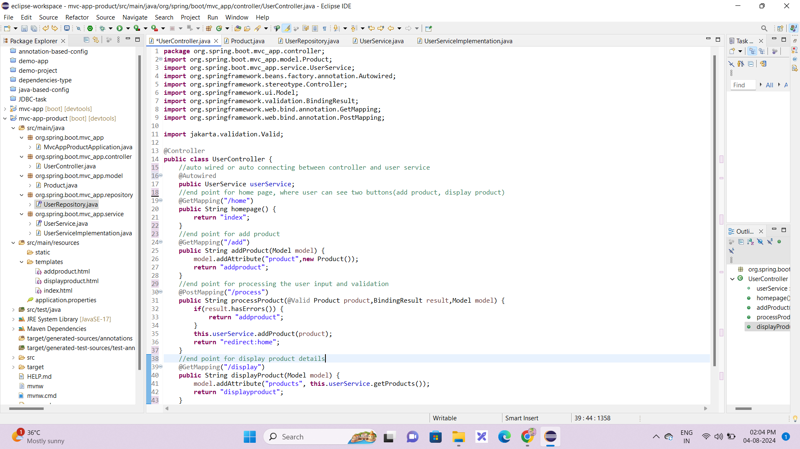

1. Model layer(Product class)

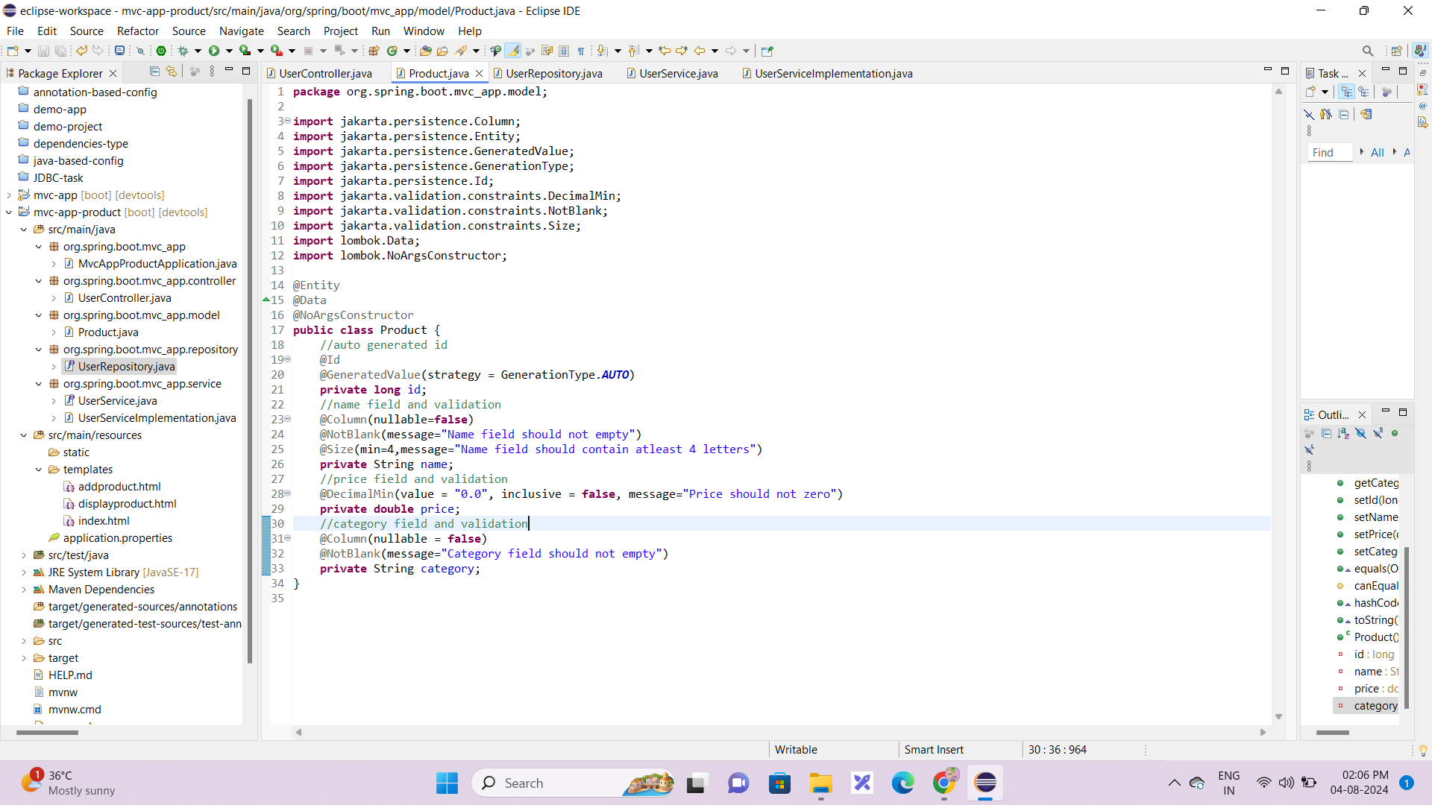

1. Repository layer

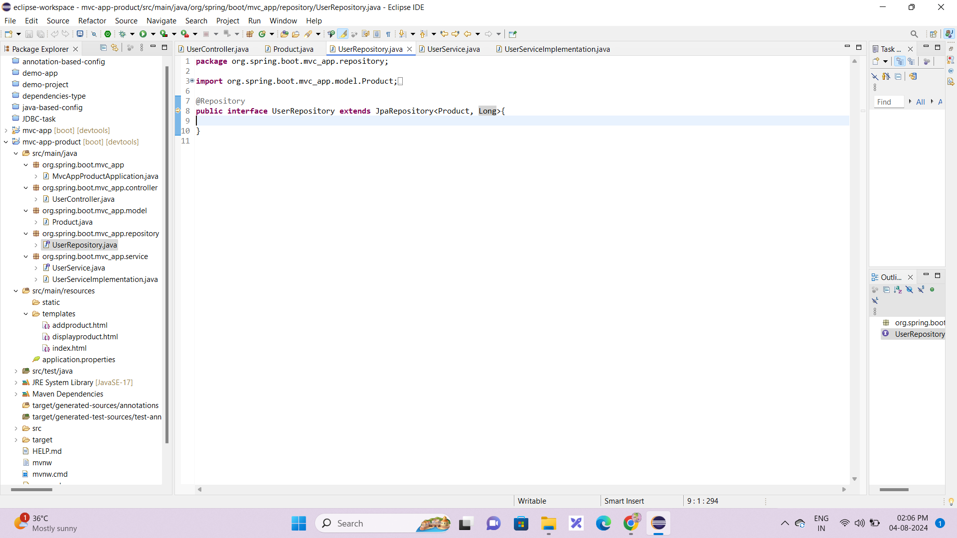

1. Service layer(Interface)

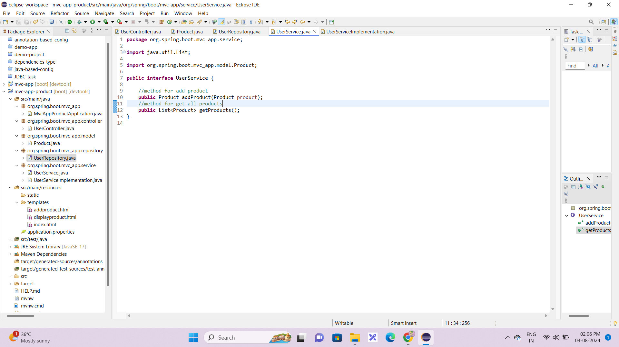

1. Service layer(Implementation)

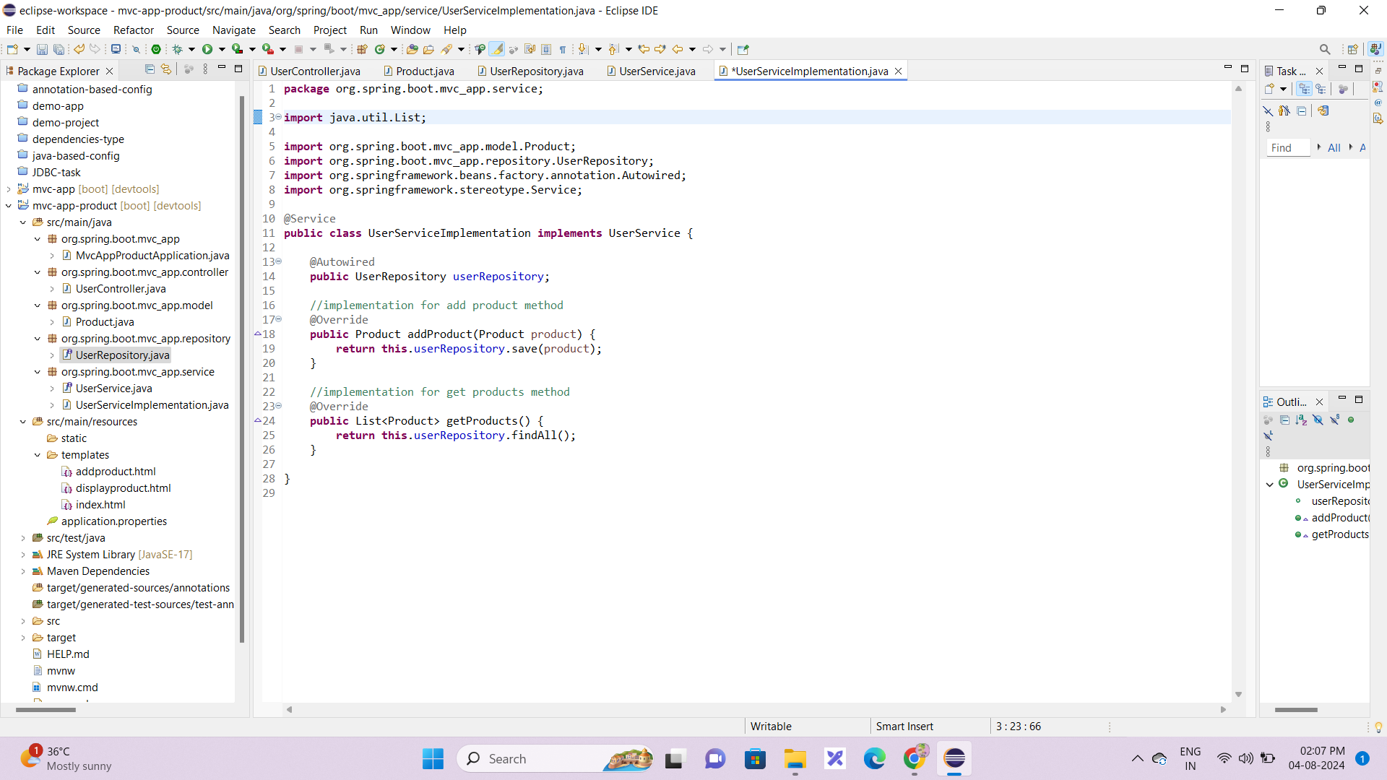

HTML Codes:

1. Index page(home page)

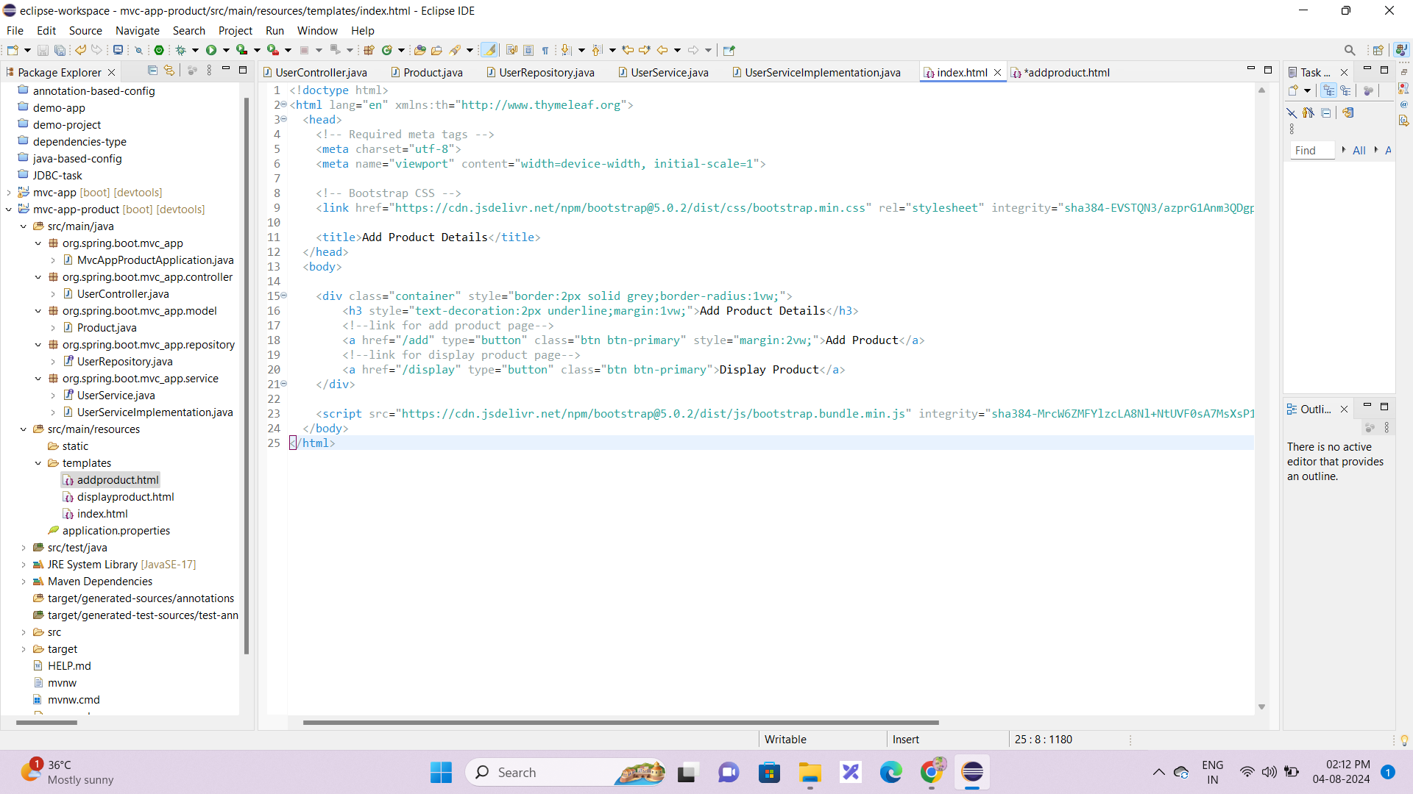

1. Add product page

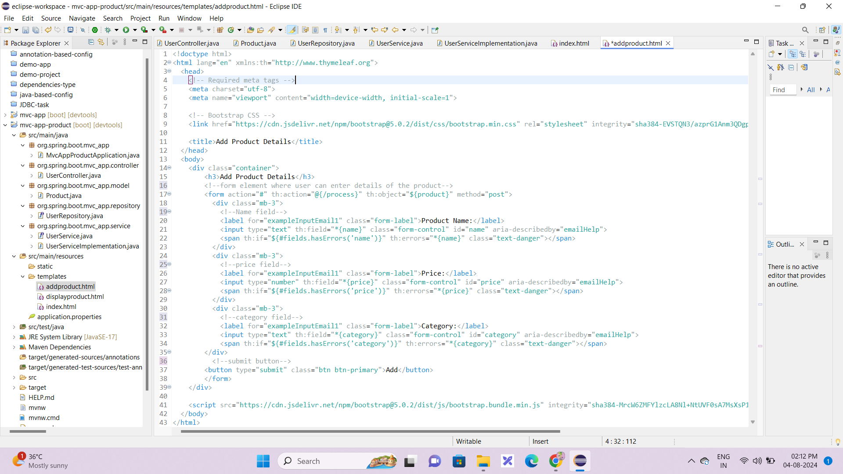

1. Display product page

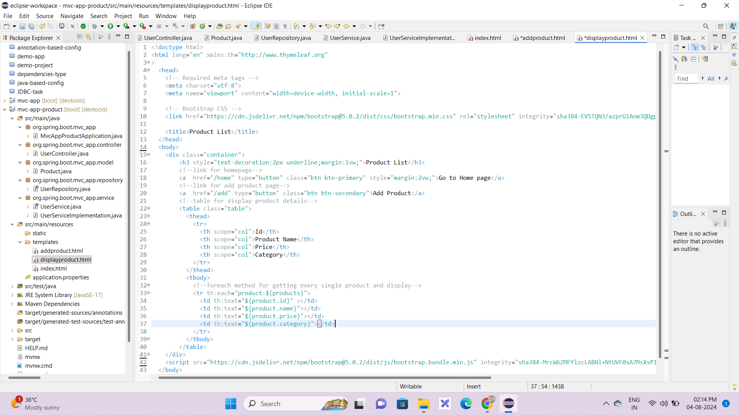

Browser website URL (end-points):

1. Home page 🡪 “<http://localhost:8080/home>”
2. Add product page 🡪 “<http://localhost:8080/add>”
3. Display product page 🡪 “<http://localhost:8080/display>”

Database Output:

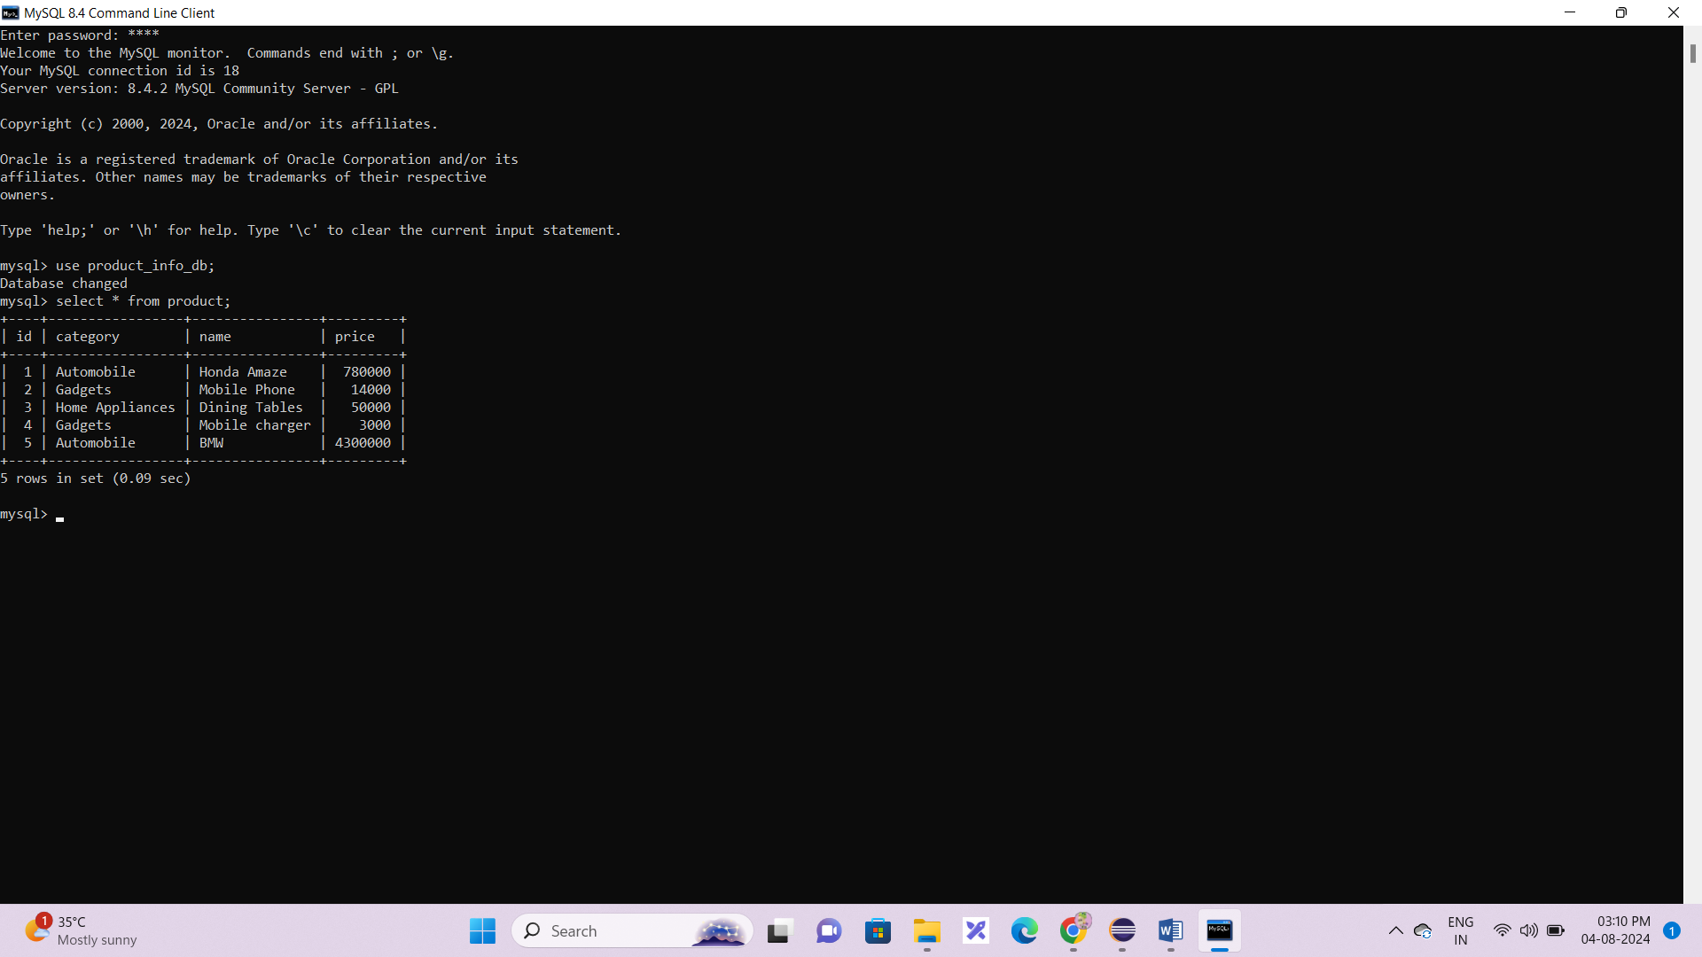

Browser website outputs:

1. Home page

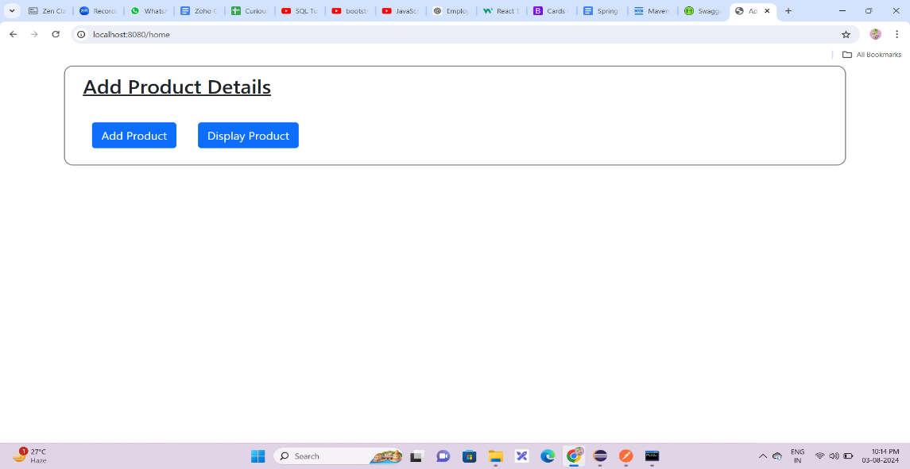

1. Add product page

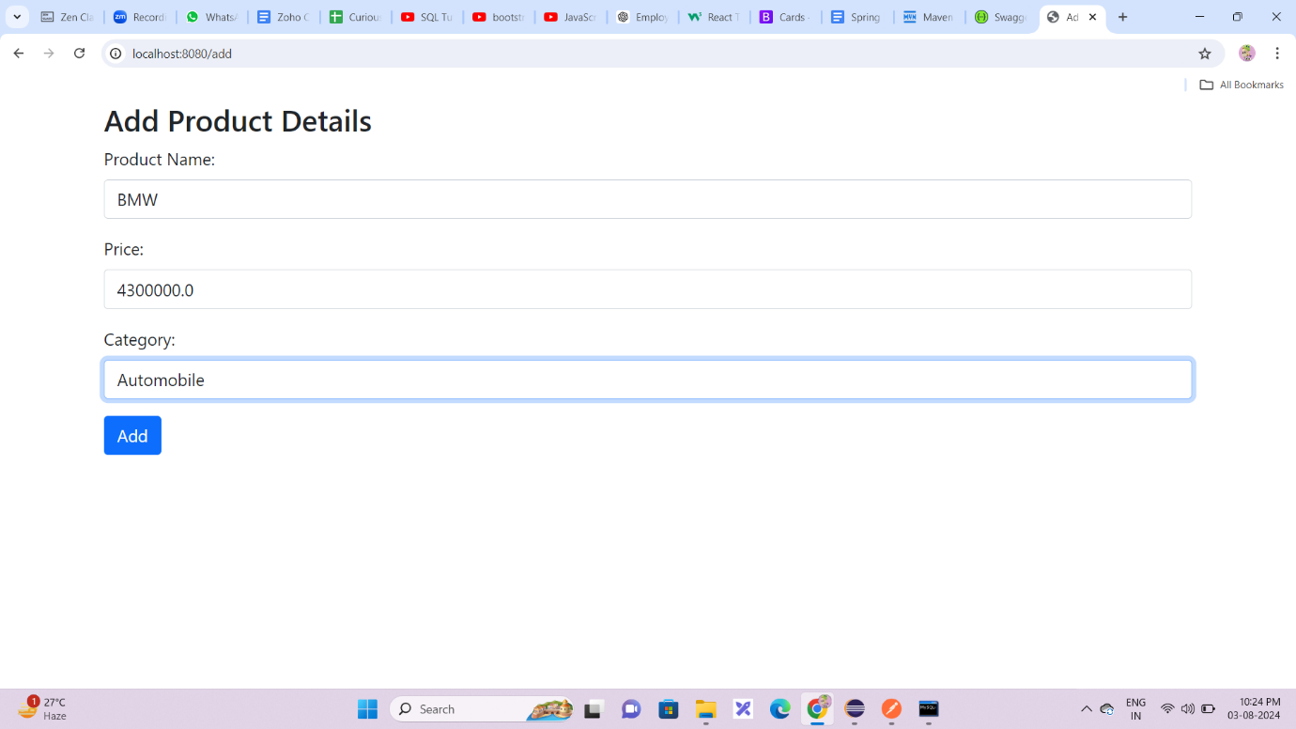

1. Validation for add product page

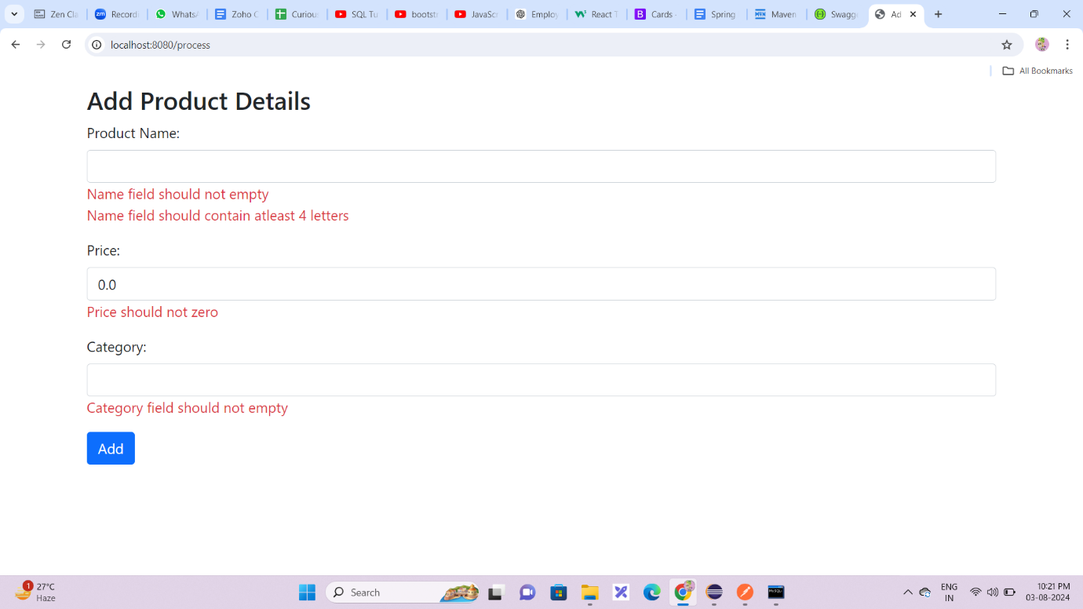

1. Display product page

