POST-ROUTE STATIC TIMING ANALYSIS
VSDBABYSOC • SKY130HD • OpenROAD
Evidence-based report from the supplied run logs and screenshots
ROLL NUMBER : 24EG104A57
NAME: MOLUGU DHEEKSHITH
DATE: 10/10/26

Executive summary
The routed VSDBABYSOC design was analyzed using OpenROAD and the supplied post-route database and extracted parasitics. Sixteen standard-cell timing-library corner runs completed successfully at the command-execution level. However, successful execution does not imply that timing passes at every corner: six recorded corners have negative worst setup slack. The macro timing libraries for the DAC and PLL were loaded with their existing characterizations and were not independently swept.
The typical corner (tt_025C_1v80) records worst setup slack of 6.134855908035339 ns, worst hold slack of 0.31975795138977164 ns, setup TNS of 0.0 ns, and hold TNS of 0.0 ns. These values are copied exactly from the supplied terminal output.

1. Scope and source artifacts
The reported STA script used the following inputs:
- Routed database: results/sky130hd/vsdbabysoc/base/5_2_route.odb
- Timing constraints: results/sky130hd/vsdbabysoc/base/5_1_grt.sdc
- Fresh extracted parasitics: results/sky130hd/vsdbabysoc/base/5_2_route_fresh.spef
- Standard-cell libraries: 16 SKY130HD Liberty files covering the recorded FF, SS, and TT corners
- Macro libraries loaded for each run: designs/sky130hd/vsdbabysoc/lib/avsddac.lib and avsdpll.lib
The numerical timing results in this report are transcribed from the supplied terminal output. The screenshots are supporting visual evidence of the recorded flow stages and GUI views; they are not used to infer unreported numerical values.

2. STA methodology and limitations
For each run, one standard-cell Liberty file was loaded, followed by the existing DAC and PLL macro Liberty files. The same routed database, SDC, RC setup, and freshly extracted SPEF were used for the corner sweep. The script queried worst setup slack, worst hold slack, total negative setup slack (TNS), and total negative hold slack.
The macro libraries were not independently swept across all 16 standard-cell corners. Therefore, these results should be described as a 16-corner standard-cell sweep with fixed existing macro characterizations—not a full macro-and-standard-cell multi-corner sweep.
The GUI timing charts reported unconstrained pins (30 for setup and 26 for hold in the captured views). Consequently, positive slack values alone do not establish that all design paths are constrained or that the design is timing-clean in every respect.

3. Recorded 16-corner results
The values below are preserved exactly as recorded. Slack and TNS are in nanoseconds. No rounding or replacement values have been introduced.
Corner | Worst setup slack (ns) | Worst hold slack (ns) | Setup TNS (ns) | Hold TNS (ns)
ff_100C_1v65 | 7.224981262210372 | 0.2581743225613201 | 0.0 | 0.0
ff_100C_1v95 | 8.0721192015409 | 0.20476920738622517 | 0.0 | 0.0
ff_n40C_1v56 | 5.994856780670661 | 0.3004591105403578 | 0.0 | 0.0
ff_n40C_1v65 | 6.722481428466274 | 0.26471903196543123 | 0.0 | 0.0
ff_n40C_1v76 | 7.356369499552525 | 0.23399333133419167 | 0.0 | 0.0
ff_n40C_1v95 | 8.073913321999436 | 0.19710489354126626 | 0.0 | 0.0
ss_100C_1v40 | -3.548233807202439 | 0.9180407804912493 | -390.06912937085104 | 0.0
ss_100C_1v60 | 1.2364669638141668 | 0.6502604194711363 | 0.0 | 0.0
ss_n40C_1v28 | -29.210426904079725 | 1.8034942938420702 | -14131.261595530419 | 0.0
ss_n40C_1v35 | -16.312878620756575 | 1.341694571197994 | -6593.494349575268 | 0.0
ss_n40C_1v40 | -10.867935303749812 | 1.1233976289410281 | -3379.482318532099 | 0.0
ss_n40C_1v44 | -7.690801102540313 | 0.9886260978579468 | -1900.7227902925204 | 0.0
ss_n40C_1v60 | -0.4466684926135195 | 0.667834362269558 | -5.89415821722158 | 0.0
ss_n40C_1v76 | 2.9057912454249095 | 0.5008239520410285 | 0.0 | 0.0
tt_025C_1v80 | 6.134855908035339 | 0.31975795138977164 | 0.0 | 0.0
tt_100C_1v80 | 6.219275492858546 | 0.32447823124591785 | 0.0 | 0.0

4. Interpretation of results
Negative worst setup slack was recorded at ss_100C_1v40, ss_n40C_1v28, ss_n40C_1v35, ss_n40C_1v40, ss_n40C_1v44, and ss_n40C_1v60. These negative values indicate setup timing violations under the timing models and constraints used in those runs. The most negative recorded setup slack is -29.210426904079725 ns at ss_n40C_1v28, with setup TNS of -14131.261595530419 ns.
All recorded worst hold slack values are positive, and recorded hold TNS is 0.0 ns for all 16 corners. This describes the reported hold metrics only; it does not remove the setup timing failures or the unconstrained-pin limitation.
All 16 commands are marked OK in the run-status output. This status reflects successful completion of the analysis runs, not universal timing closure.

5. Physical-design flow evidence
The following seven selected screenshots provide a compact evidence set: synthesis statistics, detailed-route output, design metrics, timing-report output, the routed design in the OpenROAD GUI, and setup/hold slack histograms. The selection prioritizes evidence relevant to physical implementation and timing rather than including every screenshot in the archive.
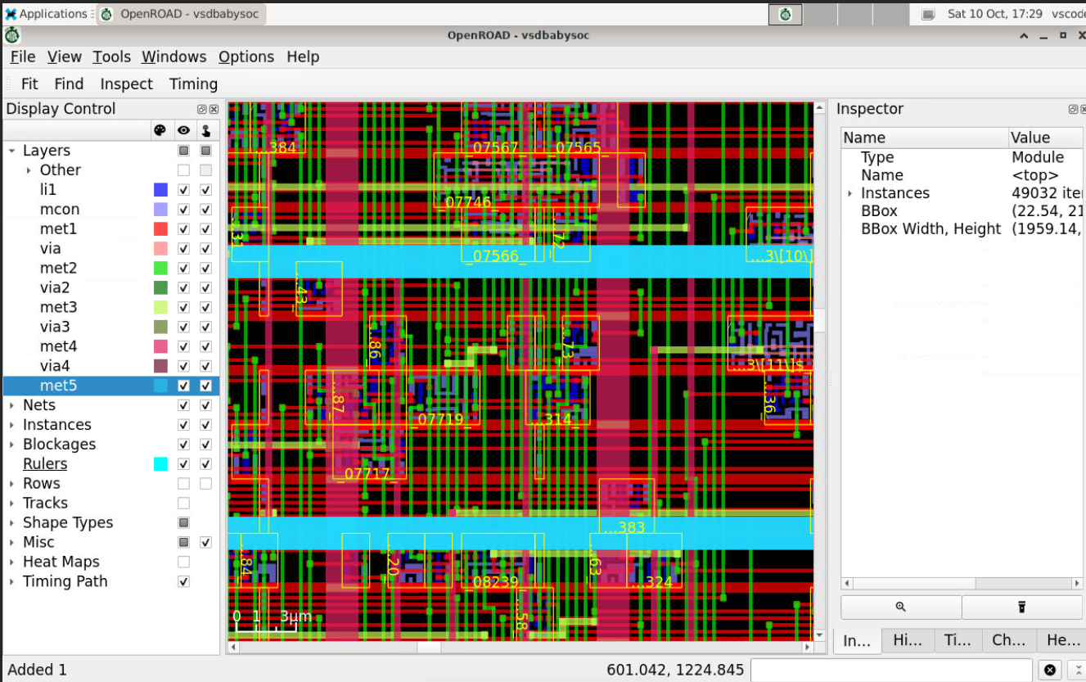
Figure 1. Synthesis statistics captured from the project flow.
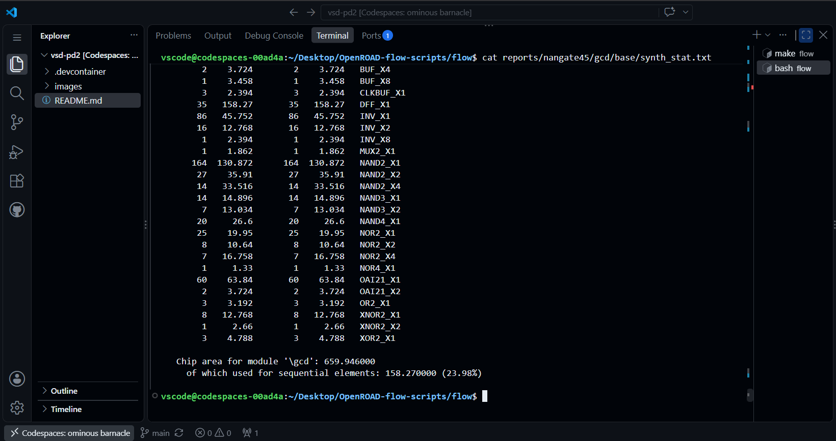

Figure 2. Detailed-routing stage output from the recorded flow.
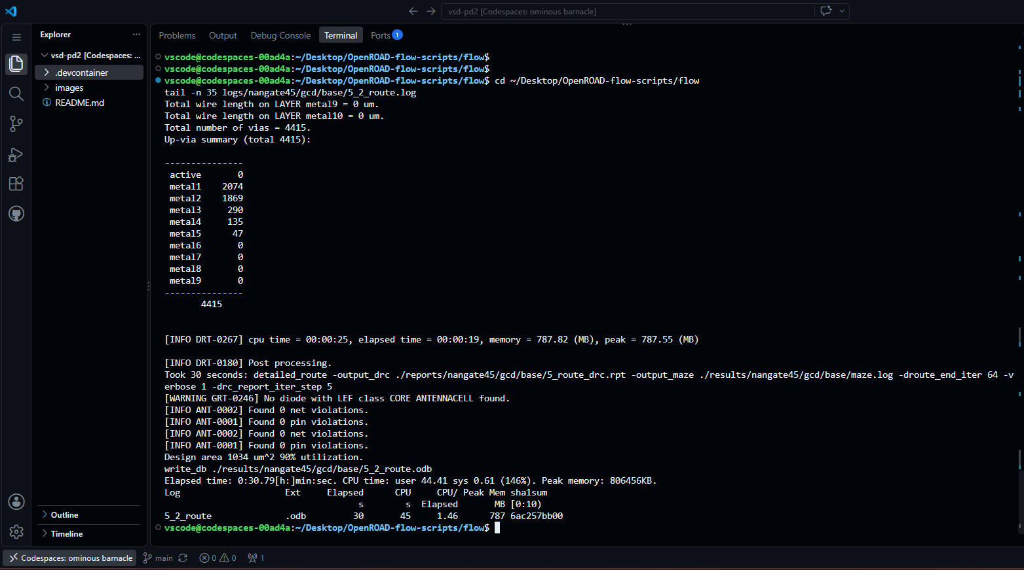

Figure 3. Design metrics reported by the flow.
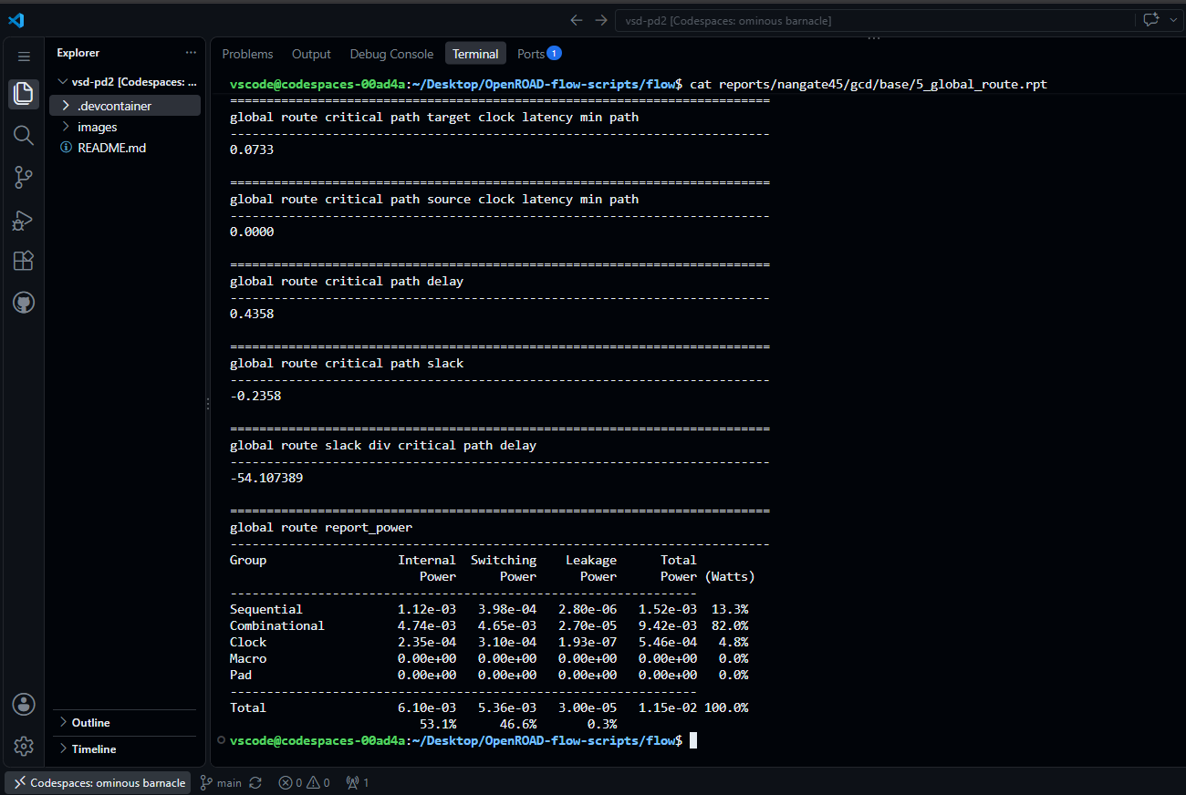
Figure 4. Timing-report output captured from the flow.
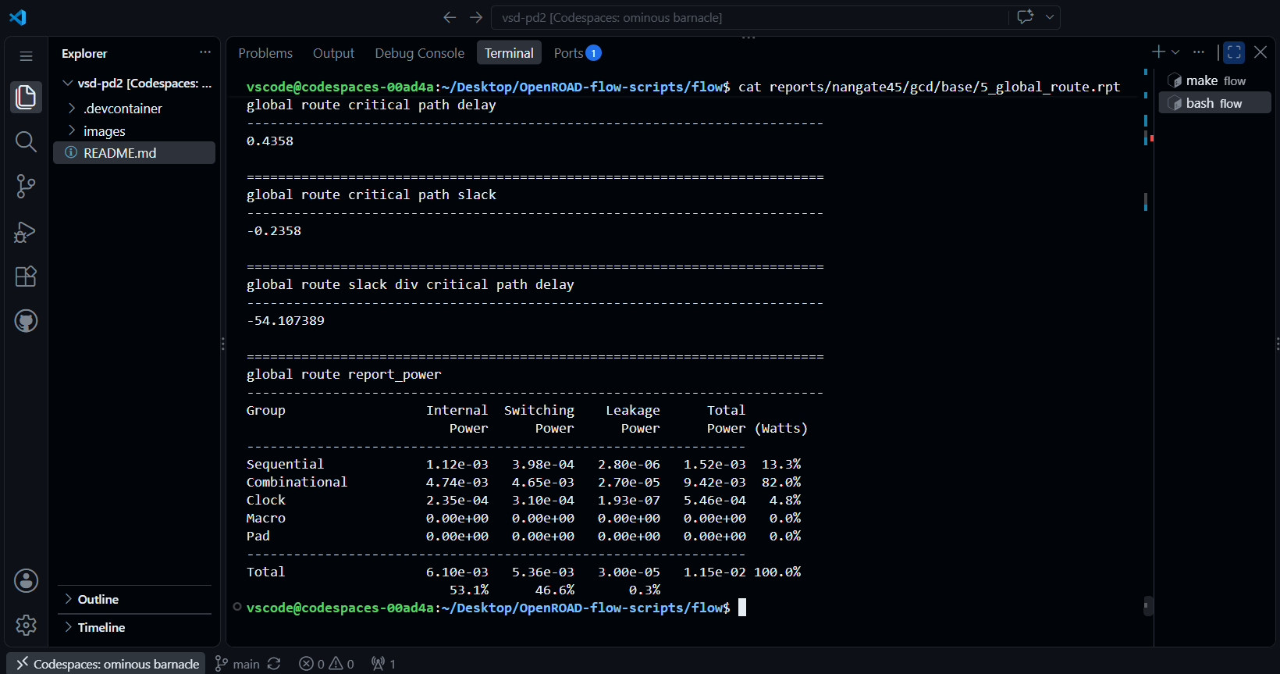

Figure 5. OpenROAD GUI view of the routed design.
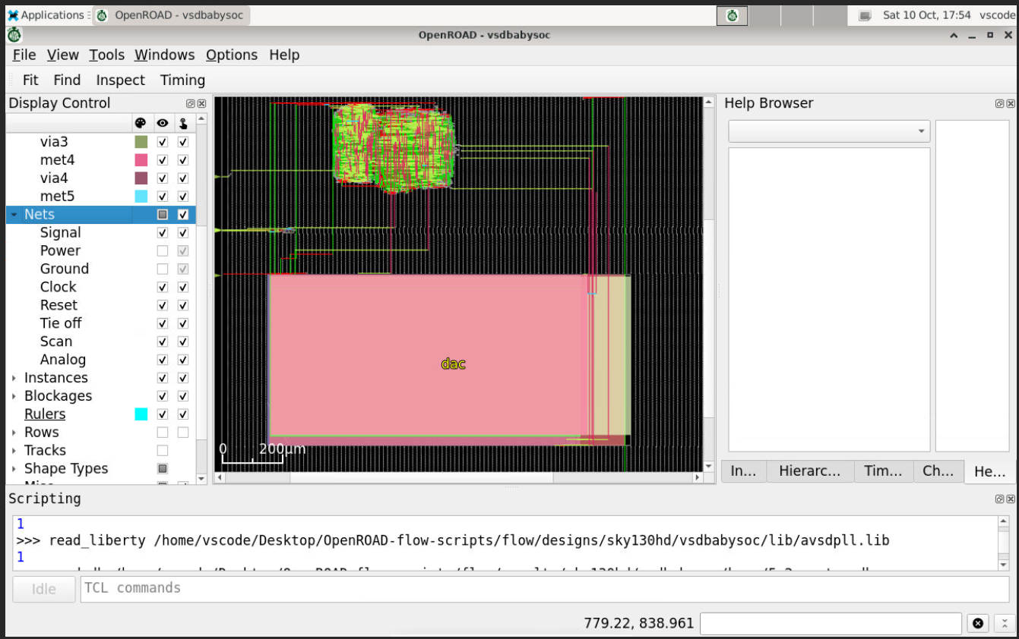
Figure 6. Setup-slack histogram in the OpenROAD GUI.
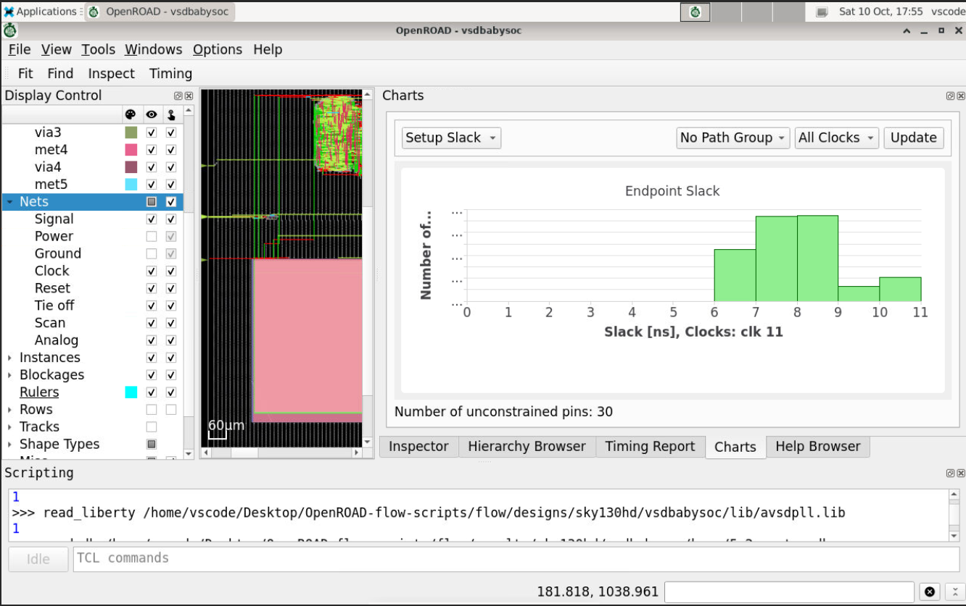

Figure 7. Hold-slack histogram in the OpenROAD GUI.
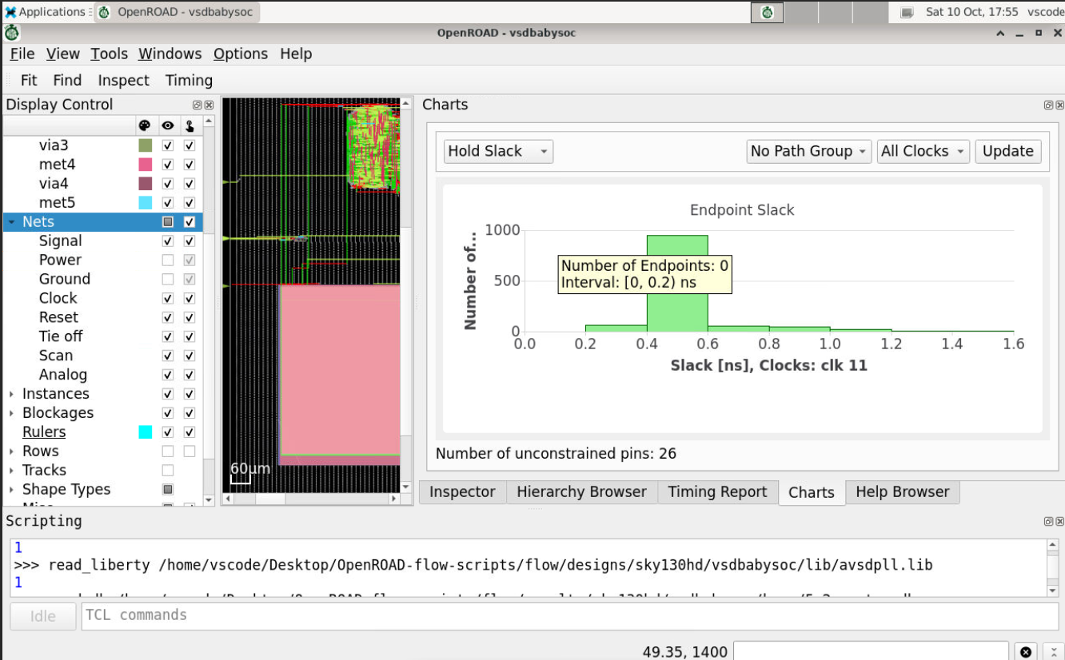

6. Routing and sign-off caveats
The detailed-routing output previously recorded 28 routing violations, described as metal-1 shorts, while antenna net/pin violations were reported as zero. Accordingly, the report does not claim a DRC-clean final layout. These routing findings should be resolved or explicitly accepted before treating the design as sign-off ready.
The available evidence supports reporting the routed database, fresh parasitic extraction, the 16 standard-cell corner STA results, GUI timing charts, and the noted limitations. It does not support claiming that every corner passes setup timing or that all routing checks are clean.

7. Conclusion
The post-route analysis produced reproducible STA output for all 16 standard-cell library corners. The typical-corner setup and hold slack values are positive, but six corners show negative setup slack and therefore require attention. The macro libraries were held at their existing characterizations, unconstrained pins remain in the GUI reports, and detailed-route metal-1 shorts were recorded. The results are useful for documenting the implementation and identifying timing issues, but they should not be presented as complete timing and physical sign-off.

