STATIC TIMING ANALYSIS

16-Liberty-Model STA Assessment
Escrow Release Controller | SKY130 HD | OpenSTA 2.4.0

1. Executive summary
The setup WNS ranges from -5.86 ns to +7.26 ns. The worst reported setup result is -5.86 ns at sky130_fd_sc_hd__ss_n40C_1v28, indicating a setup violation under the current constraints. Worst hold slack is positive in all 16 rows, ranging from +0.30 ns to +1.69 ns. All results remain REVIEW.
TNS (total negative slack) was not captured in the supplied summary/log output. It is therefore marked NOT CAPTURED—not zero. The WNS graph is included; a numeric TNS graph requires rerunning the sweep with a TNS reporting command.

2. Methodology
- OpenSTA 2.4.0.
- Clock period: 10 ns.
- Input delay: 2 ns; output delay: 2 ns.
- Propagated clocks enabled.
- Routed SPEF from the existing physical-design run.
- The same routed SPEF was reused for all 16 Liberty models.
This is a preliminary multi-model timing assessment, not a signoff-validated PVT matrix. Timing constraints have not been independently validated for signoff.

3. Setup WNS by Liberty model
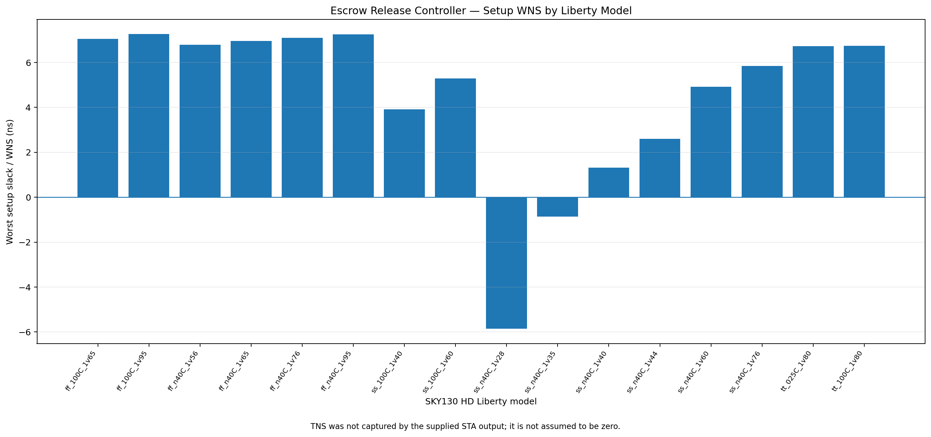
Figure 1. Setup WNS by model. Negative values indicate setup violations. TNS is not plotted because it was not captured.

4. Results
Liberty model | Setup WNS (ns) | Hold worst slack (ns) | Status
ff_100C_1v65 | +7.05 | +0.39 | REVIEW
ff_100C_1v95 | +7.26 | +0.31 | REVIEW
ff_n40C_1v56 | +6.79 | +0.45 | REVIEW
ff_n40C_1v65 | +6.95 | +0.40 | REVIEW
ff_n40C_1v76 | +7.09 | +0.35 | REVIEW
ff_n40C_1v95 | +7.25 | +0.30 | REVIEW
ss_100C_1v40 | +3.91 | +1.43 | REVIEW
ss_100C_1v60 | +5.29 | +0.99 | REVIEW
ss_n40C_1v28 | -5.86 | +1.48 | REVIEW
ss_n40C_1v35 | -0.86 | +1.63 | REVIEW
ss_n40C_1v40 | +1.31 | +1.69 | REVIEW
ss_n40C_1v44 | +2.59 | +1.56 | REVIEW
ss_n40C_1v60 | +4.92 | +1.03 | REVIEW
ss_n40C_1v76 | +5.84 | +0.75 | REVIEW
tt_025C_1v80 | +6.72 | +0.47 | REVIEW
tt_100C_1v80 | +6.74 | +0.48 | REVIEW

5. Critical setup path
At sky130_fd_sc_hd__ss_n40C_1v28, the critical path starts at _116_ (timeout_count_q[0]) and ends at _120_ (timeout_count_q[4]). Data arrival is 15.71 ns, data required time is 9.84 ns, and setup slack is -5.86 ns. The largest incremental delay in the supplied path listing is 5.67 ns at _060_ (sky130_fd_sc_hd__or4b_4). This identifies an investigation point but does not prove that one RTL expression alone causes the violation.

6. Excluded model variants
Excluded from the 16-model sweep:
- sky130_fd_sc_hd__ff_n40C_1v95_ccsnoise.lib
- sky130_fd_sc_hd__ss_n40C_1v60_ccsnoise.lib
These are excluded CCS-noise model variants, not additional PVT corners.

7. Warnings and limitations
- OpenSTA reported sky130_fd_sc_hd__tapvpwrvgnd_1 unavailable in the linked netlist and created a black box for PHY_28.
- Liberty warning: default_fanout_load = 0.0.
- Same routed SPEF reused across all models.
- Timing constraints need independent validation.
- TNS was not captured in the supplied output.

8. Required follow-up for WNS/TNS graph
Update the per-corner OpenSTA Tcl script to emit total negative slack for setup, rerun the 16-model sweep, and regenerate the CSV, graph, and report. Do not substitute WNS for TNS or assume TNS is zero.

