FINAL INFERENCE- ASSESSMENT 29-08-2026
RTL vs. GLS Functional Equivalence
I verified that the synthesized gate-level netlist preserves the functional behavior of my RTL design for this testbench. I ran both simulations — the RTL simulation with state[2:0] binary-encoded, and the gate-level simulation with state[6:0] one-hot-encoded after synthesis — and compared their detected waveforms directly. In both runs, I observed detected pulses occurring at identical simulation times across the entire test, with the same clustering pattern and the same total pulse count, even though the internal state representation was completely different due to Yosys's FSM re-encoding (fsm_recode) during synthesis. Since the externally observable behavior of my design — the detected signal's timing — was bit-for-bit and cycle-for-cycle identical between the two simulations, I'm confident this is solid evidence of RTL-to-gate functional equivalence, which is exactly the confidence check GLS is meant to give me before trusting a synthesized design to move forward toward tapeout.
RTL SCREENSHOT:
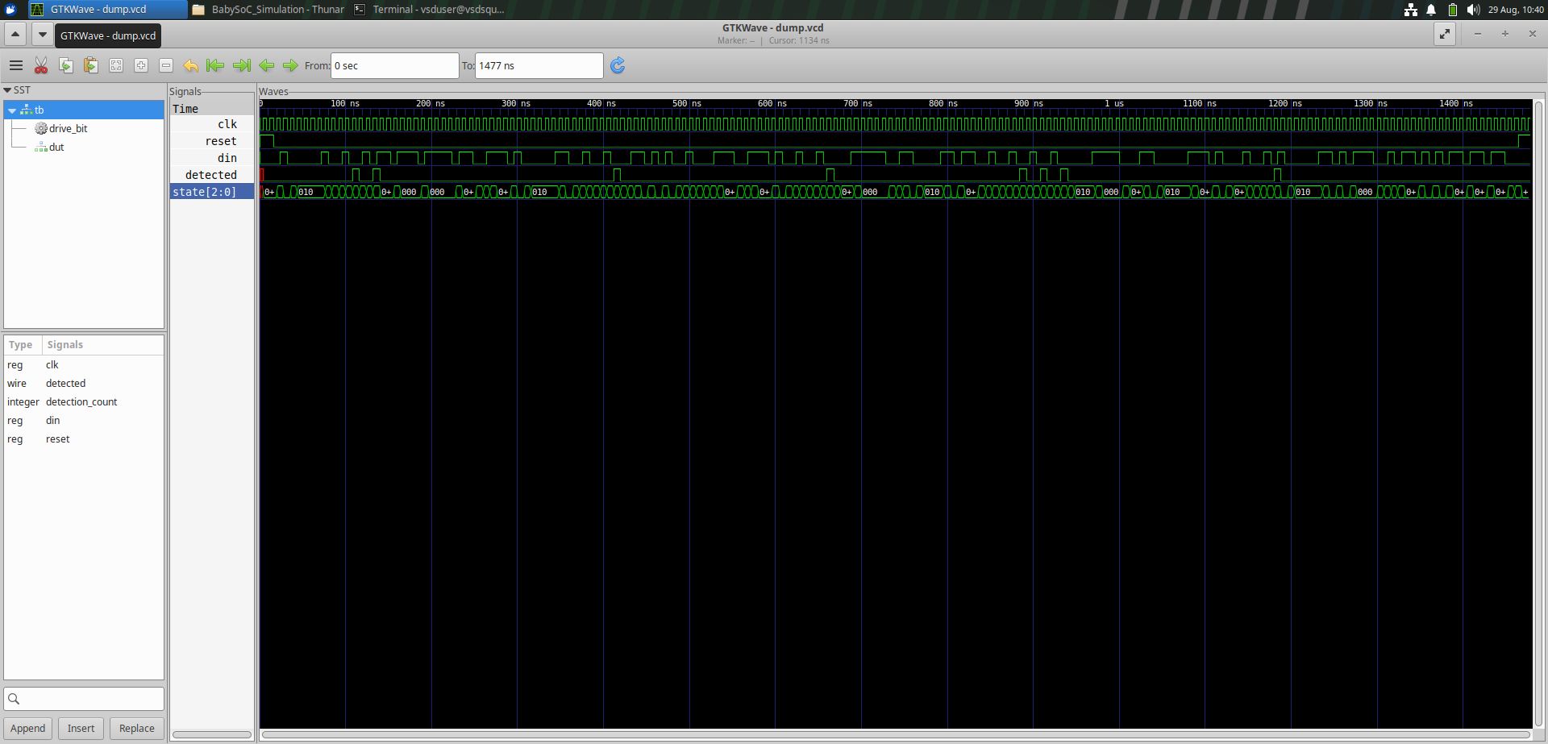
GLS SCREENSHOT: