# ASSIGNMENT-2

1. **Donut Chart** – Sales by Payment Method:--

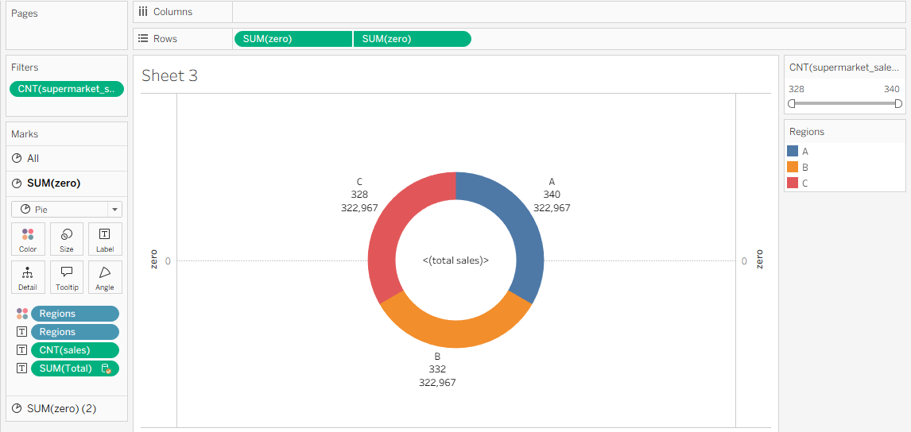

1. **Area Chart** – Sales Trend over Time:--

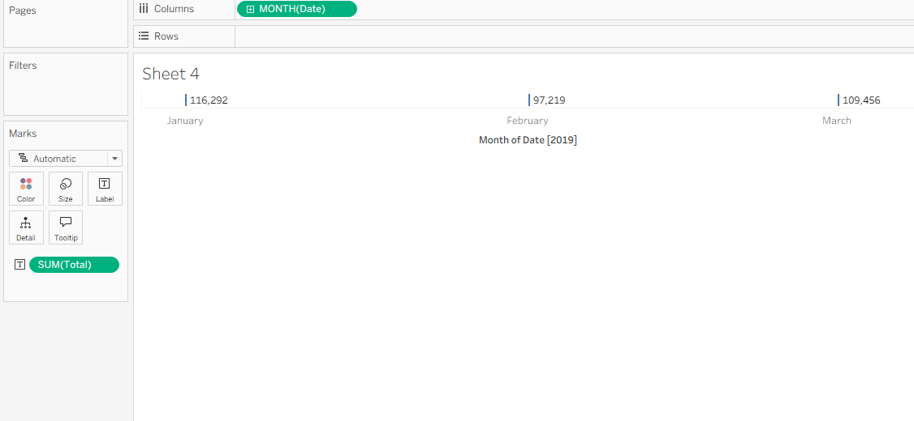

1. **Text Table** – Branch-wise Monthly Sales:--

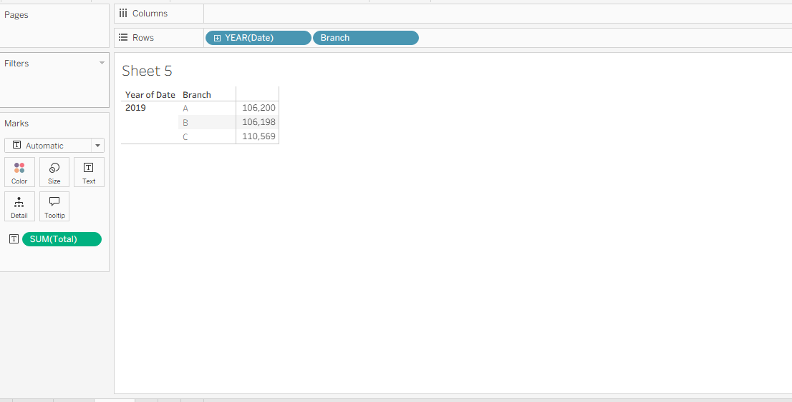

1. **Word Cloud** – Product Line Word Cloud:--

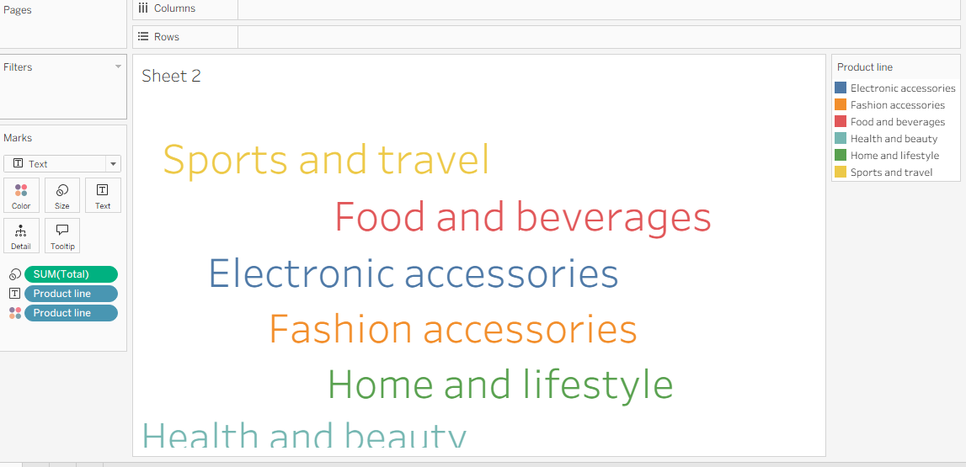

1. **Highlighted Table** – Product Line vs Average Rating:--

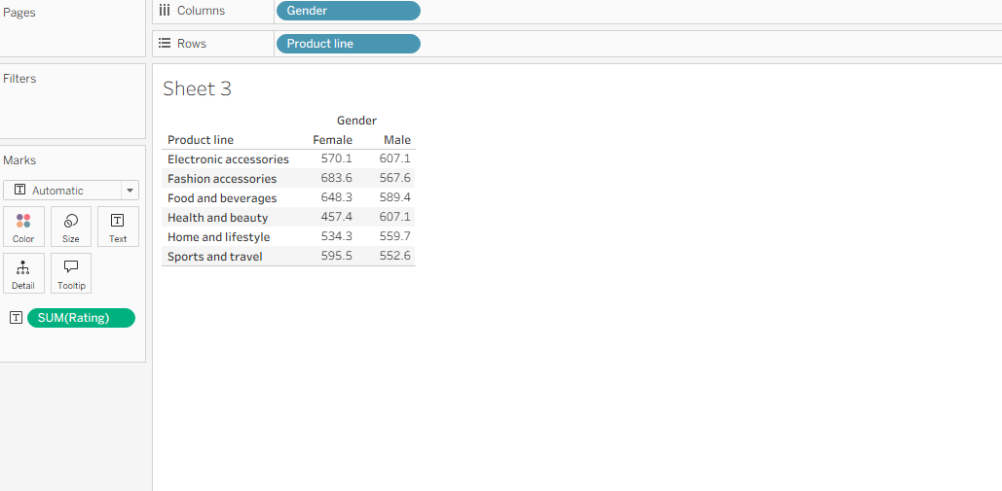

1. **Funnel Chart** – Sales Funnel by Product Line:--

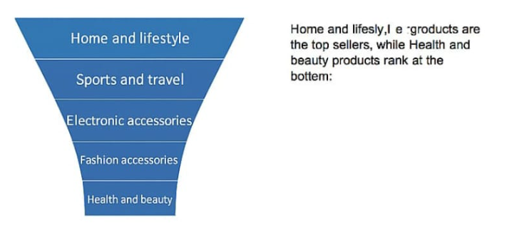

**7.waterfall-**

