| **FINAL EXAM** | |
| --- | --- |
| Name: Urbano, Dheen B. | Date: 13/12/2024 |
| Section: CPE31221 | Professor: Robin Valenzuela |

1. Create a repository and label it as "Final_Exam_Surname"

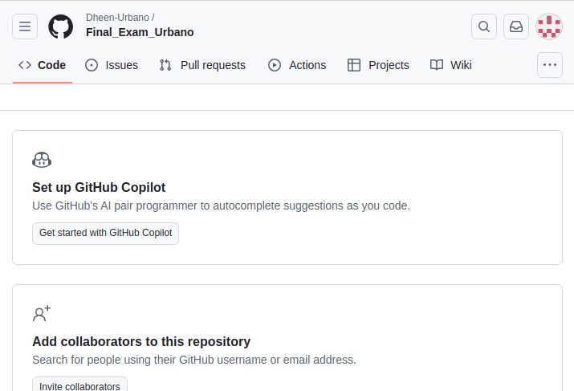

2. Clone your new repository in your VM

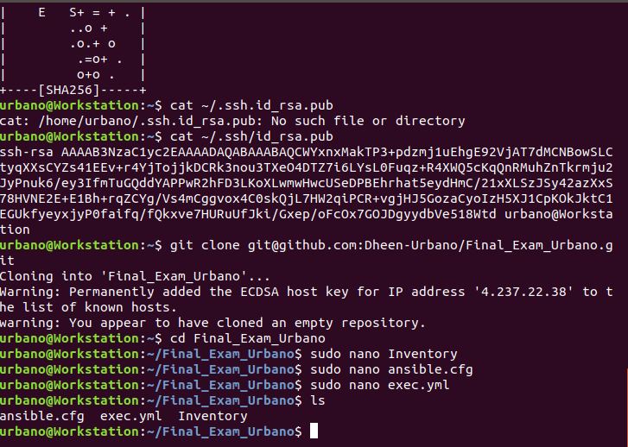

3. Create an Ansible playbook that does the following with an input of a config.yaml file and structure inventory file.

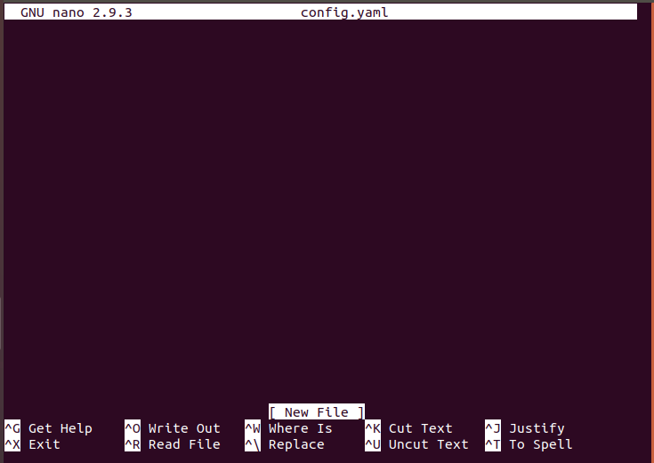

3.1 Install and configure one enterprise service that can be installed in Debian and Centos servers

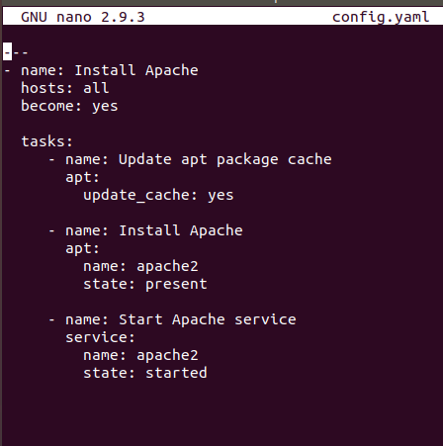

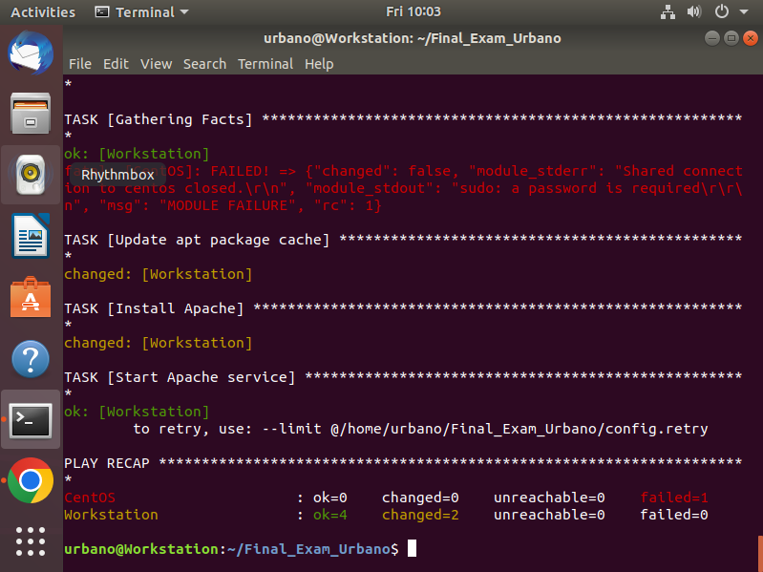

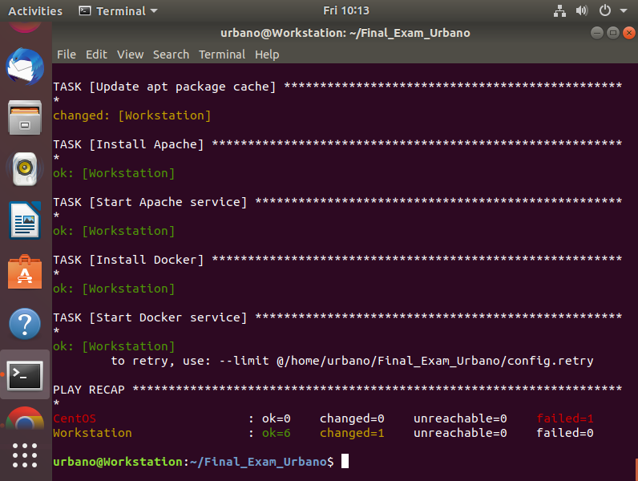

Adding The installation and starting of the docker

3.2 Install and configure one monitoring tool that can be installed in Debian and Centos servers (if it is a stack there should be option of different host)

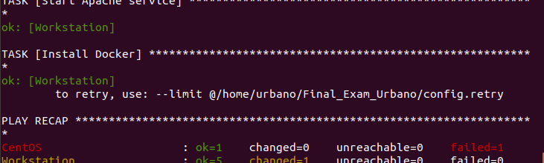

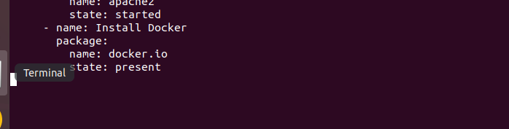

4.4 Change Motd as "Ansible Managed by <username>"

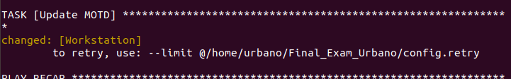

4. Push and commit your files in GitHub

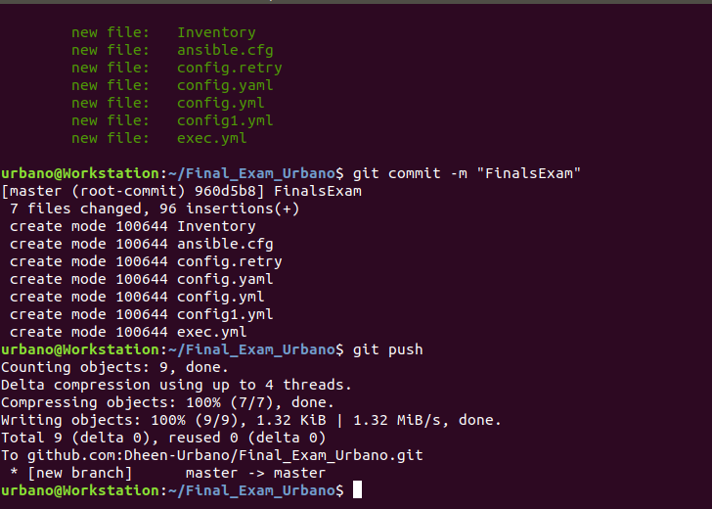

5. Make sure to show evidence of input (codes) process (codes successfully running) and output (evidence of installation)

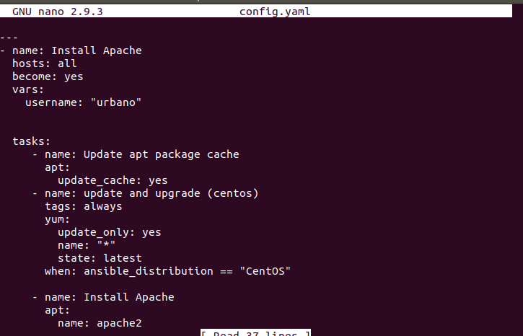

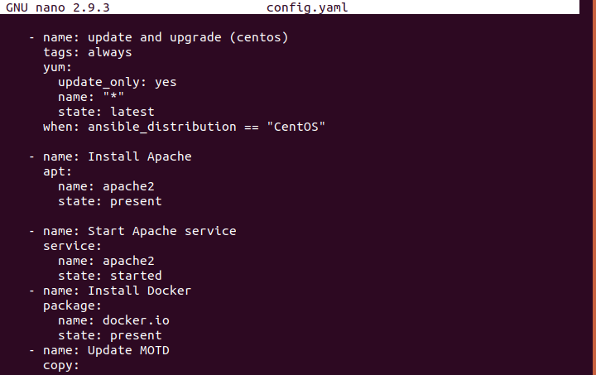

5. For your final exam to be counted, please paste your repository link as an answer in this exam.

Note: Extra points if you will implement the said services via containerization.