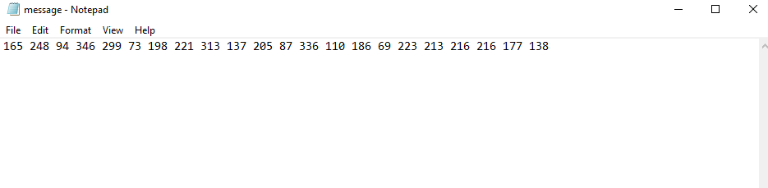

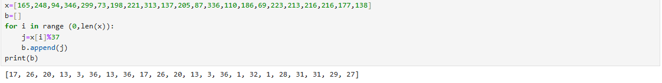

By these remainders I got the flag,

picoCTF{R0UND_N_R0UND_B6B25531}