



Essay / Assignment Title: Machine Learning and Visualization for Data

Programme Title: MSc Information Technology Management

Name: KORVI DHEEPAK

Year: TERM 2

Abstract

Customer churn prediction is a major challenge in Telecom industry because retaining existing customers is easier and less expensive than the acquisition of new customers. In this project, we are seeking to build a machine learning model for churn prediction, using the Telco Customer Churn dataset from Kaggle. The study employed the entire process of machine learning such as problem definition, data preprocessing, exploratory data analysis, model development, model evaluation and visualisation. Data quality enhancement and model performance improvement techniques were utilized in processing the data which included handling missing values, encoding categorical variables, feature scaling, and feature selection. Four machine learning algorithms were used to implement them and compared using different evaluation metrics such as; Accuracy, Precision, Recall, F1-Score, Confusion Matrix, ROC-AUC score. The results showed that Logistic Regression performed the best with 80.7% of accuracy. Furthermore, Tableau dashboards and visualisations were developed for business story-telling and insights into the data. The study proves the usefulness of machine learning in telecom companies to prevent customer attrition and enhance the strategies for customer retention.
Table of Contents

Table of Contents
Abstract 2
GIT HUB 5
Chapter 1: Introduction 7-8
1.1 Background of Customer Churn 7
1.2 Problem Statement 7
1.3 Research Aim 7
1.4 Research Objectives 7
1.5 Business Importance of Churn Prediction 8
1.6 Scope of the Study 8
1.7 Report Structure 8
Chapter 2: Literature Review 9-12
2.1 Introduction 9
2.2 Customer Churn in Telecom Industry 9
2.3 Machine Learning for Business Analytics 9
2.4 Logistic Regression in Classification Problems 10
2.5 Decision Tree Algorithms 10
2.6 Random Forest Algorithms 10
2.7 Data Visualization and Business Storytelling 10
2.8 Review of Previous Studies 11
2.9 Research Gap 12
2.10 Chapter Summary 12
Chapter 3: Methodology 13-22
3.1 Introduction 13
3.2 Research Methodology Framework 13
3.3 Problem Definition 14
3.4 Dataset Collection and Description 14
3.5 Data Preprocessing 15
3.6 Exploratory Data Analysis (EDA) 15
3.7 Feature Engineering 20
3.8 Feature Selection 20
3.9 Machine Learning Models 21
3.10 Train-Test Split 21
3.11 Hyperparameter Tuning 21
3.12 Cross Validation 22
3.13 Chapter Summary 22
Chapter 4: Results and Discussion 23-33
4.1 Introduction 23
4.2 Model Performance Evaluation 23
4.3 Logistic Regression Results 24
4.4 Decision Tree Results 25
4.5 Random Forest Results 25
4.6 Support Vector Machine Results 26
4.7 ROC Curve Analysis 27
4.8 Cross Validation Results 28
4.9 Model Accuracy Comparison 29
4.10 Feature Importance Analysis 30
4.11 Tableau Dashboard and Business Storytelling 31
4.12 Discussion of Findings 33
4.13 Chapter Summary 33
Chapter 5: Conclusion and Recommendations 34
5.1 Conclusion 34
5.2 Business Recommendations 34
5.3 Limitations of the Study 34
5.4 Future Work 34
BIBLIOGRAPHY 35-36

GIT HUB

GitHub Repository Link:
https://github.com/Dheepak-Deepu/Q1130184_KorviDheepak_Assignment
This repository contains all project-related files developed as part of the Customer Churn Prediction using Machine Learning and Tableau project.
Repository Contents:
• Python Source Code
• Data Preprocessing Scripts
• Exploratory Data Analysis (EDA)
• Feature Engineering and Feature Selection
• Machine Learning Models
Project Documentation and Final ReportThe repository provides the complete implementation used to develop, evaluate, and visualize customer churn prediction models and supports the findings presented in this report.

Statement of compliance with academic ethics and the avoidance of plagiarism

I honestly declare that this dissertation is entirely my own work and none of its part has been copied from printed or electronic sources, translated from foreign sources and reproduced from essays of other researchers or students. Wherever I have been based on ideas or other people texts I clearly declare it through the good use of references following academic ethics.
(In the case that is proved that part of the essay does not constitute an original work, but a copy of an already published essay or from another source, the student will be expelled permanently from the program).

Name and Surname (Capital letters):
KORVI DHEEPAK
Date: 06/06/2026

Chapter 1: Introduction

1.1 Background of Customer Churn
Churning is the identification of customers who have ceased using a Company's products or services over a period of time. Telecommunications is one such industry where customer service is a challenge as people can easily move to other service providers if they are not content with the deals currently being offered by the firm. Churn rates can cost businesses money as they may generate losses in revenue, profitability and cost of marketing, with new customers. To deal with this issue, more companies are using data analytics and machine learning approaches so they can identify customers who are likely to churn and develop ways to make the customers stay satisfied.

1.2 Problem Statement
A telecom provider stores a tremendous amount of customer information, but identifying customers who are more likely to churn remains a major challenge. Traditional methods are often time-consuming and less effective in accurately predicting customer behaviour. Customer churn is a serious business issue because losing existing customers reduces company revenue, increases marketing and customer acquisition costs, and negatively impacts long-term business sustainability. Therefore, there is a need for intelligent predictive models that can analyse customer information, identify reliable churn patterns, and support business decision-making and customer retention strategies (Omari et al., 2025).

1.3 Research Aim
This project aims to create a machine learning-based model for predicting "customer churn" in the "Telco Customer Churn" dataset, and compare their predictive performance using evaluation metrics.

1.4 Research Objectives
The main goals behind this project are:
- Completing data preprocessing activities and an exploratory data analysis using customer churn dataset.
- Using machine learning algorithms such as Logistic Regression, Decision Tree, Random Forest, and Support Vector Machine (SVM) for customer churn prediction and performance comparison.
- Evaluating how models perform with several assessment criterias.
- Tableau dashboards and various charts have to be made for showing the customer churn patterns.

1.5 Business Importance of Churn Prediction
The significance of customer churn prediction lies in the fact that retaining existing customers is more cost-effective than acquiring new customers. Accurate churn prediction enables telecom companies to identify high-risk customers, improve customer experience, reduce revenue loss, and develop targeted marketing strategies. High customer churn can significantly impact business profitability because telecom companies must spend additional resources on customer acquisition, promotional campaigns, and retention programs. Predictive analytics and machine learning techniques help organizations analyse customer behaviour patterns and support data-driven decision-making to improve long-term customer relationships and reduce churn rates (Afzal et al., 2024).

1.6 Scope of the Study
In this study, an attempt has been made to predict customer churn for a telecom company using Supervised machine learning algorithms. The dataset chosen for this project is the Telco Customer Churn dataset provided by Kaggle, which also encompasses data preprocessing, feature engineering, model training, evaluation and visualization on Tableau.

1.7 Report Structure
This report comprises five chapters. The research topic and objectives are introduced in Chapter 1. The literature review is given in Chapter 2. The machine learning methodology and implementation is described in Chapter 3. The experimental results and visualizations are discussed in Chapter 4 and conclusions and suggestions for further work are provided in Chapter 5.

Chapter 2: Literature Review

2.1 Introduction
Customer churn prediction has become one of the most important fields in telecommunication research because customer retention has a direct impact on profitability and long-term viability of the business. As machine learning and data analytics continues to grow in strength and usage scales, Organizations increasingly use predictive models to identify customers who are likely to churn. Previous studies related to customer churn prediction, machine learning algorithms, business analytics and data visualization techniques are reviewed.

2.2 Customer Churn in Telecom Industry
Customer Churn: It is a term used for customers leaving a company over a period of time. Within the telecom industry, churn prediction is critical, since competition makes it easy for customers to move to the competition. With the impact that customer churn has on revenue generation and customer satisfaction, it has become an important research thrust at present, as stated by Shahabikargar et al. (2025). Likewise, Saleh and Saha (2023) reported that Telecom companies need good predictive systems to build customer relations and minimize losses in operations. Their work has shown that churn analysis can be a valuable tool for data-driven business strategy and increase customer retention.

2.3 Machine Learning for Business Analytics
Businesses use ML techniques extensively for their ability to process vast amounts of customer data and discover linkages that are overlooked in general data analysis. Ensemble learning and predictive analytics are important capabilities for machine learning to improve strategies for keeping customers which is pointed out by Afzal et al. (2024). Sophisticated algorithms were found to help increase accuracy of classification and make business choices stronger.In addition, Zaghloul et al. (2025) describes a hybrid machine learning and predictive analytics that organizations use for boosting customer relationships and keeping them in market with lot of competition.

2.4 Logistic Regression in Classification Problems
Logistic Regression is a widely-used supervised learning algorithm for classification tasks. It is very popular for customer churn prediction because of the simplicity and interpretability. In a new research, Saleh and Saha (2023) applied classification techniques in churn prediction and provided proof that using statistical learning techniques for churn prediction has been a effective way of categorizing customers into churned and churn not customers. Logistic Regression is a good model choice when the independent variable(s) and dependent variable(s) are linearly related and the results of the model can be easily understood for business analysis.

2.5 Decision Tree Algorithms
Decision Trees are widely used classification algorithms that represent decision-making processes through a tree-like structure in the form of decision trees are widely used. They can deal with both categorical and numerical data. In telecom datasets, reducing the dimensionality of the data is crucial for determining the most significant features, resulting in a more precise classification, which is where the churn prediction framework proposed by Sana et al., (2022) with feature selection and transformation techniques comes into the picture. The results revealed that Decision Tree-based models have the ability to detect the most important customer behavior patterns related to churn. Decision Trees are also helpful in understanding customer segmenting and customer decision-making processes.

2.6 Random Forest Algorithms
Random Forest is an ensemble learning method based on a multiple decision trees to offset overfitting and increase prediction accuracy. Taherkani et al. (2023) adopted random forest model to predict churn with the improved performance over traditional models. Likewise, Afzal et al. (2024) highlighted on how the use of ensemble methods, such as the Random Forest, increases the robustness of customer retention analysis and accuracy of the classification. Random forest algorithms work well on large number of features on large data sets.

2.7 Data Visualization and Business Storytelling
Storytelling and visualizing data has a big significance for the business analytics as it helps assist decision-makers in interpreting complex business information, and share conclusions well. When people use Tableau dashboards and business analytic visuals, decision makers are able to take the information and change it to useful conclusions for business. Shahabikargar et al. (2025) explained that visualization is starting to be main element in churn analysis currently, which is applied with a machine learning models for robust understanding of business matters. A valuable dashboard lets telecom firms follow how customers act know attrition speed, and also develop plans for the renewals.

2.8 Review of Previous Studies
Table 1 : Summary of Previous Research Studies
Author | Method | Dataset | Accuracy | Key Findings
Afzal et al. (2024) | Ensemble Methods | Telecom Data | High Accuracy | Improved customer retention prediction
Amin et al. (2023) | Naïve Bayes + Evolutionary Computing | Telecom Dataset | Improved Accuracy | Adaptive learning improved churn prediction
Sana et al. (2022) | Feature Selection + Classification | Telecom Dataset | Effective Results | Feature engineering enhanced performance
Saleh & Saha (2023) | Classification Models | Telecom Case Study | Good Performance | Data-driven retention strategies improved business decisions
Taherkhani et al. (2023) | Random Forest | Hotel Industry Dataset | High Accuracy | Random Forest improved prediction capability
Zaghloul et al. (2025) | Deep Learning + K-Means | Retail Dataset | Advanced Performance | Hybrid models improved customer retention
Kotan et al. (2025) | Whale Optimization Algorithm | SaaS Dataset | Optimized Results | Optimization improved churn analysis
Shahabikargar et al. (2025) | Survey Study | Multiple Datasets | Comparative Analysis | Reviewed recent churn prediction approaches

2.9 Research Gap
Most existing research works have been conducted on customer churn prediction based on advanced machine learning or advanced hybrid deep learning models. Little work has been done to combine traditional classification models with approaches to business storytelling and visualization using Tableau, however. Besides, most studies have limited practical implications and are not fully explored in terms of visual analytics, besides their emphasis on accuracy of prediction. In this way, the purpose of this research is to integrate the machine learning technique together with interactive visualization to aid in predictive accuracy and business decision making in the telecom industry.

2.10 Chapter Summary
The chapter examined the current literature on customer churn prediction, machine learning algorithms, business analytics and visualization techniques. Studies demonstrated that machine learning models perform effectively in predicting customer churn like a Logistic Regression, Decision Tree and a Random Forest. But review also faced out it is important to get the group more familiar with how the business storytelling and visualization tools are meaningful when doing decision making in companies. The methodology of the research, the preprocessing of the data used, the feature engineering performed and the machine learning models implemented for the purposes of this study are explained in the following chapter.

Chapter 3: Methodology

3.1 Introduction
This chapter explains the methodology used to develop the customer churn prediction system for the telecommunications industry. The research followed the complete machine learning project lifecycle that had steps such as figuring out an problem, finding the dataset, cleaning up the data, performing exploratory data analysis, creating new features, developing and evaluating machine learning models, and then drawing things with graphs. Models were done with Python and Tableau was used to get business insights in a visual way.

3.2 Research Methodology Framework
The methodology in research used a specific machine learning framework that was structured into lots of stages. First step was to work out the telecom churn issue and getting the Telco Customer Churn dataset taken from a Kaggle. Then The dataset was preprocessed using several data cleaning and transformation techniques like dealing with missing values, getting rid of duplicates, putting features into codes and scaling the features to improve data quality. EDA was used for see how customer acted and to find variables that matter most. After “preprocessing the dataset, machine learning models such as Logistic Regression, Decision Tree and a Random Forest were made and checked.At last, business reporting and predictions were helped with dashboards and graphs in Tableau.
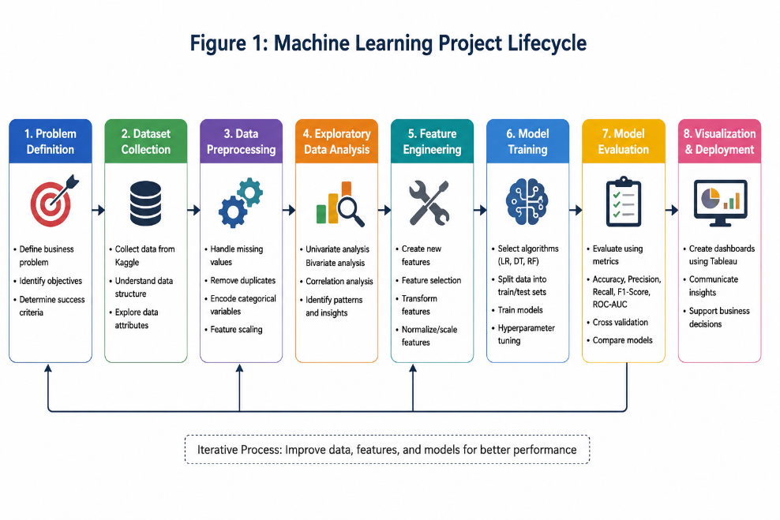
Figure 1 : Machine Learning Project Lifecycle

3.3 Problem Definition
Customer churn is a major challenge for telecommunication companies because losing customers directly reduces company revenue and increases customer acquisition costs. Telecom firms require predictive systems that can identify customers who are likely to discontinue services before churn occurs. The primary objective of this research is to develop a machine learning-based customer churn prediction system capable of accurately classifying customers into churn and non-churn categories. The success criteria for this project include achieving strong classification accuracy, identifying important churn-related factors, and generating meaningful business insights through dashboards and data visualization techniques to support customer retention strategies.

3.4 Dataset Collection and Description
For this research, it is the Telco Customer Churn dataset from the Kaggle that is utilized. Inside the dataset we can find demographic information about customers, subscription of service, account features and churn information. There are categorical and also numeric type variables, and all of them help with the classification analysis.
Table 2 : Dataset Attributes Description
Attribute | Description
gender | Customer gender
SeniorCitizen | Whether customer is senior citizen
tenure | Number of months customer stayed
Contract | Contract type
InternetService | Internet service type
MonthlyCharges | Monthly subscription charges
TotalCharges | Total charges paid
Churn | Target variable indicating customer churn

3.5 Data Preprocessing
To make data better and easier for machine learning work, preprocessing steps were done. First, if values were missing in TotalCharges column, they were filled by using a median after transforming this column to an numeric type. Duplicated rows got deleted which helps for more stable data. There was a customerID column that was taken away since it does not help in making predictions. For categorical variable data, these were changed into numbers through using one-hot encoding. Also by using StandardScaler, the numerical variables were normalized,this was for making results of the models more good.

3.6 Exploratory Data Analysis (EDA)
Exploratory Data Analysis was necessary to find out about customer habits and finding trends in customer churn. For this, distinct visualizations like charts, graphs got started with the Python tools Matplotlib and Seaborn. It was seen month-to-month type contract customers leave more, compared to longer contract customers. Customers using fiber optic internet services demonstrated higher churn rates. Histograms and distribution charts looked at the trend of monthly charges and customer tenure. Correlation heatmaps also helped to look for links among variables.
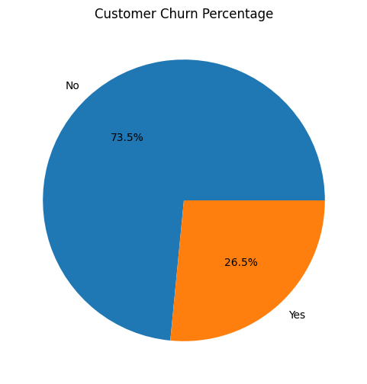
Figure 2 : Customer Churn Percentage
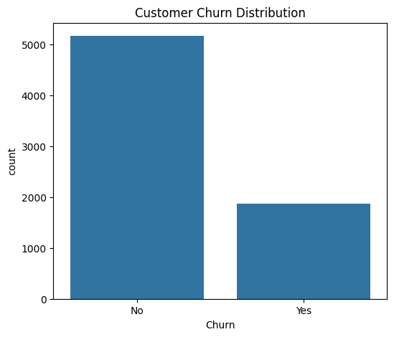
Figure 3 : Customer Churn Distribution

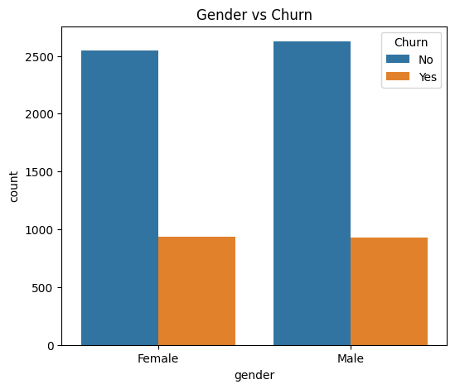
Figure 4 : Gender vs Churn
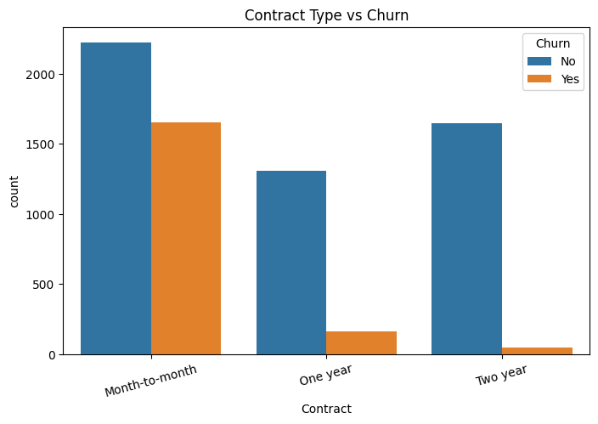
Figure 5 : Contract Type vs Churn
Customers with month-to-month contracts exhibited significantly higher churn rates compared to customers with one-year and two-year contracts.
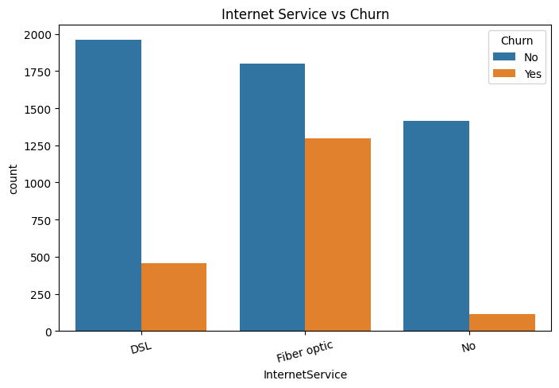
Figure 6 : Internet Service vs Churn
Customers using fiber optic internet services showed the highest churn rates among all internet service categories.
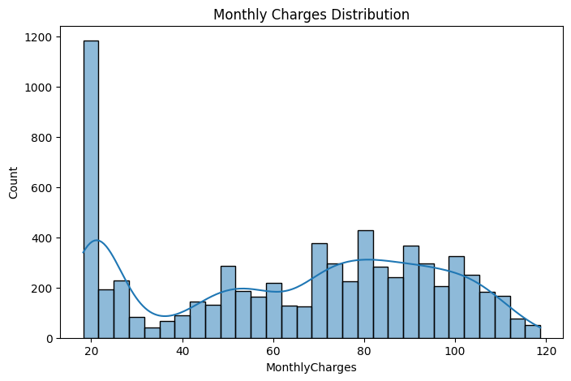
Figure 7 : Monthly Charges Distribution
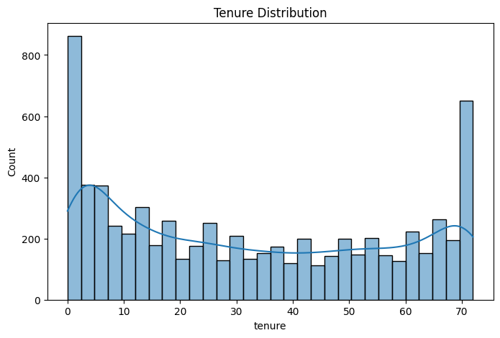
Figure 8 : Tenure Distribution
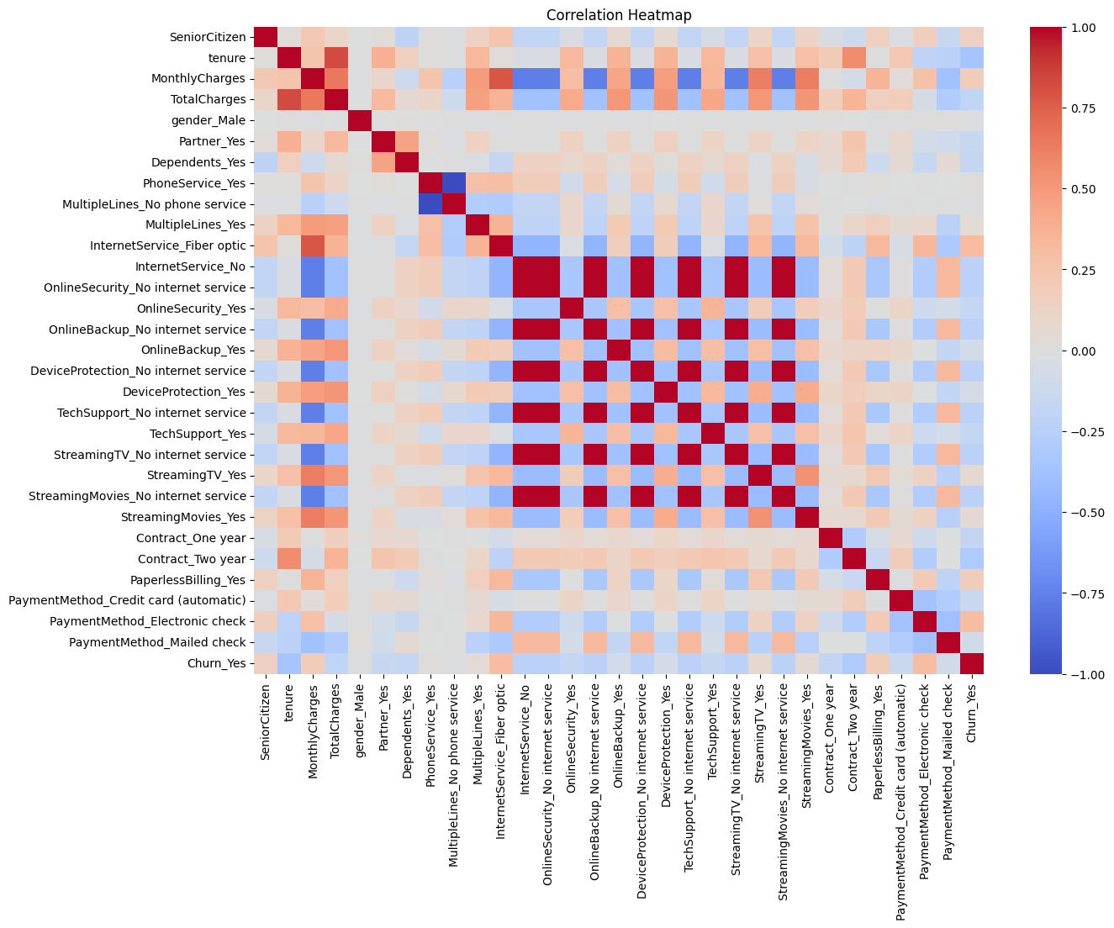
Figure 9 : Correlation Heatmap

3.7 Feature Engineering
Different feature engineering methods were utilized for better results in models (Azam Mehmood Qadri et al., 2023). One-hot encoding changed categorical type variables to binary coded numbers for the machines. Standardization was done for all numerical characteristics so that each one can impact evenly when model gets trained. Particular features such as tenure, contract type, monthly charges of internet service, along with a payment kinds are recognized to hold higher influences regarding decision of customers to leave.

3.8 Feature Selection
For selecting features, both feature importance checking and correlation analysis were done. Random Forest algorithm found out that most useful features for identifying customer churn are the contract type, tenure, MonthlyCharges and also TotalCharges. Correlation heatmaps were also applied to check linkage between predictive variables and whether customer leaves or not (Li et al., 2024).

3.9 Machine Learning Models
Four classifiers were used for this analysis.
3.9.1 Logistic Regression
Logistic Regression model got chosen as the basic and most simple kind of an algorithm since it does binary classification in a way that works with it in addition to being direct.
3.9.2 Decision Tree
Decision Tree was applied to get rules for classifying customers likely to churn. It tries to divide the space by decisions for finding patterns.
3.9.3 Random Forest
Random Forest, which is an ensemble algorithm of several trees, gives higher accuracy of predictions by combining multiple trees, and also avoids overfitting problem usually.
3.9.4 Support Vector Machine (SVM)
SVM was selected because of its ability to identify complex patterns and non-linear relationships within customer behavior data. for customer churn prediction. The model used the Radial Basis Function (RBF) kernel to improve classification performance for non-linear customer behavior patterns. SVM works by identifying the optimal decision boundary between churn and non-churn customers and is widely used for binary classification problems.

3.10 Train-Test Split
Data was split into training and test using ratio of 80:20. Training data is for learning for the models, and test data is to check how well prediction does.

3.11 Hyperparameter Tuning
Adjusting the model settings (hyperparameter tuning) was done by GridSearchCV for the Random Forest. Best values for n_estimators, max_depth, with min_samples_split were searched for.

Table 3 : Hyperparameter Tuning Results
Model | Parameters Tested | Best Parameters
Random Forest | max_depth, n_estimators, min_samples_split | max_depth=10, n_estimators=100

3.12 Cross Validation
For reliable validation of models, a five-fold cross validation was utilized to help ensure strong assessment and lessen chances that overfitting happens. Cross validation gave more trustable performance values by using several portions of dataset for training models and then testing them (Kalita, Singh and Kalita, 2026).

3.13 Chapter Summary
Research methodology along with how machine learning was deployed for churn prediction of the customers was clarified in this chapter.Dataset gathering, methods for preprocessing, feature building, exploratory data analysis, chosen machine learning algorithms and hyperparameter tuning plus ways the models were examined got covered. Coming chapter is about showing the experiment findings, evaluation of a performance and the gained business knowledge from models.

Chapter 4: Results and Discussion

4.1 Introduction
This part describes what was achieved when using machine learning approaches to predict customer churn among telecom companies. Different models like Logistic Regression, a Decision Tree and Random Forest were tested through classification measures which include Accuracy, Precision, Recall, F1-Score, Confusion Matrix, ROC-AUC and Cross Validation. On top of that, dashboards in the Tableau and some visuals were discussed for extracting business information and how customer churn can be explained.

4.2 Model Performance Evaluation
Machine learning models were checked using lots of classification metrics which were looking to display how well they can predict. Recall measures how effectively the model identifies actual churn customers and is important for reducing customer loss in telecom businesses. F1-Score provides a balance between Precision and Recall, especially when the dataset is imbalanced. ROC-AUC evaluates the ability of the model to distinguish between churn and non-churn customers, where higher values indicate stronger classification performance. Accuracy was taken for figuring out the general correct predictions. Precision and Recall were more about models sorting those who churned correctly. F1-Score makes an attempt at striking a balance between Recall and Precision while ROC-AUC provides how capable the models were in classifying.They were also evaluated for stability throughout different data sets (Varoquaux and Colliot 2023).

Table 4 : Model Performance Comparison
Model | Accuracy | Precision | Recall | F1-Score | ROC-AUC
Logistic Regression | 0.807 | 0.659 | 0.579 | 0.616 | 0.729
Decision Tree | 0.794 | 0.631 | 0.540 | 0.582 | 0.713
Random Forest | 0.799 | 0.655 | 0.513 | 0.576 | 0.708
Support Vector Machine (SVM) | 0.792 | 0.642 | 0.489 | 0.555 | 0.695
The results show that Logistic Regression achieved the highest accuracy and ROC-AUC score among all models.

4.3 Logistic Regression Results
Logistic Regression got highest results with about an 80.7 percent accuracy.This model gave the top ROC-AUC outcome, which is 0.729. That means it demonstrated strong classification performance. The value of Precision and Recall showed that churned customers were noted effective and the predictions stayed mostly balanced in tests.
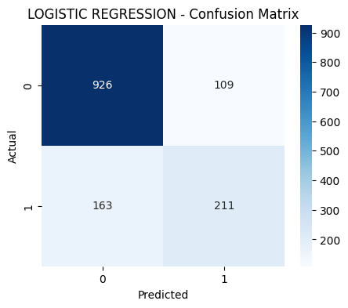
Figure 10 : Logistic Regression Confusion Matrix
One advantage that Logistic Regression has is it is simple and the model is highly interpretable, so it is good for business analytics and when people need to make decisions. But, if relationships are non-linear or variables become complex, the model does not work so well.

4.4 Decision Tree Results
Decision Tree model got a 79.4 percent accuracy while the F1-score goes to an 0.582. The model found several decision rules that are related to the customer churn and this also gives results people can explain. Decision Trees help because they provide visual and interpretable decision-making structures.
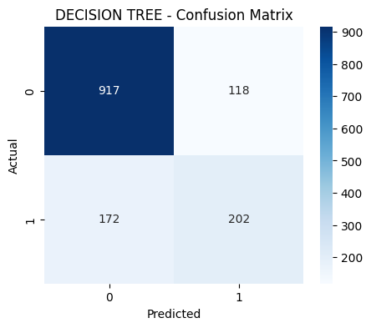
Figure 11 : Decision Tree Confusion Matrix
Although model had decent outcomes, its Recall and Precision came a little less than an Logistic Regression. When Decision Trees are trained with big datasets and lack enough tuning they can produce overfit results.

4.5 Random Forest Results
The Random Forest model achieved an accuracy score of 79.9% and obtained higher stability by using ensemble learning methods. The model was combining several decision trees,this action dropped down an overfitting and made the predictions to be stronger.
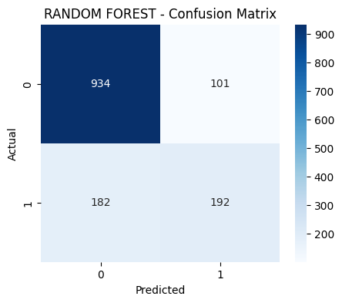
Figure 12 : Random Forest Confusion Matrix
Random Forest demonstrated strong classification capability and detected some important churn indicators for example a contract type in the tenure and monthly charges too. But, while hyperparameters were tuned, Logistic Regression slightly outperformed the Random Forest model when talking about how correct it is and ROC-AUC scoring.

4.6 Support Vector Machine Results
The Support Vector Machine (SVM) model was implemented using the Radial Basis Function (RBF) kernel for customer churn classification. The model achieved competitive performance in predicting churn customers and demonstrated strong classification capability for telecom customer behaviour data.
SVM performed effectively because of its ability to classify complex and non-linear patterns in the dataset. The confusion matrix showed that SVM correctly classified 933 non-churn customers and 183 churn customers. However, the model produced a higher number of false negatives than Logistic Regression, which contributed to its lower recall score.
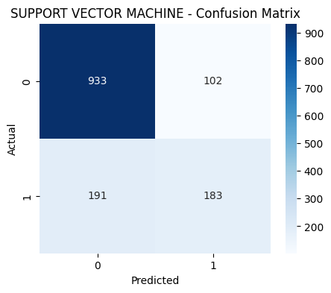
Figure 13 : Confusion Matrix Support Vector Machine

4.7 ROC Curve Analysis
They used ROC Curve for checking how well models did at classifying. This result suggests that the churn patterns within the dataset became more linearly separable after preprocessing and feature engineering, allowing Logistic Regression to outperform the other classification models, which means it identified churners and not-churners better.
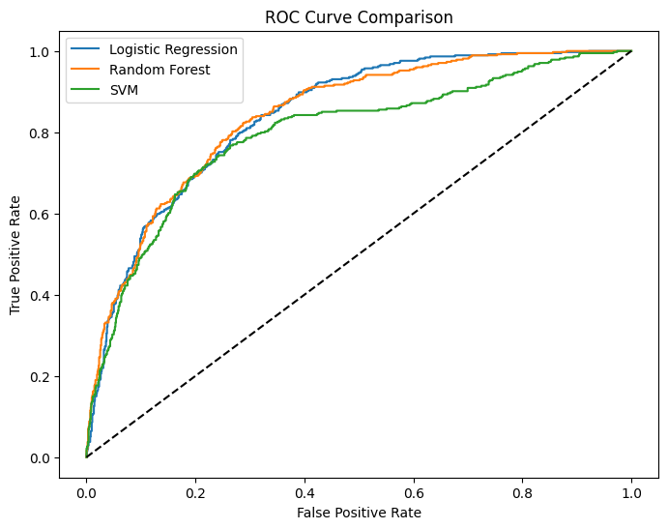
Figure 14 : ROC Curve
Greater ROC-AUC scores reflect better classification skills. In this research, an ROC analysis was used to check the models and Logistic Regression proved to be the most reliable model for predicting the customer churn.

4.8 Cross Validation Results
Five-fold cross validation method was used to keep model evaluation steady and trustworthy. Using cross validation, overfitting was lowered and the performance estimation of model remained stable (Sweet et al., 2023).
Table 5 : Cross Validation Scores
Fold | Accuracy
Fold 1 | 0.806
Fold 2 | 0.802
Fold 3 | 0.780
Fold 4 | 0.813
Fold 5 | 0.797
The mean value for cross validation was near 80 percent showing the model performed stably and consistency.

4.9 Model Accuracy Comparison
According to a graph for accuracy comparison, Logistic Regression did better than an Decision Tree and the Random Forest models.
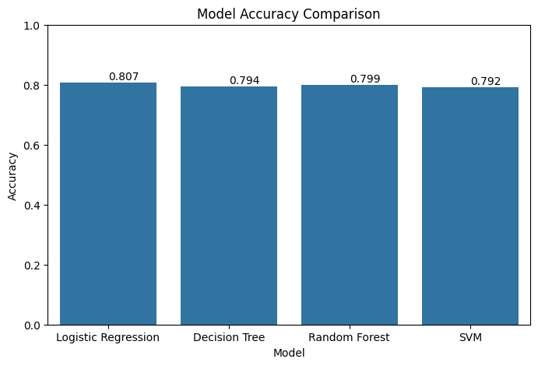
Figure 15 : Model Accuracy Comparison
The comparison makes it evident that in some datasets, not very complex algorithms for classification actually can have better results than ensemble techniques and it depends on how the features behave.

4.10 Feature Importance Analysis
For a feature importance, the analysis found main variables influencing the customers who leave. Using the Random Forest model, the most influential features were tenure, TotalCharges, MonthlyCharges, internet service type, and contract type. These variables significantly contributed to customer churn prediction.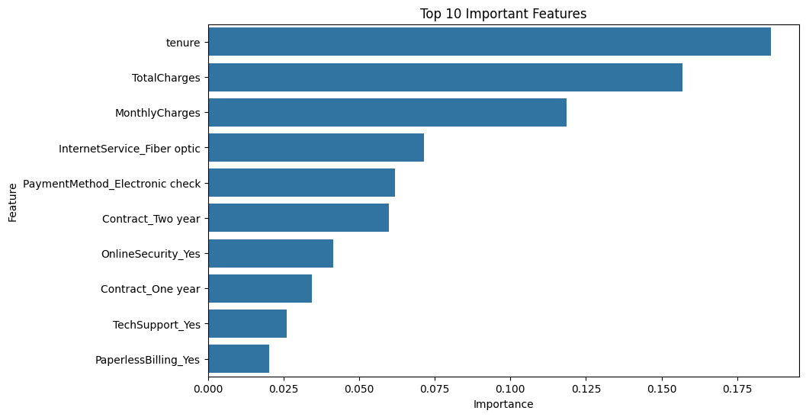
Figure 16 : Top 10 Important Features
Customers with shorter tenure and who paid a greater payment every month have much more risk they decide to go away. Customers choosing a monthly contract or who bought a fiber optic internet also usually leave company more.

4.11 Tableau Dashboard and Business Storytelling
Using Tableau, dashboards and visuals were made which help with a business analysis stories and also people could interact with the figures. The dashboard enabled users to check how churn is spread out and look at male and females, contract kinds, internet options, monthly charge and contract time basically through charts. I believe this dashboard is really important for the business use.
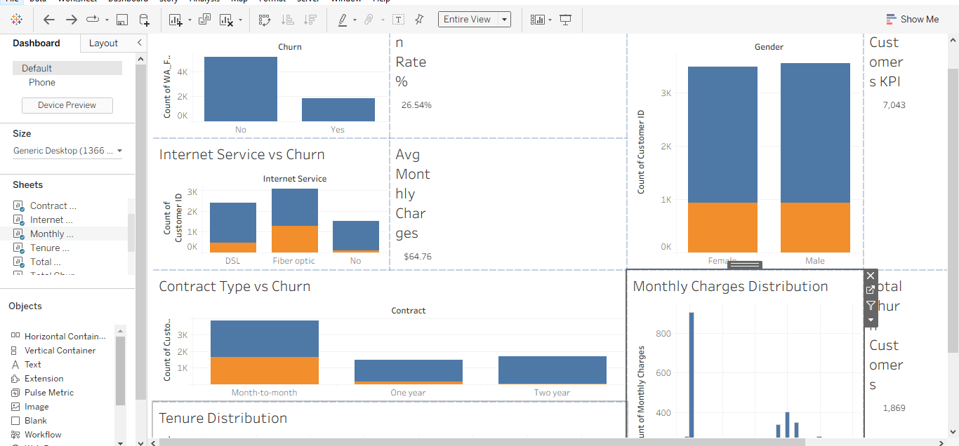
Figure 17 : Customer Churn Analysis Dashboard
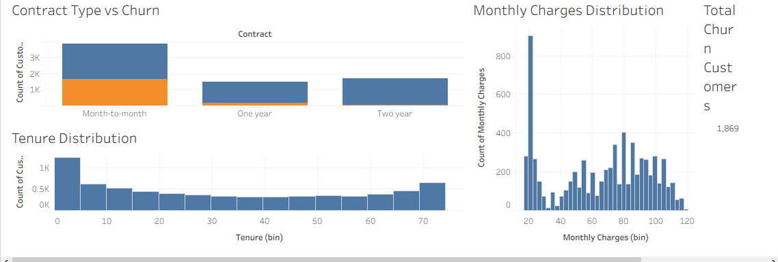
Figure 18 : Customer Churn Analysis Dashboard
The visualizations revealed that customers with month-to-month contracts and fiber optic internet services demonstrated higher churn rates than other customer groups. Tableau dashboard clarified the data so people get customer activities better with an interactive approach.
Interactive filters were added in the Tableau dashboard to allow users to analyze churn behavior dynamically based on customer gender, contract type, internet service, and churn category. KPI cards such as Total Customers, Total Churn Customers, Churn Rate, and Average Monthly Charges were also integrated for quick business insights and improved dashboard storytelling.

4.12 Discussion of Findings
The experimental results demonstrated that Logistic Regression achieved the best overall performance as it was more balanced and ROC-AUC score was high. Main discoveries also included the key churn behaviors in telecom data. Customers paying more each month, with a brief tenure and who had flexible contracts were more often leaving service. These results can help the telecom companies to plan retention efforts in a targeted manner, raise satisfaction of customers and prevent losing income with the predictive analysis.

4.13 Chapter Summary
This chapter displayed what was found out from the experiments and also discussion about predicting customer churn using different models. Of all algorithms that were used and tried, Logistic Regression offered the greatest accuracy in predicting outcomes. The chapter included some useful business points detected with use of feature importance analysis and visualizations by Tableau software. The next chapter will wrap up this study and gives ideas for where to go with research and company enhancements (Zaghloul, Barakat and Rezk, 2025).

Chapter 5: Conclusion and Recommendations

5.1 Conclusion
The research reached success with production of a machine learning customer churn prediction tool for telecommunication sector, and was based by the Telco Customer Churn data. Nearly all the major goals were completed which were work on data cleaning, looking for insights, running machine learning algorithms and business dashboards built with Tableau. There were Four classifiers included: Logistic Regression, Decision Tree SVM and Random Forest which were analyzed with metrics including Accuracy, Precision, Recall, F1-score and ROC-AUC. From all these, Logistic Regression achieved an accuracy of 80.7%, which was the highest among all evaluated models. Important factors such as how long customer stayed, which contract they have, the internet package, and the charge per month have a real importance for churn.

5.2 Business Recommendations
Telecom companies need for better ways to keep users who stay on a monthly contract and pay higher charges each month as the outcomes say these people will maybe go away. Companies are supposed to give more enjoyable deals for each person, presenting more rewards for loyal users and offering improved support to make customer frustration lesser. If predictive analytics are used on daily basis, it helps to spot people who might leave, before they actually stop the service. Implementing churn prediction models can help telecom companies reduce customer acquisition costs, improve customer retention rates, increase customer lifetime value, and support proactive business decision-making.

5.3 Limitations of the Study
In our research there was only an public dataset used which means results might not perfectly match all telecom industries. Also only traditional machine learning models happened to be used.

5.4 Future Work
In later research, scientists might use deep learning, create tools that predict fast when a user might leave or apply much bigger dataset to get more good outcomes for the businesses. Such changes may give a businesses a new forward step.

BIBLIOGRAPHY

Afzal, M., Rahman, S., Singh, D. and Imran, A. (2024). Cross-Sector Application of Machine Learning in Telecommunications: Enhancing Customer Retention through Comparative Analysis of Ensemble Methods. IEEE Access, pp.1–1. doi: https://doi.org/10.1109/access.2024.3445281.
Amin, A., Adnan, A. and Anwar, S. (2023). An adaptive learning approach for customer churn prediction in the telecommunication industry using evolutionary computation and Naïve Bayes. Applied Soft Computing, 137, p.110103. doi: https://doi.org/10.1016/j.asoc.2023.110103.
Azam Mehmood Qadri, Raza, A., Munir, K. and Mubarak Almutairi (2023). Effective Feature Engineering Technique for Heart Disease Prediction With Machine Learning. IEEE Access, 11, pp.56214–56224. doi: https://doi.org/10.1109/access.2023.3281484.
Kalita, B.K., Singh, K.A. and Kalita, M. (2026). Fivefold Cross-Validation Approach in Evaluating the Robustness of Machine Learning Models for Prediction of Esophageal Cancer. Indian Journal of Community Medicine. doi: https://doi.org/10.4103/ijcm.ijcm_454_24.
Li, J., Mohd Shahizan Othman, Chen, H. and Lizawati Mi Yusuf (2024). Optimizing IoT intrusion detection system: feature selection versus feature extraction in machine learning. Journal of Big Data, 11(1). doi: https://doi.org/10.1186/s40537-024-00892-y.
Muhammed Kotan, Ömer Faruk Seymen, Levent Çallı, Kasım, S., Yavuz, B.Ç. and Tijen Över Özçelik (2025). A novel methodological approach to SaaS churn prediction using whale optimization algorithm. PLoS ONE, 20(5), pp.e0319998–e0319998. doi: https://doi.org/10.1371/journal.pone.0319998.
Omari, A., Al-Omari, O., Al-Omari, T. and Fati, S.M. (2025). A predictive analytics approach to improve telecom’s customer retention. Frontiers in Artificial Intelligence, 8. doi: https://doi.org/10.3389/frai.2025.1600357.
Saleh, S. and Saha, S. (2023). Customer retention and churn prediction in the telecommunication industry: a case study on a Danish university. SN Applied Sciences, 5(7). doi: https://doi.org/10.1007/s42452-023-05389-6.
Sana, J.K., Abedin, M.Z., Rahman, M.S. and Rahman, M.S. (2022). A novel customer churn prediction model for the telecommunication industry using data transformation methods and feature selection. PLOS ONE, 17(12), p.e0278095. doi: https://doi.org/10.1371/journal.pone.0278095.
Shahabikargar, M., Beheshti, A., Zhang, X., Foo, J. and Jolfaei, A. (2025). A comprehensive survey on customer churn analysis studies. Journal of Information and Telecommunication, pp.1–47. doi: https://doi.org/10.1080/24751839.2025.2528440.
Sweet, L., Christoph Müller, Anand, M. and Jakob Zscheischler (2023). Cross-Validation Strategy Impacts the Performance and Interpretation of Machine Learning Models. Artificial intelligence for the earth systems, 2(4). doi: https://doi.org/10.1175/aies-d-23-0026.1.
Taherkhani, L., Daneshvar, A., Hossein Amoozad Khalili and Mohamad Reza Sanaei (2023). Analysis of the Customer Churn Prediction Project in the Hotel Industry Based on Text Mining and the Random Forest Algorithm. Advances in Civil Engineering, 2023, pp.1–8. doi: https://doi.org/10.1155/2023/6029121.
Varoquaux, G. and Colliot, O. (2023). Evaluating Machine Learning Models and Their Diagnostic Value. Neuromethods, pp.601–630. doi: https://doi.org/10.1007/978-1-0716-3195-9_20.
Zaghloul, M., Barakat, S. and Rezk, A. (2025). Enhancing customer retention in Online Retail through churn prediction: A hybrid RFM, K-means, and deep neural network approach. Expert Systems with Applications, [online] 290, p.128465. doi: https://doi.org/10.1016/j.eswa.2025.128465.
Zaghloul, M., Barakat, S. and Rezk, A. (2025). Enhancing customer retention in Online Retail through churn prediction: A hybrid RFM, K-means, and deep neural network approach. Expert Systems with Applications, [online] 290, p.128465. doi: https://doi.org/10.1016/j.eswa.2025.128465.
IBM Telco Customer Churn Dataset. Kaggle. Available at:
https://www.kaggle.com/datasets/blastchar/telco-customer-churn

