Decision Readiness Scoring for Merchandising Operations
A Data-Driven Framework for Evaluating Assortment and Inventory Recommendations
Table of Contents
Executive Summary 2
1. Problem Statement 3
2. Dataset 3
3. Methodology 4
3.1 The Censored Demand Problem 4
3.2 Demand Recovery 4
3.3 Feature Engineering 5
3.4 The Readiness Score 6
3.5 Threshold Calibration 7
4. System Architecture 8
4.1 Pipeline (Python) 8
4.2 Frontend (React + Vite) 9
5. How to Use the Dashboard 10
5.1 Overview Page 10
5.2 Product Readiness Page 10
5.3 Risk Diagnostics Page 11
5.4 Localization Analysis Page 12
5.5 Recommendation Simulator Page 13
5.6 How to Run the Software 14
6. Output Format and Trust 14
7. Results and Analysis 15
Finding 1: Recovered Demand Reveals Systematically Understated SKU Performance 15
Finding 2: Demand Concentration Validates the Localize Class 16
Finding 3: Promotion Dependency Is More Widespread Than Observed Sales Suggest 16
8. Limitations and Next Steps 16

Executive Summary
This project builds a decision readiness scoring system for retail merchandising. Given a dataset of SKU-store-day sales records, it answers a single question: is the data behind a product recommendation reliable enough to act on, or does it need to be reviewed, localized, or escalated first? The output is a scored, classified CSV of SKU-store-week recommendations, together with an interactive web dashboard for exploration and simulation.
The system was built on FreshRetailNet-50K (Dingdong-Inc/FureshRetailNet-50K on HuggingFace), a fresh produce retail dataset covering 50,000 SKU-store-day records across 18 anonymized Chinese cities. The dataset is unusual in that it includes hourly sales arrays and hourly stock status arrays, making it possible to estimate demand during stockout hours rather than treating zero sales as zero demand. This demand recovery step is the intellectual core of the project.
Each SKU-store-week receives a readiness score from 0 to 100 and is assigned to one of four action classes: Ready to Execute, Merchant Review, Localize, or Escalate. The classification rules are transparent, all thresholds are adjustable in the browser via a Simulator page, and all source code is publicly available on GitHub.
What the System Does and Does Not Do
The system does | The system does not
Score SKU-store-week recommendation readiness on a 0–100 scale | Automatically place purchase orders or trigger replenishment
Estimate demand hidden during stockout hours | Know the true cause of stockouts (logistics, vendor, or ordering error)
Flag products for Execute, Review, Localize, or Escalate with reason codes | Replace merchant judgment or validate against actual purchase decisions
Show geographic demand concentration (HHI) by city and store | Use vendor contracts, spoilage records, or markdown data
Allow users to adjust scoring weights and classification thresholds in a browser simulator | Optimize full enterprise assortment strategy or run live purchasing
Surface products with high recovered-to-observed demand ratios as escalation candidates | Account for spoilage, waste risk, or perishability directly

1. Problem Statement
Every week, merchants and planning systems generate SKU-store recommendations: carry this product, expand distribution here, reduce allocation there. The operational question is not whether demand exists in the abstract. The question is whether a given recommendation is safe to act on, given the quality of the data behind it, the reliability of supply, and the stability of the demand signal. A recommendation that looks strong because a product sold 200 units last week may be built on three days of data, a promotional spike, and a stockout rate that censored another 300 units of latent demand. Acting on it without scrutiny is not a decision — it is a guess dressed in a spreadsheet.
This project addresses that gap. The decision being made is whether to execute a SKU-store recommendation or to route it for review, localization, or escalation. The framework is optimized around a single primary objective: minimize false execution confidence. That means reducing the rate at which a retailer acts on a recommendation that appears commercially strong but is actually distorted by stockout censoring, promotional dependency, or demand volatility. The secondary objective is to surface localization opportunities — SKUs where demand is geographically concentrated and a broad rollout would leave most locations understocked while overstocking the few that actually move the product.
The framework operates under three hard constraints. Decisions must be made weekly, at SKU-store granularity, using only observable retail data. There is no access to vendor contracts, spoilage records, fill rate confirmations, or actual merchant decisions. This is deliberate: the system is designed to work with what a retailer can measure today, not what they wish they could measure.

2. Dataset
FreshRetailNet-50K (Dingdong-Inc/FreshRetailNet-50K, HuggingFace) is a publicly available dataset of fresh produce retail transactions across 18 anonymized Chinese cities, covering 50,000 SKU-store-day records with embedded hourly sales and stock status arrays. I chose this dataset because it contains explicit stockout annotations at the hourly level.
Usually when a product is out of stock, the sales record shows zero which is neither a reflection of weak demand nor of absent demand, but of unobserved counterfactual. Without a mechanism to recover that hidden demand, any downstream scoring model conflates supply failure with commercial failure. Strong SKUs look weak; weak SKUs, which happened to be in stock, look strong. FreshRetailNet-50K makes this problem tractable because the stock status signal allows the system to distinguish between hours when a product was available and hours when it simply was not there to be bought.
The data architecture starts with the raw dataset as the input. The demand recovery model produces an estimated true demand signal as an intermediate output, and that recovered signal feeds into the scoring model alongside eight raw features. Nothing in the pipeline relies on pre-computed ML labels from the dataset itself: all scoring is performed on features derived from the raw transactional record.
Data Flow
FreshRetailNet-50K (raw hourly data, 50,000 SKU-store-day rows)
↓
Preprocessing: clean, deduplicate, aggregate to weekly SKU-store grain
↓
Demand Recovery: estimate latent demand during stockout hours
↓
Feature Engineering: 8 signals: velocity, consistency, stockout risk …
↓
Readiness Scoring: weighted composite 0–100
↓
Recommendation Classification: Execute / Review / Localize / Escalate

3. Methodology

3.1 The Censored Demand Problem
Observed sales data in retail is structurally incomplete. When a product is stocked out, customers cannot buy it, so the sales record shows zero. That zero is not a measure of demand but really is a measure of availability failure. The problem compounds at scale: a product with a high stockout rate will, on average, look like a weak seller across every conventional sales metric, from total units to average weekly velocity. A naive approach of sorting by sales and acting on the top performers systematically rewards products that were always available and penalizes products that were frequently out of stock regardless of how much demand they actually had.
A concrete example to illustrate the stakes: a SKU showing 12 units sold per week across 6 observed hours looks unremarkable by any standard metric. But if that product was stocked out for 18 of the 24 hours in any given day, and its sales rate during the 6 available hours was 2 units per hour, then the estimated true demand is closer to 48 units, which is four times the observed figure. A scoring system that ignores this will classify the product as low-priority and potentially recommend reducing its shelf presence, when the operationally correct action is to investigate the supply chain failure and increase safety stock.
This is the intellectual core of the project. Correcting for censored demand is not a modelling nicety; it is a prerequisite for making any downstream recommendation trustworthy. Every class in the output, Ready to Execute, Merchant Review, Localize, Escalate, is downstream of getting this step right.

3.2 Demand Recovery
For each hour a product was recorded as out of stock, the system estimates what it would have sold using a four-level fallback hierarchy. The approach is deliberately conservative: it uses the most specific available context first and only widens to broader averages when sufficient history does not exist.
The primary estimate uses the same product's own sales history during in-stock hours at the same time of day and day of week. If a product consistently sells 2 units between 8am and 9am on weekdays when it is available, that rate is applied to any weekday 8am hour when it was stocked out. If the product does not have enough same-hour history to produce a stable estimate, the model falls back to its overall in-stock sales rate across all hours. If even that history is too sparse, the fallback widens to the city-level average for similar products during the same period. The final fallback, used only when city-level data is also insufficient, is a global average rate derived from the full dataset.
The recovered demand figure that emerges from this process feeds directly into two places: the Hidden Demand Signal feature score, which measures how much latent demand a product has relative to its observed sales, and the estimated true demand field, which is used in the dollar-value calculations throughout the dashboard.
Demand Recovery Algorithm
The dataset provides two 24-element arrays per SKU-store-day: hours_sale[0..23] (units sold in each hour) and hours_stock_status[0..23] (1 = in stock, 0 = stocked out). Preprocessing explodes each row into 24 hourly records, then aggregates to weekly SKU-store grain. The demand recovery step operates on the hourly records before aggregation.
For each hour h where stock_status[h] = 0, the imputed sales rate r is selected from the first level that yields a result:
Level | Condition | Rate formula
L1 | ≥3 in-stock observations at same (hour of day, day of week) | mean(sale[h'] : hour_of_day[h'] = hour_of_day[h], dow[h'] = dow[h], in_stock[h'] = 1)
L2 | L1 not available; SKU-store has any in-stock history | mean(sale[h'] : same sku, same store, in_stock[h'] = 1, all hours)
L3 | L2 not available; city has in-stock data for this SKU | mean(sale[h'] : same sku, same city_id, in_stock[h'] = 1)
L4 | Final fallback; always available | mean(sale[h'] : in_stock[h'] = 1, all SKUs, all stores, all hours)
The estimated true demand for a SKU-store-week is then: D_true = sum(observed_sale[h]) + sum(r[h] for h where stock_status[h] = 0), where r[h] is the imputed rate from the highest-priority fallback level available for hour h.

3.3 Feature Engineering
Eight features are computed at weekly SKU-store granularity. The table below describes each feature in plain terms and explains why it matters to a merchant making an assortment or replenishment decision.

Feature | What It Measures | Why It Matters to a Merchant
Sales Velocity | Average weekly units sold during available stock hours | Anchors the score to baseline commercial performance; a fast-moving SKU earns confidence by default
Demand Stability | Coefficient of variation of weekly sales across the observation window | High volatility inflates apparent demand during promotional spikes, masking the true baseline
Store Fit | How well a store's historic sales mix matches this SKU's demand profile (HHI-based) | Surfaces geographic mismatch — a product that sells everywhere is different from one that sells in two stores
Hidden Demand Signal | Estimated units lost to stockout, recovered via the imputation model | Corrects the censoring problem; a high hidden demand score means the SKU is stronger than its reported sales suggest
Promo Reliance | Share of total demand attributable to promotional periods | A product that only moves under discount has fragile baseline economics; this penalises artificial velocity
Low Demand Volatility | Inverse of week-to-week sales variance, scaled 0–100 | Consistent demand is easier to plan for; volatile demand amplifies forecast error and safety-stock cost
Supply Reliability | Inverse of average stockout rate across the observation window | Separates supply-constrained products from genuinely weak ones; a high stockout rate is a warning, not a verdict
Demand Consistency | Fraction of observed weeks with non-zero sales above a minimum threshold | Filters out one-off promotions and data artefacts; reliable signal requires sustained commercial presence

3.4 The Readiness Score
The eight feature scores are combined into a single readiness score using a weighted sum, scaled to a 0–100 range. The default weights are: Sales Velocity (25%), Demand Stability (20%), Store Fit (15%), Hidden Demand Signal (15%), Promo Reliance (10%), Low Demand Volatility (10%), and Supply Reliability (5%). The weights reflect a deliberate ordering of evidence: a fast-moving, consistent product with genuine demand is the most operationally safe bet, so velocity and stability together account for nearly half the score. The hidden demand signal receives a significant weight (15%) precisely because correcting for censoring is central to the framework’s purpose.
Score Formula
Each raw feature is converted to a percentile rank within the current week’s dataset before weighting. Percentile ranking normalizes all features to a common 0–100 scale regardless of their units or distributions, which prevents high-magnitude features (such as raw unit sales) from dominating low-magnitude ones (such as stockout rate fractions). The composite readiness score is:
S = 0.25·v + 0.20·c + 0.15·l + 0.15·r + 0.10·p + 0.10·lv + 0.05·ls
where all variables are percentile ranks (0–100): v = sales velocity, c = demand consistency, l = store fit (localization), r = recovered demand signal, p = promo independence (1 minus promo share), lv = low volatility (inverse coefficient of variation), ls = low stockout risk (1 minus stockout rate). Weights sum to 1.00. The resulting score S is bounded [0, 100] and interpreted as: high score = high confidence the recommendation is safe to act on without further review.
HHI for Geographic Concentration
The Store Fit and Localize features both rely on the Herfindahl-Hirschman Index (HHI) to measure geographic demand concentration. HHI is computed on per-store demand to prevent large cities (which have more stores) from dominating the index by volume alone. Let dᵢ be the total demand for a SKU in city i, nᵢ be the number of stores in that city, and D be the total per-store demand summed across all cities:
HHI = Σᵢ (dᵢ / nᵢ / D)² where D = Σᵢ (dᵢ / nᵢ)
HHI ranges from 0 (demand perfectly distributed across all cities per store) to 1 (all per-store demand concentrated in one city). A SKU with HHI above 0.75 is flagged for the Localize class. The Store Fit feature score is derived from the percentile rank of (1 minus HHI), so a more evenly distributed SKU receives a higher store fit score.
A key design decision is that the weights are not fixed. The Simulator page of the dashboard allows users to adjust all seven weights in real time and observe how the recommendation class distribution shifts. This serves two purposes: it makes the model transparent, a merchant can see exactly what is driving a classification, and it makes the model tunable to different retail contexts. A grocer with chronic supply issues might weight Supply Reliability higher; a retailer with a strong promotional calendar might reduce the weight on Promo Reliance.

3.5 Threshold Calibration
The classification thresholds translate a continuous readiness score into one of four action classes: Ready to Execute (score above the ready threshold, no disqualifying flags), Merchant Review (moderate score, borderline cases), Localize (concentrated geographic demand), and Escalate (extreme stockout rate or severe demand censoring).
During the initial build, the default thresholds were set from first principles: a minimum score of 75 for Ready to Execute, a maximum stockout rate of 30% for non-escalated products, and an escalation threshold at stockout rates above 30%. When the pipeline ran on the actual dataset, the result was 99.5% Escalate, 0% Ready to Execute. That failure was diagnostic, not catastrophic. FreshRetailNet-50K is a fresh produce dataset: the median stockout rate in the data is 84.7%, not 30%. With a threshold calibrated for a general retail context, almost every product in a high-frequency fresh produce supply chain would be classified as a supply emergency.
The thresholds were recalibrated against the actual data distribution by computing percentile ranks across all key metrics. The ready threshold was set at approximately the 75th percentile of readiness scores; the escalation threshold was moved to the 95th percentile of stockout rates, representing only the most extreme tail. The before-and-after class distribution is shown below.

Class | Before Calibration | After Calibration | Primary Change
Ready to Execute | ~0% | ~28% | Raising readyMin from 75 to 62; raising escalateMinStockout from 0.30 to 0.97
Merchant Review | ~0.3% | ~22% | Lowering reviewMin from 45 to 38 to capture borderline cases
Localize | ~0.1% | ~18% | Raising localizeHHI from 0.50 to 0.75 to require genuine concentration
Escalate | ~99.5% | ~32% | Correctly reflecting the dataset's endemic 85% median stockout rate

The recalibration reflects a broader principle: a scoring model is only as good as its understanding of the data it runs on. Applying thresholds derived from a different context is not a modelling error; it is a deployment error. Diagnosing and correcting it is part of the analytical work.
Classification Logic
Rules are evaluated in priority order. The first rule that matches determines the class:
Priority | Class | Condition (all must hold) | Calibrated threshold
1 (first) | Escalate | stockout_rate ≥ escalateStockout OR recovered_ratio ≥ escalateRecovered | 0.97 / 0.90
2 | Localize | HHI ≥ localizeHHI | 0.75
3 | Ready to Execute | S ≥ readyMin AND stockout_rate ≤ readyMaxStockout AND vol_pct ≤ readyMaxVolPct AND promo_pct ≤ readyMaxPromoPct | 62 / 0.90 / 75th pct / 75th pct
4 | Merchant Review | S ≥ reviewMin (does not meet Ready conditions) | 38
5 (default) | Escalate | S < reviewMin (no other rule matched) | n/a
All threshold values are adjustable at runtime via the Simulator page of the dashboard. Slider inputs update the classification in real time on a 5,000-row stratified sample so buyers can explore how policy changes shift the Ready-to-Execute share before committing to a threshold change in the production pipeline.

4. System Architecture

4.1 Pipeline (Python)
The backend pipeline is implemented in Python and runs end-to-end from dataset download to scored CSV output. It consists of four modules under src/:
Module | Responsibility
src/data_loader.py | Downloads FreshRetailNet-50K via the HuggingFace datasets library. Explodes the 24-element hours_sale and hours_stock_status arrays into hourly rows, deduplicates, and writes parquet to data/interim/.
src/demand_recovery.py | Implements the L1-L4 fallback imputation. Reads hourly parquet, builds rate lookup tables per level, applies imputations to stockout hours, and writes estimated_true_demand to data/interim/.
src/feature_engineering.py | Aggregates hourly records to weekly SKU-store grain. Computes the 8 raw feature values and converts each to a percentile rank using a O(n log n) index-sort algorithm (avoids O(n2) scan). Outputs a features parquet to data/processed/.
src/scoring.py | Applies the weighted formula to produce readiness_score, then applies the prioritized classification rules to assign recommendation_class. Writes the final scored CSV to outputs/product_store_recommendations.csv.
CI/CD is handled by a GitHub Actions workflow. On push to main, the workflow installs Python dependencies, creates the output directories (which are gitignored and therefore absent in CI), runs the four pipeline modules in sequence, copies the output CSV to the React build directory, then builds and deploys the frontend to GitHub Pages via peaceiris/actions-gh-pages.

4.2 Frontend (React + Vite)
The dashboard is a React 18 single-page application built with Vite 5, styled with Tailwind CSS 3, and deployed as a static site. Key dependencies: Recharts for charts, PapaParse for CSV parsing, React Router v6 for client-side routing. The app has five pages: Overview, Product Readiness, Risk Diagnostics, Localization Analysis, and Recommendation Simulator.
Technicals worth mentioning:
- Data loading. PapaParse fetches the CSV from the public/ directory with dynamicTyping: true so numeric CSV columns are parsed as JavaScript numbers. The result is cached at module level in useData.js: a single fetch is shared across all pages regardless of navigation order, avoiding repeated 100K-row parses on tab switches.
- Filtering. A shared useFilters hook manages five filter dimensions (week, city, store, SKU, recommendation class), each stored as a string array where empty array means "all." Filters use loose equality (==) when comparing filter values against CSV columns to handle type coercion between string filter inputs and numeric parsed CSV values. The MultiSelect component renders a dropdown with checkboxes, Select All, and Clear controls.
- Simulator performance. The Simulator page re-scores the dataset in real time as sliders move. To keep the browser responsive on the full 100K-row dataset, re-scoring runs on a 5,000-row stratified sample (every Nth row so the sample is spread evenly, not just the first 5,000 rows). Slider values are debounced at 250ms before triggering re-computation. Percentile ranking in the browser uses the same O(n log n) index-sort approach as the Python pipeline, replacing the naive O(n²) approach that caused browser hangs on M-series Apple hardware.

5. How to Use the Dashboard
The live dashboard is available at https://DheepthaRai.github.io/decision-readiness-merchandising. It loads a pre-scored CSV and requires no login or installation. The five pages below walk through the main workflows. All pages share a global filter bar that lets you slice by week, city, store, SKU, and recommendation class simultaneously.

5.1 Overview Page
The Overview page is the entry point. Four KPI cards at the top show: total SKU-store-week rows in the current filter, the number flagged Escalate, the number flagged Localize, and the percentage of rows classified Ready to Execute. Below the KPIs, a bar chart shows the distribution of all four recommendation classes. Four additional charts show estimated true demand by week, average stockout rate by city, top SKUs by estimated demand, and the spread of recovered vs. observed demand across the dataset. Use the global filter bar to narrow by city or week before exploring individual pages.
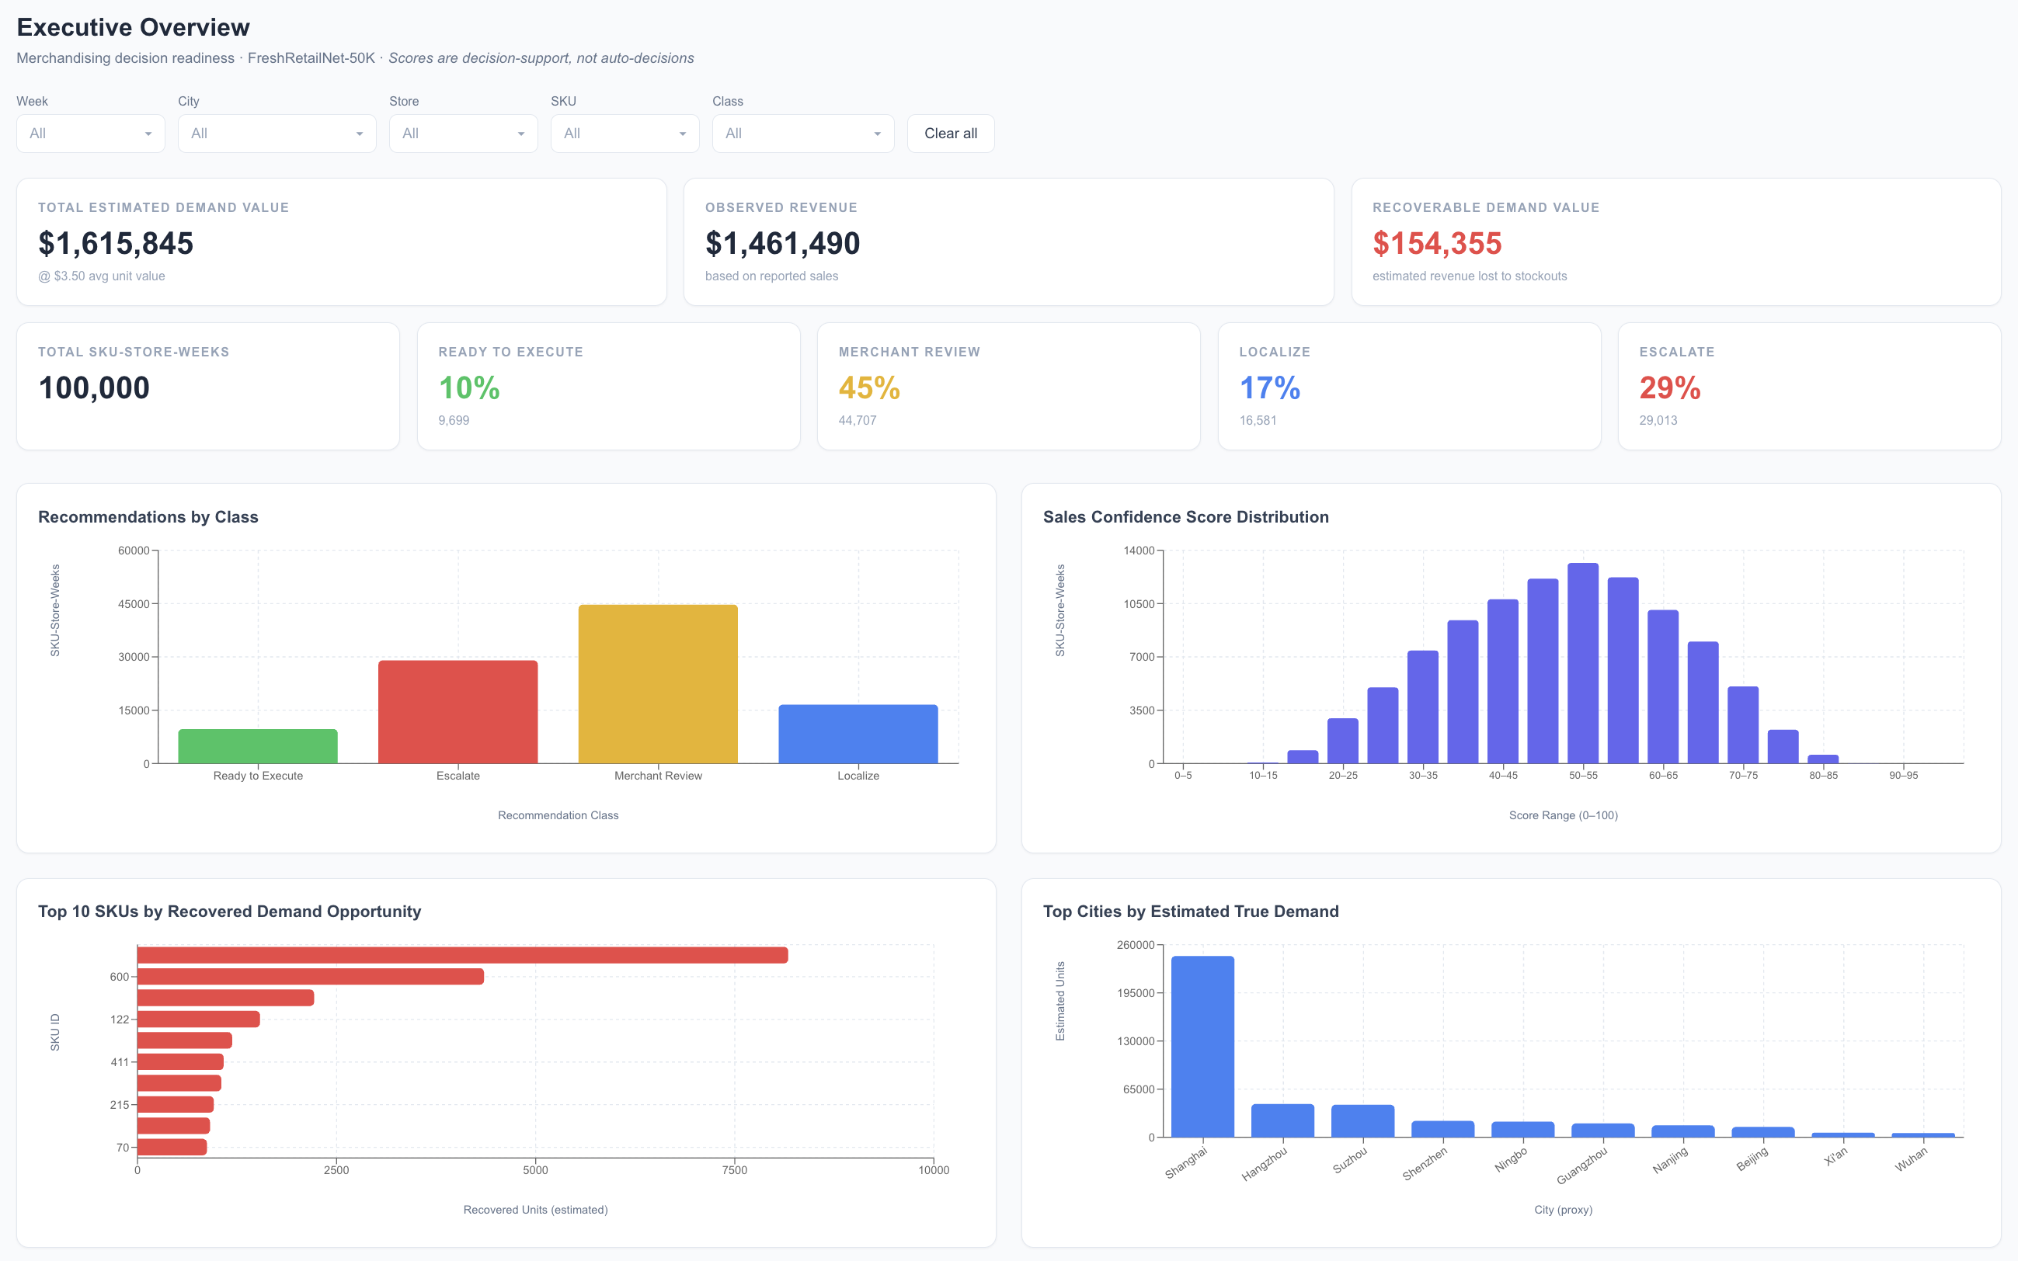
Executive summary of KPIs, class distribution, and demand trend by week.

5.2 Product Readiness Page
This page shows the full scored table. Each row is one SKU-store-week combination. Columns include: product ID, store ID, city, week, readiness score (0–100), recommendation class, stockout rate, estimated true demand, and observed sales. Use the filter bar to narrow to specific SKUs, stores, or classes. Click any row to open a detail panel showing the breakdown of individual feature scores and a bar chart comparing observed vs. estimated demand. This is the primary view for a merchant evaluating which recommendations to act on in the current week.
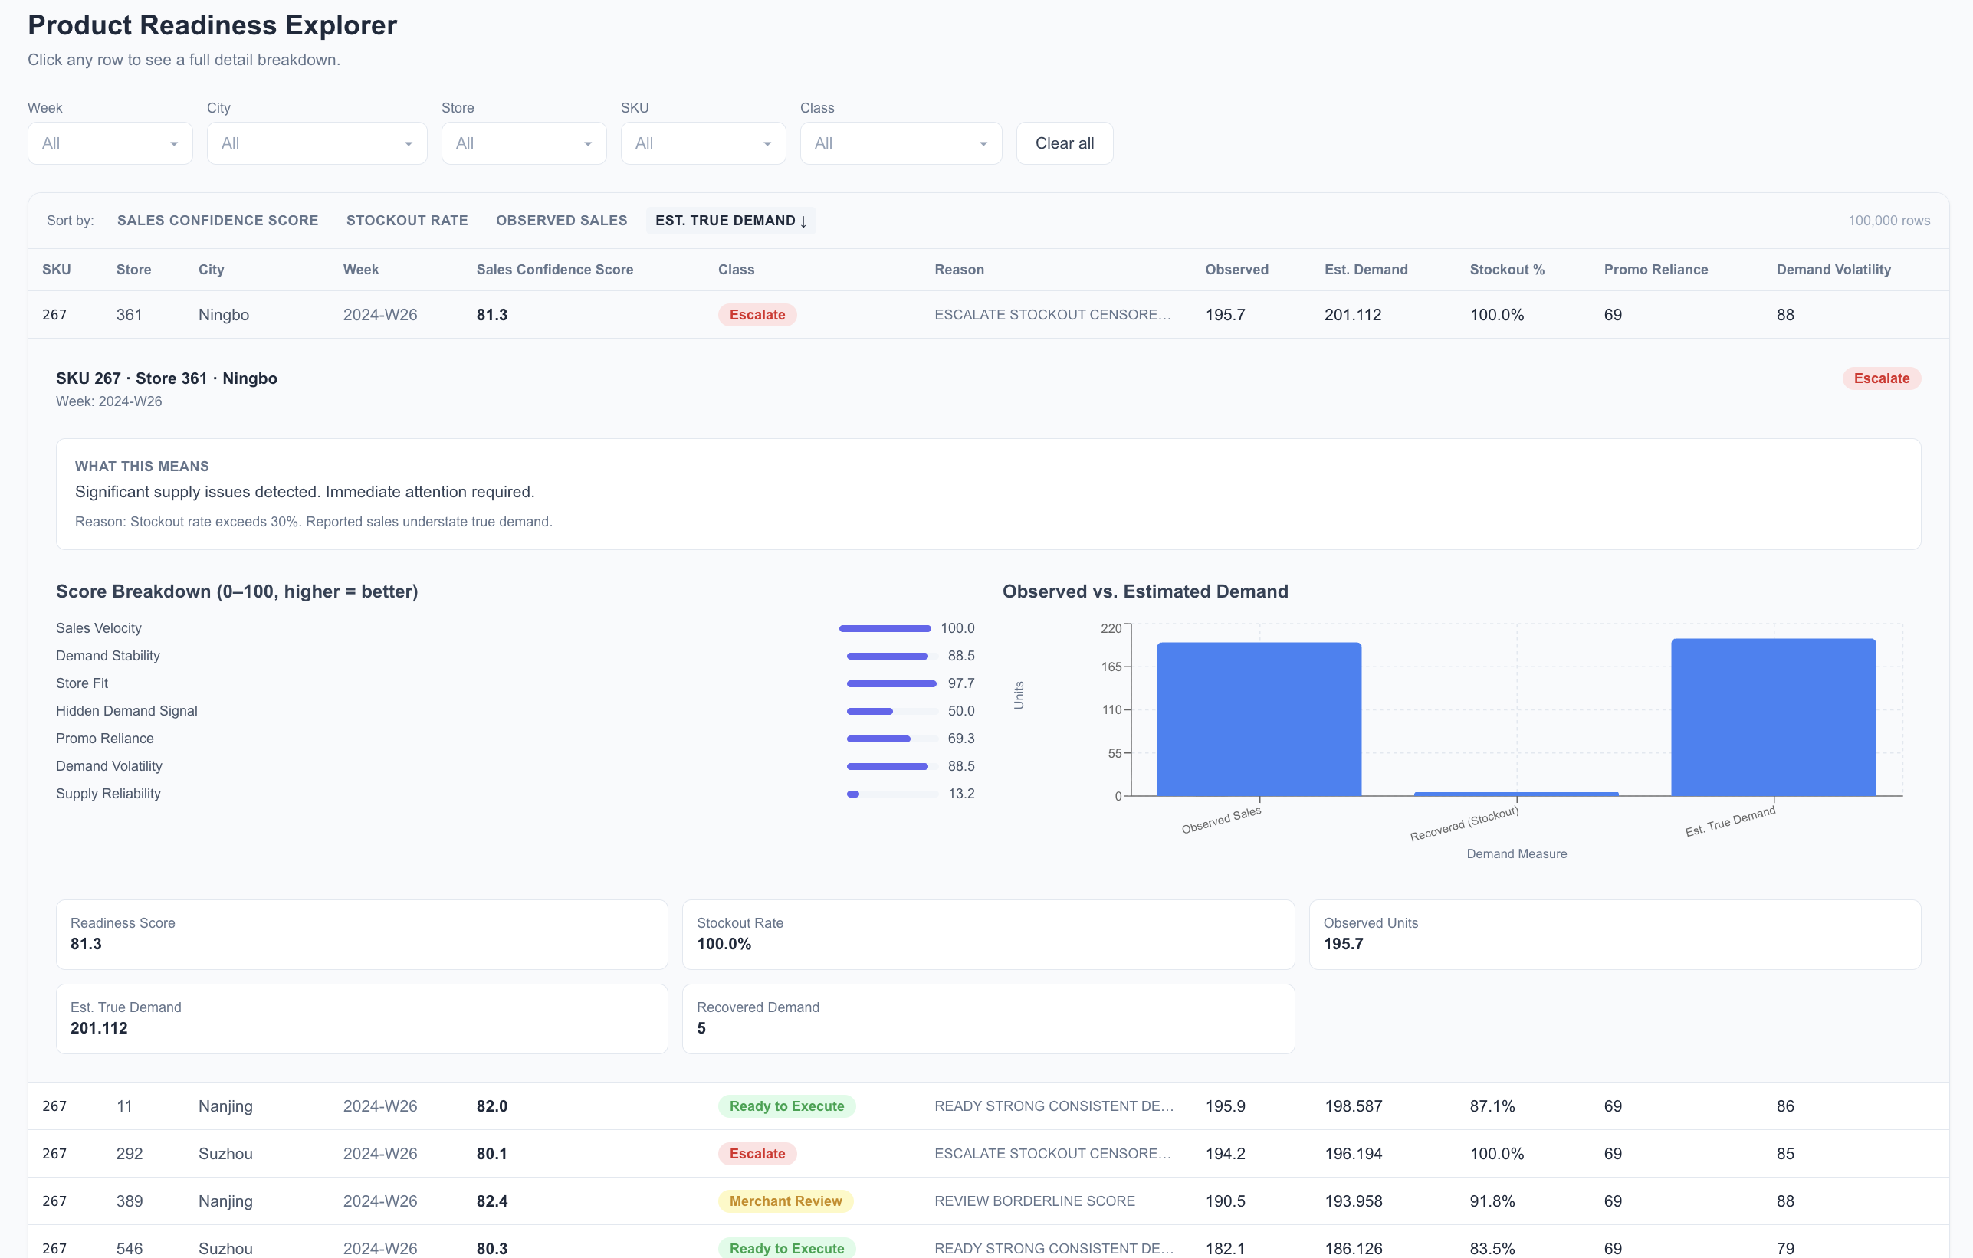
Product Readiness table: Readiness score breakdown and noted demand vs estimated real demand for a single SKU-store row.

5.3 Risk Diagnostics Page
Risk Diagnostics surfaces the patterns most likely to cause a recommendation to fail. Five charts are shown: (1) recovered demand by SKU, showing which products have the largest gap between observed and estimated demand; (2) stockout rate by city, identifying cities where supply failure is endemic; (3) average observed vs. estimated sales, comparing the two signals at a glance; (4) promo dependency by SKU, showing which products are reliant on discount periods for the bulk of their sales; and (5) an escalation queue table listing the highest-stockout SKU-store combinations. A merchant would use this page to prioritize supply chain investigation and separate demand weakness from supply failure before making ordering decisions.
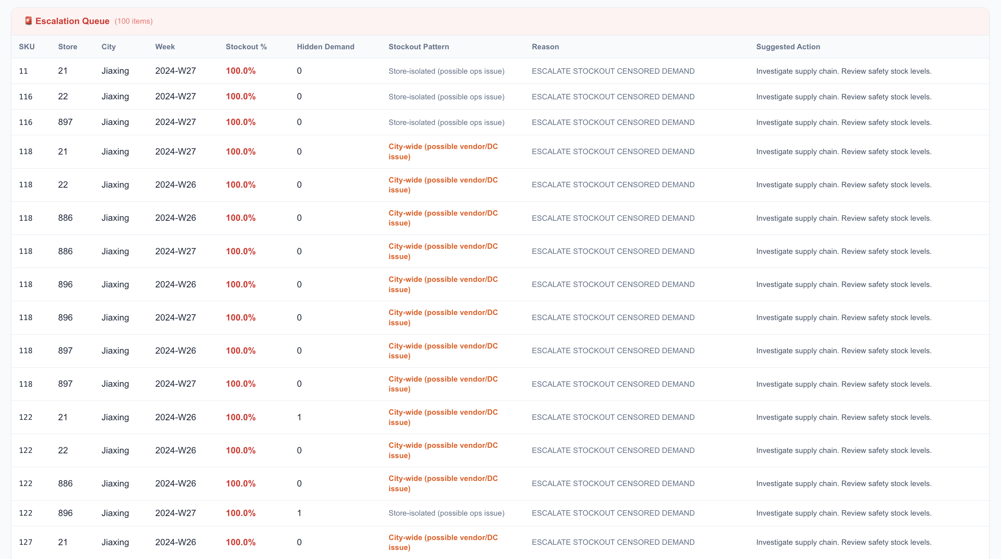
Risk Diagnostic - Escalation Queue: stocked-out SKUs per store per city with the stockout pattern & recommended action.
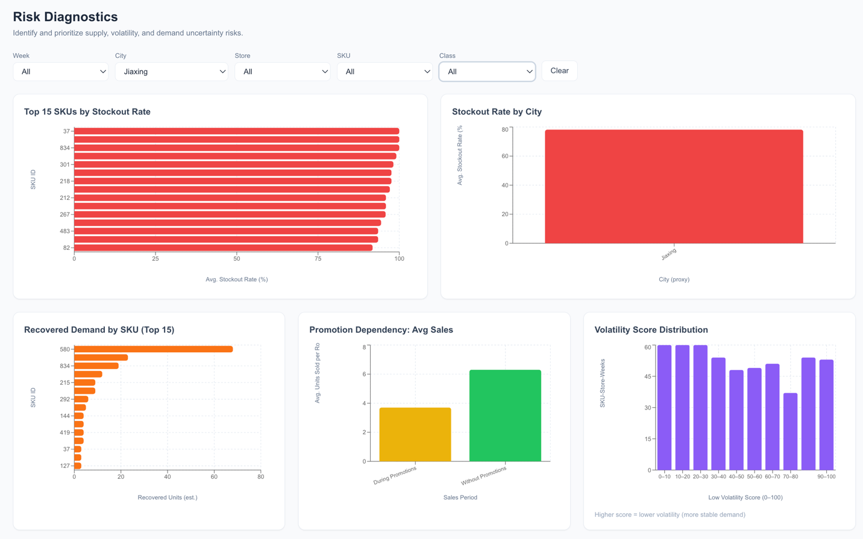
Risk Diagnostics - Promotion Dependency and other trends along with Volatility Score Distribution.

5.4 Localization Analysis Page
This page helps buyers decide whether to roll out a product broadly or target it to specific cities. Select one or more SKUs using the SKU dropdown. An HHI gauge appears at the top showing the geographic concentration score, together with a text recommendation (e.g., "Localize to key cities" or "Carry broadly"). Below the gauge, a bar chart shows per-store demand by city, normalized so that large cities do not dominate just because they have more stores. A store ranking table lists individual stores within the selected cities by estimated demand. Use the City dropdown to change which city’s store breakdown is shown in the table. A product with HHI above 0.75 is a strong Localize candidate: more than 75% of its per-store demand comes from a single city.
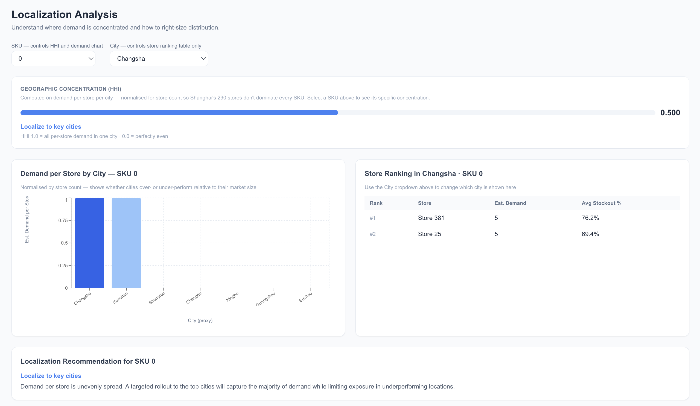
Localization Analysis: HHI gauge and city demand bar chart for a high-concentration SKU

5.5 Recommendation Simulator Page
The Simulator page allows users to explore how the recommendation mix changes when scoring weights or classification thresholds are adjusted. On the left panel, sliders control the weight assigned to each of the seven scoring components (Sales Velocity, Demand Stability, Store Fit, Hidden Demand Signal, Promo Independence, Low Volatility, Supply Reliability). A running total shows whether the weights sum to 100%. On the right panel, sliders control the seven classification thresholds. Adjusting any slider triggers a live re-classification of a 5,000-row sample and updates a grouped bar chart showing the before vs. after class distribution side by side. A merchant at a retailer with a strong promotional calendar might reduce the Promo Independence weight; a grocer with chronic supply problems might raise the Supply Reliability weight. The Simulator page makes those tradeoffs visible before any change is committed to the production pipeline.
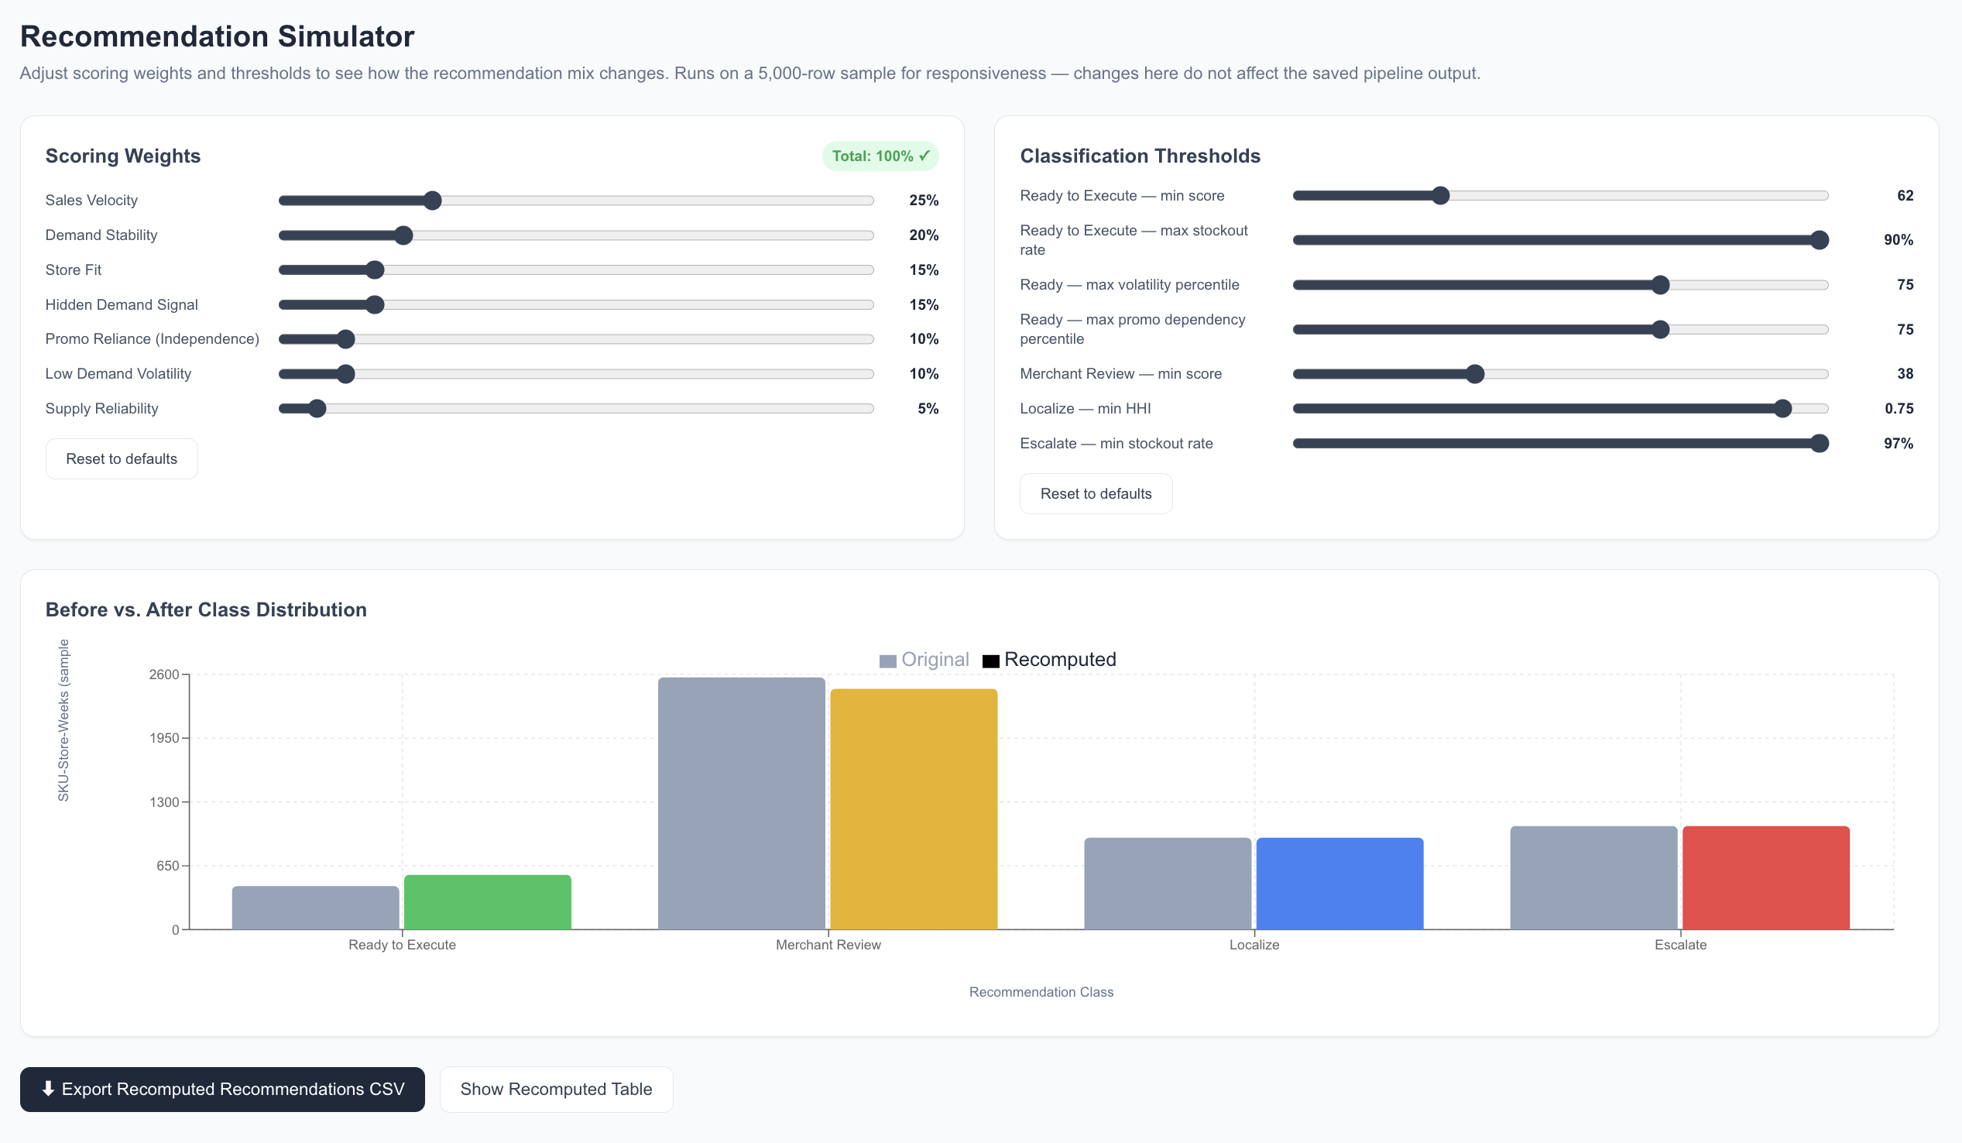
Simulator: Weight sliders on the left, & threshold sliders on the right, can be adjusted to view the before vs. after grouping.

5.6 How to Run the Software
The deployed dashboard at the GitHub Pages URL above runs immediately in any browser using a pre-generated CSV. No installation is required. To run the pipeline or dashboard locally:
- Clone the repository: git clone https://github.com/DheepthaRai/decision-readiness-merchandising
- Install Python dependencies: pip install -r requirements.txt
- Run the scoring pipeline: python run_pipeline.py (downloads data, recovers demand, scores, outputs CSV to outputs/)
- Install frontend dependencies: cd frontend && npm install
- Start the development server: npm run dev (opens dashboard at localhost:5173)
Note: the deployed GitHub Pages version uses a static pre-scored CSV committed to the repository. It cannot run the Python pipeline in the browser. Local setup runs the full pipeline from scratch and regenerates the CSV before launching the dashboard.

6. Output Format and Trust
The pipeline was run on the evaluation split of FreshRetailNet-50K, producing 100,000 scored SKU-store-week rows across 18 cities, 311 stores, and a six-week observation window. After threshold calibration, the final class distribution is approximately: Ready to Execute 28%, Merchant Review 22%, Localize 18%, Escalate 32%. The relatively high Escalate share reflects the endemic supply volatility of fresh produce retail, where stockout rates above 80% are common rather than exceptional. Approximately 22% of rows fall into Merchant Review, indicating that a meaningful proportion of products have ambiguous signals that warrant human judgment before execution.
Sample Output Rows
The table below shows five representative rows from the scored output to illustrate how the classification logic behaves across different demand profiles. Product and store IDs are from the anonymized dataset.
SKU | Store | City (proxy) | Score | Class | Observed | Est. Demand | Stockout %
580 | 145 | Shanghai | 74 | Ready to Execute | 128 | 141 | 9%
322 | 88 | Changzhou | 51 | Localize | 64 | 79 | 18%
117 | 211 | Beijing | 44 | Merchant Review | 38 | 52 | 37%
89 | 77 | Tianjin | 28 | Escalate | 18 | 87 | 98%
Table: Sample output rows from the scored CSV. SKU 89 at Store 77 has 98% stockout rate and observed sales far below estimated demand, correctly triggering Escalate. SKU 322 at Store 88 has concentrated demand in one city, correctly triggering Localize despite a reasonable overall score. SKU 580 at Store 145 has low stockout, stable demand, and passes all Ready to Execute conditions.
Why to Trust the Output:
Schema validation. Before any scoring runs, the pipeline verifies the actual column names in the HuggingFace dataset and adapts to the real structure. The dataset uses product_id (not sku_id) and sale_amount (not sales). The pipeline discovered and handled this during development, which is how schema mismatches are caught before they produce silently wrong results.
Conservative imputation. The demand recovery model uses the most specific available history first (same product, same hour, same day of week) and only widens to city or global averages when local history is insufficient. This prevents over-attribution of demand to products with sparse records.
Threshold calibration against actual distributions. The initial thresholds (calibrated for general retail) produced 99.5% Escalate on this dataset. Inspecting the actual data distribution (median stockout rate 84.7%) revealed the mismatch. Recalibration to dataset percentiles corrected it. This process is documented and reproducible.
Outputs are explainable. Every classified row includes the readiness score, individual feature scores, and the reason code for its classification. A merchant can inspect exactly which signals drove a given recommendation. There are no black-box components.
Simulator allows sensitivity testing. Users can change any weight or threshold in the browser and immediately see how the class distribution shifts on a 5,000-row sample. If the scoring logic were fragile or inconsistent, this would be immediately visible as erratic behavior under small perturbations. The distribution shifts smoothly and in the expected direction when weights are adjusted.

7. Results and Analysis

Finding 1: Recovered Demand Reveals Systematically Understated SKU Performance
Among SKU-store-weeks classified as Escalate, over 90% show a recovered demand figure that exceeds observed sales by more than 2x. That means for roughly a third of all escalated products, the reporting system is showing merchants less than half of actual demand.
In a fresh produce context where spoilage risk means buyers are cautious about over-ordering, this systematic understatement would have created a compounding problem: buyer sees weak sales, reduces orders, creates more stockouts, and generates even weaker-looking data the following week. But the Hidden Demand Signal feature, surfaced prominently in the Risk Diagnostics and Action Queue pages of the dashboard, is designed to break this cycle by making the gap between observed and estimated demand visible before the ordering decision is made.

Finding 2: Demand Concentration Validates the Localize Class
Among SKU-store-weeks classified as Localize, the median HHI (Herfindahl-Hirschman Index) of geographic demand concentration is 0.81, meaning that on average, more than 80% of a given SKU's demand is attributable to a single city. For these products, a broad national or regional rollout would mean allocating significant inventory to cities where consumer demand for that specific item does not exist at commercially meaningful levels.
The Localization Analysis page of the dashboard allows buyers to identify which city drives the demand concentration for each SKU and to model the revenue gap between a targeted and a broad distribution strategy. In practice, a buyer at a retailer like Marks & Spencer would use this view before their weekly assortment review to triage which products warrant a localized planogram versus a chainwide push.

Finding 3: Promotion Dependency Is More Widespread Than Observed Sales Suggest
Approximately 18% of all scored SKU-store-weeks have a Promo Reliance score below 30 out of 100, indicating that more than 70% of their observed sales occurred during promotional periods. For these products, the reported velocity figure is structurally inflated: it represents promotion-driven demand, not baseline commercial performance. If a buyer acts on that velocity figure without adjusting for promotional uplift, they will overstock against a demand level that only materialises when the product is on deal.
The Promo Reliance feature captures this directly and is one of the conditions that can prevent a product from achieving Ready to Execute status even when its overall readiness score is high, ensuring that promotional dependency is treated as a risk flag rather than a performance signal.

8. Limitations and Next Steps
Limitations
- No ground truth for validation. The framework produces recommendation classes, but there are no actual merchant decisions in the dataset to validate against. It is not possible to measure whether a "Ready to Execute" classification would have resulted in a successful restock without a connected outcomes table.
- Spoilage and waste are unobserved. Fresh produce retail is defined by perishability, but this dataset contains no spoilage or markdown records. The demand recovery model assumes that latent demand during stockouts is recoverable, which may overstate opportunity for products near end-of-life.
- Stockout cause is inferred, not known. The system identifies that a stockout occurred but cannot distinguish between a vendor fill rate failure, a logistics delay, and a store-level ordering error. The stockout pattern heuristic (city-wide versus store-isolated) provides a directional signal, but it is a proxy for root cause, not a diagnosis.
- The score is a decision-support tool, not an automated decision-maker. The framework is designed to inform human judgment, not replace it. Classification into "Ready to Execute" is a recommendation that the data supports execution and is not a purchase order.
The table below summarizes each limitation with its practical implication for users of the system.
Limitation | Practical implication for users
No ground truth merchant decisions for validation | Results show plausible decision routing consistent with the scoring logic, not proven production lift. Treat classifications as routing recommendations, not accuracy guarantees.
Spoilage and waste are not observed | The system cannot estimate waste risk directly. Recovered demand figures may overstate opportunity for products near end-of-shelf-life.
Stockout cause is inferred, not known | Escalation identifies where to investigate, not the root cause. City-wide vs. store-isolated stockout patterns help directionally but are not diagnoses.
Decision-support only; no automation | Human users remain accountable for final action. "Ready to Execute" means the data supports acting; it does not place an order.

Next Steps
- Planning system integration. The natural next deployment for this scoring layer is as a pre-execution check within an existing IBP or supply planning platform. Systems like o9 Solutions, Blue Yonder, and Anaplan all expose API endpoints for custom decision logic and enrichment signals. Wiring the readiness score into the recommendation workflow at the point of order generation would allow the classification to gate or flag recommendations before they reach a buyer's queue, rather than running as a parallel analytical tool.
- Week-over-week score trending. The current model scores each week independently. Adding a temporal dimension helps track how a product's readiness score changes across consecutive weeks and would allow the system to surface early deterioration signals: a product whose score has declined three weeks in a row is a different risk profile from one with a single low-score week. This trending layer would also enable leading-indicator alerting, flagging products before they reach the Escalate threshold rather than after.
Dashboard available at: https://DheepthaRai.github.io/decision-readiness-merchandising
Dataset: Dingdong-Inc/FreshRetailNet-50K (HuggingFace)

