Assignment 1 – UI/UX
Dheer Ramnani
1032231709
Panel D ( D2 )
Critical Analysis of Indeed.com
an internationally available web-application that connects workers and recruiters , indeed.com is a leading global job board that serves as a comprehensive search engine for positions across all employment sectors, bridging the gap between millions of diverse jobseekers and global employers. Unlike regional mobile-first applications, Indeed operates on a powerful, cross-platform architecture designed to aggregate millions of listings from corporate career pages, recruiting agencies, and direct postings. Because its universal user base ranges from entry-level laborers to executive professionals, Indeed's interface prioritizes functional utility and data density over visual flair. The platform flawlessly handles high-stakes interactions by offering an iconic, dual-field search engine that delivers instant results, yet its sprawling homepage layout and extensive algorithmic filtering reveal a distinct operational balance. The desktop-first framework constantly navigates the complex tension between providing a streamlined, user-friendly application funnel for candidates and optimizing massive directories for automated search-engine indexing.
- Parameter | Description
Learnability –
Indeed’s minimalist layout maximizes immediate learnability by utilizing a familiar, Google-like dual-search bar. The clear placeholder text instantly communicates its core purpose: inputting a job title and location to start searching.
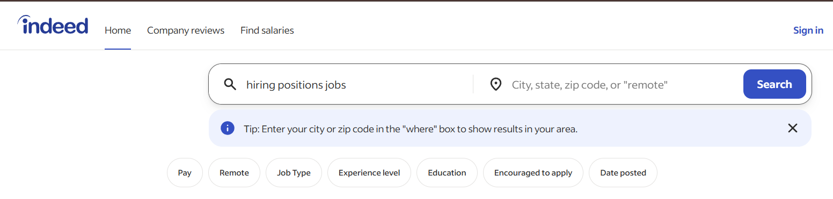

Usability –
The search interface split-design features a magnifying glass icon inside the "what" field paired with an explicit, high-contrast blue Search button on the far right. Rather than creating functional ambiguity, this design effectively guides the eye across the dual-input structure, defining a clear starting point on the left and a decisive, actionable conclusion on the right.
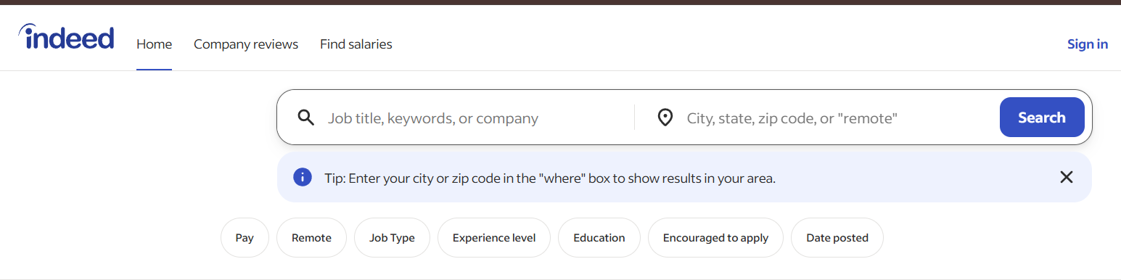

Consistency
Indeed demonstrates high global consistency by maintaining a uniform visual language across its core pages, though minor structural shifts occur to accommodate specialized features.
Visual and Brand Uniformity
- Color Palette: The signature deep blue brand color is strictly reserved for high-priority user actions across all pages,
- Typography and Hierarchies: Font styling remains highly standardized
- UI Elements: Component design stays uniform
Consistency Critique
- While Indeed maintains a highly unified color palette, a closer inspection across these interfaces reveals several structural discrepancies and broken interaction patterns that disrupt user expectations.

Search Architecture Discrepancies
- Inconsistent Fields: Job search uses a dual-input "What/Where" layout, while company reviews drops the location field entirely, breaking the established search mental model.
- Varying CTA Labels: Primary buttons switch unpredictably between "Search", "Find Companies", and "Find jobs" for identical core search actions.
Navigation & Filter Mismatches
- Shifting Menu Links: The third global header link alternates between "Find salaries" and "Salary guide", creating disjointed navigation across sub-platforms.
- Asymmetrical Pill Buttons: Basic filter pills on the home interface randomly sprout complex dropdown counters (like "Distance 1") on the results page.

- 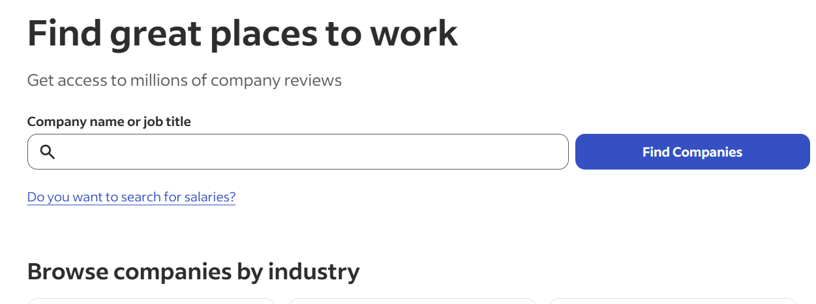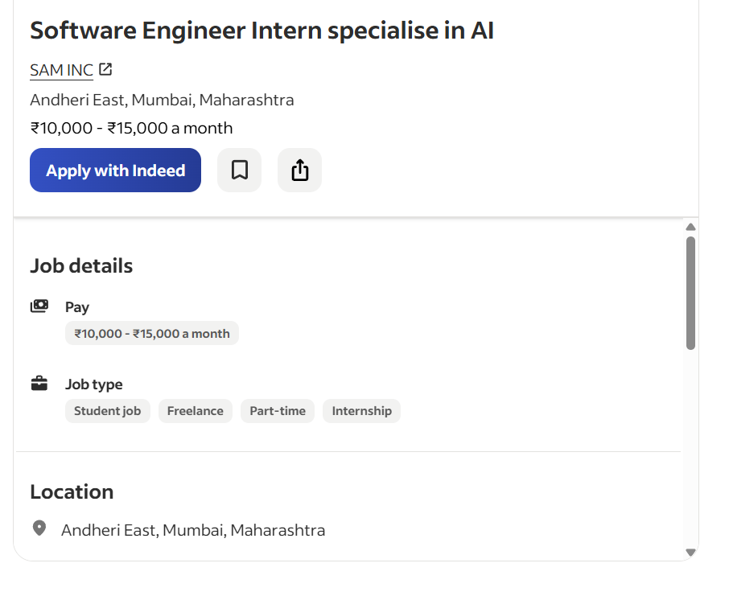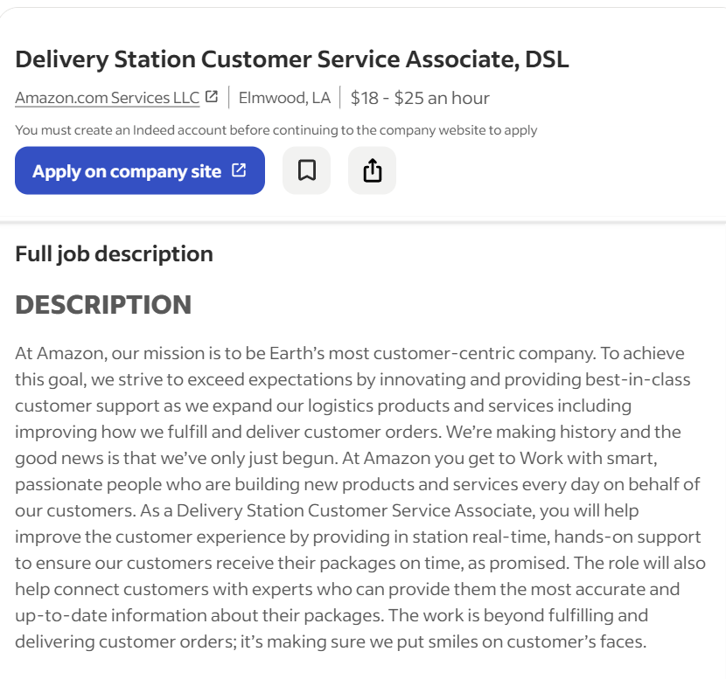

Use of Metaphors
The UI does not use as much universally recognised iconography to streamline navigation, however utilizing magnifying glasses for search functions, buildings for corporate entities, houses for remote positions, and briefcases for distinct job categories and cash symbol for salary
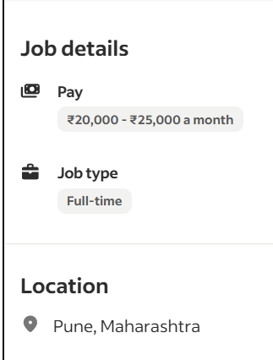

Navigation Structure
The top navigation clearly separates major sections into Jobs, Companies, Services, and For Employers, allowing users to move between different areas without confusion.

Visual Hierarchy
The layout leverages a deliberate vertical hierarchy. Users are greeted first by the primary heading and search input, directing their initial focus before they seamlessly scan downward to the secondary category cards. One distince feature is the reverse hierarchy
rr
rr
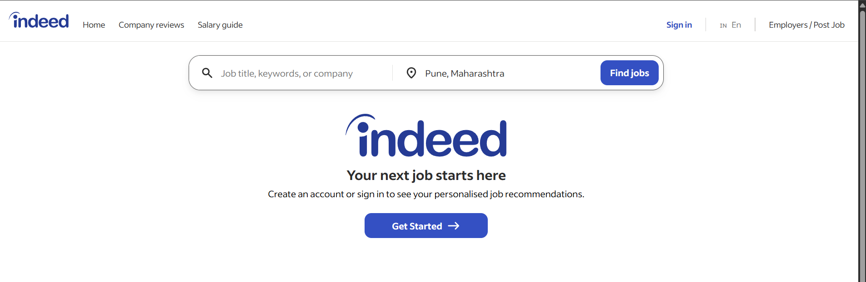

Accessibility
This layout breaks basic accessibility rules by creating a backwards visual flow. The huge central logo and "Get Started" button steal the spotlight, forcing the actual search bar into a cramped spot at the very top of the page. This unnatural setup disrupts standard reading patterns, making low-vision users or anyone using a screen reader hunt for the main tool. It adds unnecessary cognitive strain by separating the core search inputs from the central action of the page.

Responsiveness
While the layout stays centered on large monitors, the responsiveness fails because this specific desktop design cannot scale down cleanly to smaller screens without major layout overhauls.
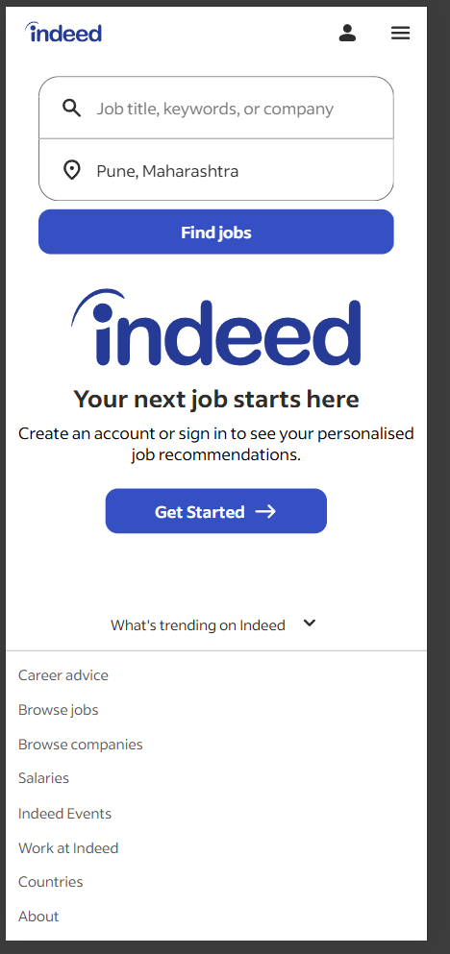
heavy visual compression is seen

Efficiency of Interaction
The landing page streamlines the user journey by offering immediate job search functionality without forced registration. Placing core filters ,like title, experience, and location—directly on the homepage eliminates unnecessary steps. Furthermore, quick-access category shortcuts for popular fields like Remote, Internship, Startup, and Marketing bypass manual typing entirely. Together, these design choices minimize friction and accelerate task completion.

Feedback and System Status
This Indeed page does a decent job showing you where you are by pre-filling the location to Pune, which lets users know the system is tracking their location correctly. The main buttons like "Find Jobs" and "Get Started" stand out good so you know exactly what action to take next. However, because it's just a blank landing page, it don't show any active feedback like a loading spinner or search progress until after you type something and hit enter.

Error Prevention and Recovery
The search layout helps prevent mistakes by keeping job titles, experience, and location in completely separate boxes. On the downside, the homepage doesn't show any helpful tips, examples, or error messages before you hit the submit button. If they added some simple placeholder examples or inline hints, it would really clear things up and make the whole search experience a lot smoother for users.

Aesthetic and Minimalist Design
The clean, uncluttered layout keeps the entire focus on the search bar. By removing unnecessary banners, ads, and walls of text, the interface drastically reduces cognitive load for job seekers. It gets users straight to the point without any distracting noise. However, the extreme lack of content leaves a massive amount of empty white space below the fold. This can make the page feel a bit sterile or unengaging before a user actively interacts with it.

Content Readability
The website presents information using large headings, readable typography and well-spaced content cards that are easy to scan. Job roles, company names and descriptions are grouped logically, allowing users to distinguish information without difficulty. The consistent typography and spacing contribute to an overall pleasant reading experience.


Search and Discoverability

The homepage delivers a highly efficient, intent-driven user experience by stripping away visual clutter and prioritizing a familiar, side-by-side search bar layout that reduces cognitive load. Automatically populating the location field instantly streamlines the user journey, while the clear top navigation provides direct paths to high-value secondary resources like company reviews and salary data. However, the strict reliance on keyword search creates a cold-start barrier for exploratory users who might benefit from visible industry categories or trending job tags. Additionally, completely locking personalized recommendations behind an account wall misses an opportunity to showcase platform value through dynamic, location-based job previews prior to authentication.

Performance Perception
The clean layout and organized structure make this interface feel fast and reliable. Clearly separated sections and balanced visual elements keep scrolling smooth and natural. Even without exact speed metrics, the platform looks highly responsive and well-optimized during daily use.

Trust and Credibility
the Indeed homepage does not feature government recognition, enterprise partnerships, or user testimonials to establish trust. The layout completely omits company logos, user ratings, and placement stories, leaving the platform without immediate on-screen cues to reinforce its credibility to new visitors.
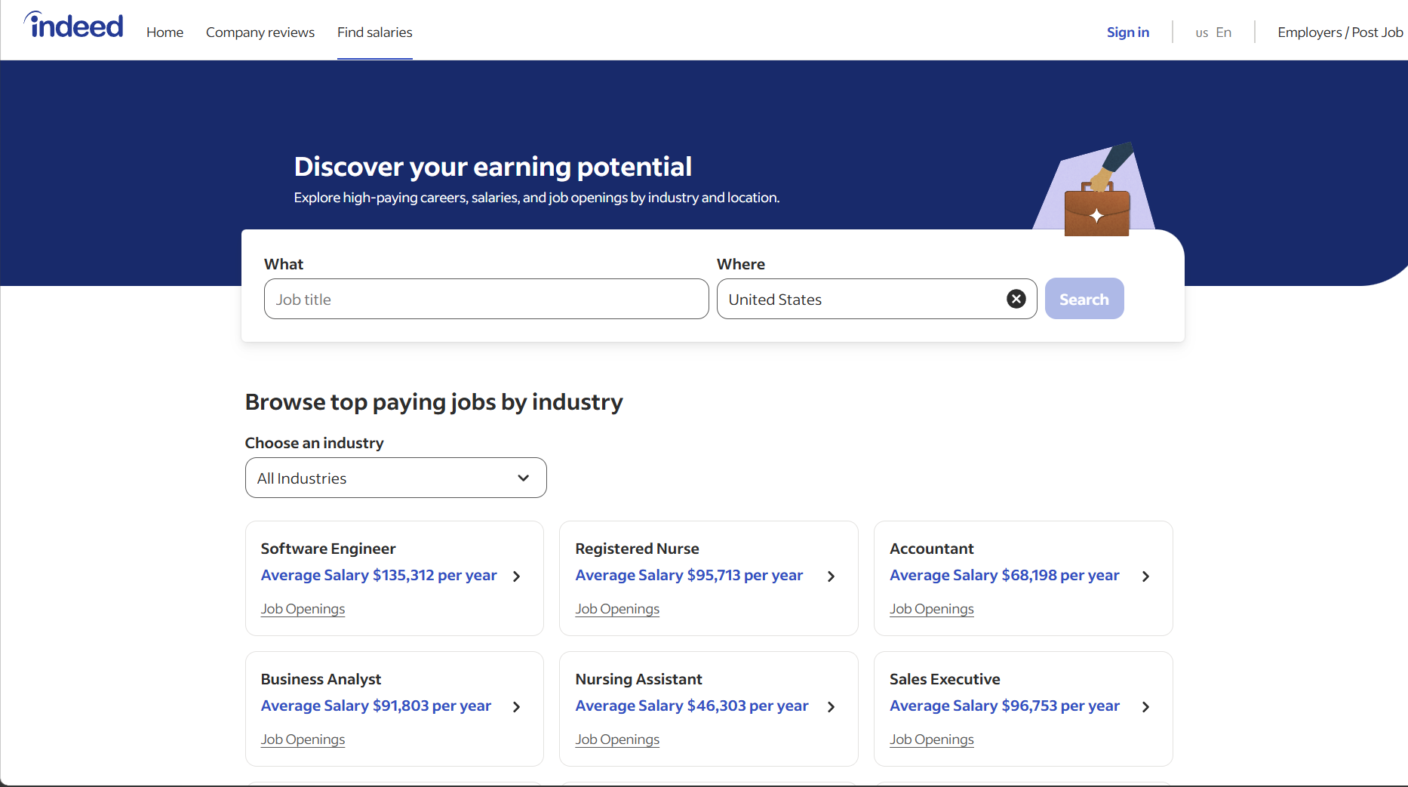

User Satisfaction
The Indeed landing page effectively optimizes user satisfaction by prioritizing a clean, minimalist layout that eliminates cognitive overload and guides users directly toward their primary goal. The immediate visibility of the familiar corporate branding establishes quick platform trust, while the singular, high-contrast blue call-to-action button creates a frictionless entry point for both new and returning users. Clear, concise subtext sets accurate expectations about personalized job recommendations to incentivize sign-ups without overwhelming the viewport with unnecessary decorative elements. This highly focused, task-oriented approach minimizes search time and interaction cost, resulting in strong initial user satisfaction and high conversion rates for the core user flow.

4. Conclusion
Indeed's interface thrives on aggressive functional minimalism. The hyper-focused landing page, the immediate dual-input search layout (What/Where), and the clear separation of job seeker versus employer entry points minimize early decision fatigue. However, the platform's primary weakness is its foundational prioritization of indexing efficiency over progressive visual disclosure. Once users bypass the simplified gateway, massive clusters of dense, text-heavy categorical links built for search engine indexing dominate the lower real estate. This heavy structural reliance on static indexing undermines the modern, spacious hierarchy initiated at the top, increasing cognitive load for desktop users looking for browse-based discovery.
Recommendations
- Introduce expandable or accordion-style category trays for footer and deep-page directory lists to preserve structural SEO value without cluttering primary human sightlines.
- Dynamicize the initial search experience by embedding micro-filters like salary baseline, remote availability, and experience level as contextual dropdowns right beside the main query inputs.
- Elevate technical white space usage and visual hierarchy across secondary pages to ensure the clean aesthetic from the login gateway remains consistent across dense data tables.
- Implement personalized historical shortcuts, converting static link fields into smart, interactive search suggestions based on the user's active job tracking profile.

Evaluation Against Shneiderman's Eight Golden Rules
Website Evaluated: Indeed.com
# | Golden Rule | Observation (from screenshots) | Verdict | Suggestion
1 | Strive for consistency | Nav bar (Home, Company reviews, Salary guide, Sign in) and search bar layout stay identical across the homepage and results page. Blue CTA buttons ("Find jobs", "Apply with Indeed") use the same color and style throughout. | Met | None needed - this is a solid point in the evaluation.
2 | Enable frequent users to use shortcuts | No visible keyboard shortcuts or saved-search quick filters on the homepage; returning users must retype job title and location every time (no autofill or recent searches shown). | Partially Met | Add a recent searches dropdown or saved-search chips for repeat users.
3 | Offer informative feedback | The search results page clearly states "did not match any jobs" with reasoning, and shows job type tags (Internship, Full-time). Good real-time labeling of system status. | Met | None needed.
4 | Design dialogs to yield closure | No confirmation or success screen is visible in the available screenshots, but the "Apply with Indeed" button implies a completed action once clicked. Cannot fully confirm the closure step from current evidence. | Not Verified | Recommend confirming a clear "Application Submitted" screen exists; note as a limitation of available screenshots.
5 | Offer simple error handling | The zero-results state does not just say "no results" - it gives three actionable suggestions (broader keywords, check spelling, remove abbreviations) and also shows similar jobs. Strong recovery design. | Met (strong point) | Highlight this as a best-practice example in the report.
6 | Permit easy reversal of actions | No explicit "back" or "undo" button is visible in these screenshots; the browser back button appears to be the only implied way to reverse a search. | Partially Met | Add an explicit "Clear filters" or "Edit search" button near the results.
7 | Support internal locus of control | The user can freely edit job title, location, and filters (Distance, Date posted) without forced steps, giving a sense of user-driven control rather than system-driven flow. | Met | None needed.
8 | Reduce short-term memory load | Search fields stay pre-filled and visible at the top of the results page, so the user does not need to remember what they searched. Good persistence of context. | Met | None needed.

