# Ex: 1 An application that uses GUI components, Fonts, Colours Date: 18/08/2022

**Aim:**

To create a mobile application that uses GUI components, fonts, and colours.

# Code:

import 'package:flutter/material.dart';

void main() {

  runApp(MaterialApp(

    home: Home(),

  ));

}

class Home extends StatelessWidget {

  const Home({Key? key}) : super(key: key);

  @override

  Widget build(BuildContext context) {

    return Scaffold(

      appBar: AppBar(

          title: Text("Hello World"),

          centerTitle: true,

          backgroundColor: Color.fromARGB(255, 34, 126, 255)),

      body: Center(

        child: Text(

          "Hello World",

          style: TextStyle(

            fontSize: 45.0,

            fontWeight: FontWeight.bold,

            letterSpacing: 2.0,

            color: Colors.blueGrey[600],

            fontFamily: 'Arial',

          ),

        ),

      ),

      floatingActionButton: FloatingActionButton(

        onPressed: () {},

        child: Text("+"),

        backgroundColor: Color.fromARGB(255, 34, 126, 255),

      ),

    );

  }

}

# Output:

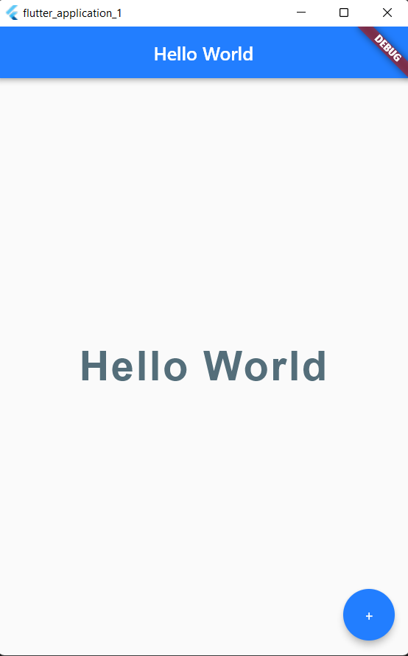

**Result:**

A mobile application which uses GUI components, fonts, and colours has been implemented successfully

# Ex: 2 An application that uses Layout Managers and Event Listeners Date: 25/08/2022

**Aim:**

To create a mobile application that uses Layout Managers and Event Listeners

# Code:

import 'package:flutter/material.dart';

void main() {

  runApp(const MaterialApp(

    home: Home(),

  ));

}

class Home extends StatefulWidget {

  const Home({Key? key}) : super(key: key);

  @override

  State<Home> createState() => _HomeState();

}

class _HomeState extends State<Home> {

  int projects = 0;

  @override

  Widget build(BuildContext context) {

    return Scaffold(

      backgroundColor: Color.fromARGB(255, 223, 223, 225),

      appBar: AppBar(

        title: Text("Sample layout"),

        backgroundColor: Colors.black12,

        centerTitle: true,

        elevation: 0.0,

      ),

      body: Padding(

        padding: EdgeInsets.fromLTRB(30.0, 40.0, 30.0, 0.0),

        child: Column(

          crossAxisAlignment: CrossAxisAlignment.start,

          children: <Widget>[

            Center(

              child: CircleAvatar(

                backgroundImage: AssetImage('assets/flutter.png'),

                radius: 50.0,

              ),

            ),

            SizedBox(

              height: 20.0,

            ),

            Text(

              "Sample layout",

              style: TextStyle(

                color: Colors.black,

                letterSpacing: 2.0,

              ),

            ),

            SizedBox(

              height: 10.0,

            ),

            Text(

              "$projects",

              style: TextStyle(

                color: Colors.blue,

                letterSpacing: 2.0,

                fontSize: 28.0,

                fontWeight: FontWeight.bold,

              ),

            ),

            SizedBox(

              height: 20.0,

            ),

            ElevatedButton(

              onPressed: () {

                setState(() {

                  projects++;

                });

              },

              onLongPress: () {

                setState(() {

                  projects *= 2;

                });

              },

              child: Icon(

                Icons.add,

              ),

              style: ElevatedButton.styleFrom(

                primary: Colors.green,

              ),

            ),

            SizedBox(

              height: 20.0,

            ),

            ElevatedButton(

              onPressed: () {

                setState(() {

                  if (projects > 0) projects--;

                });

              },

              onLongPress: () {

                setState(() {

                  if (projects > 0) projects ~/= 2;

                });

              },

              child: Icon(

                Icons.remove,

              ),

              style: ElevatedButton.styleFrom(

                primary: Colors.deepOrange,

              ),

            ),

            SizedBox(

              height: 20.0,

            ),

            Row(

              children: [

                SizedBox(

                  width: 20.0,

                ),

              ],

            )

          ],

        ),

      ),

    );

  }

}

# Output:

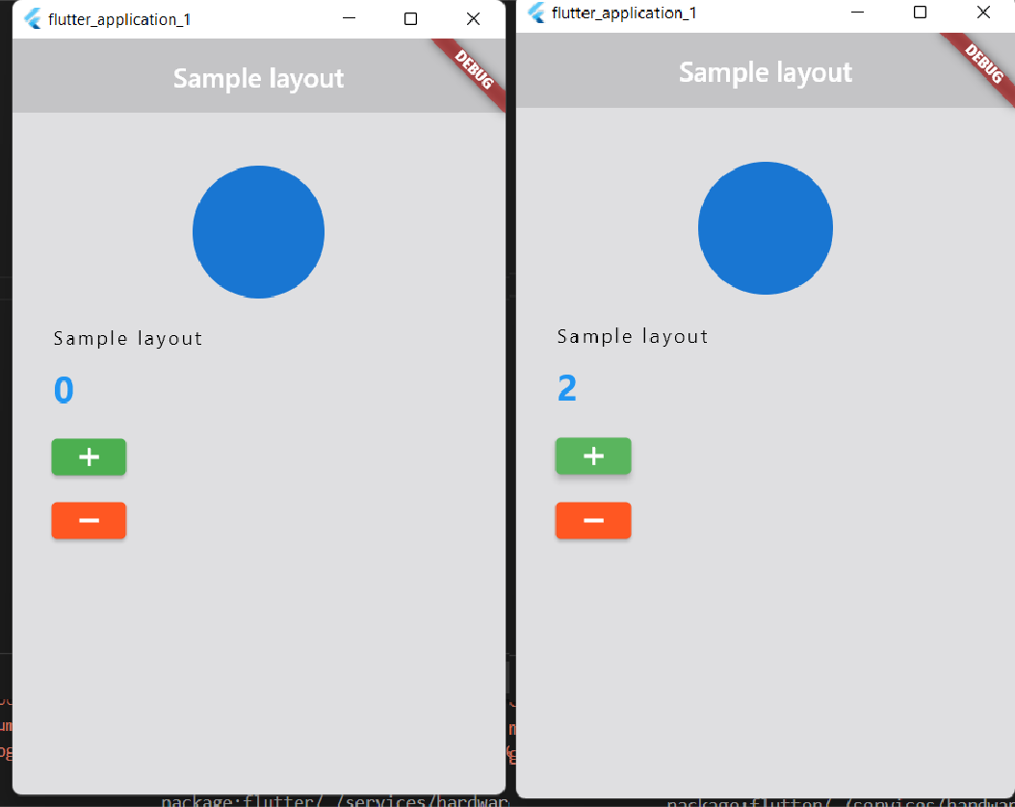

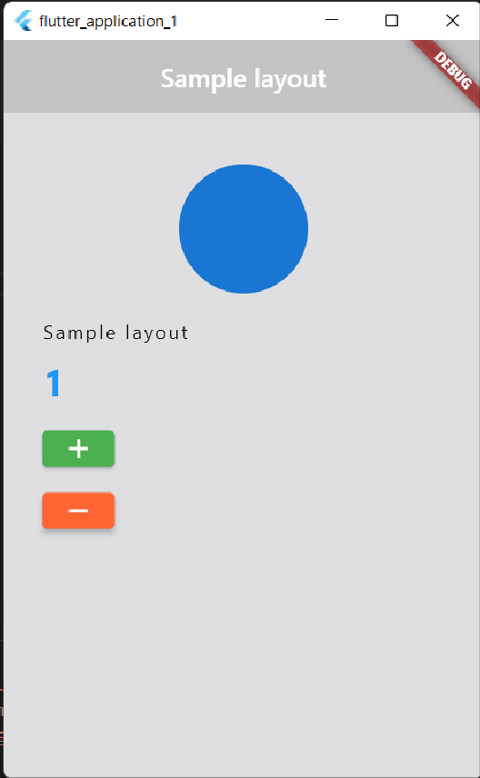

**Result:**

An application that uses layout managers and event listeners has been implemented successfully.

# Ex: 3 Creation of Calculator Application

**Date: 01/09/2022 Aim:**

To create a mobile calculator application

# Code:

import 'package:flutter/material.dart';

void main() => runApp(const MyApp());

class MyApp extends StatelessWidget {

  const MyApp({Key? key}) : super(key: key);

  @override

  Widget build(BuildContext context) {

    return MaterialApp(

      title: 'Calculator',

      theme: ThemeData(

        primarySwatch: Colors.blue,

      ),

      debugShowCheckedModeBanner: false,

      home: const MyHomePage(),

    );

  }

}

class MyHomePage extends StatefulWidget {

  const MyHomePage({Key? key}) : super(key: key);

  @override

  _MyHomePageState createState() => _MyHomePageState();

}

class _MyHomePageState extends State<MyHomePage> {

  String output = "0";

  String _output = "0";

  double num1 = 0.0;

  double num2 = 0.0;

  String operand = "";

  buttonPressed(String buttonText) {

    if (buttonText == "CLEAR") {

      _output = "0";

      num1 = 0.0;

      num2 = 0.0;

      operand = "";

    } else if (buttonText == "+" ||

        buttonText == "-" ||

        buttonText == "/" ||

        buttonText == "X") {

      num1 = double.parse(output);

      operand = buttonText;

      _output = "0";

    } else if (buttonText == ".") {

      if (_output.contains(".")) {

        return;

      } else {

        _output = _output + buttonText;

      }

    } else if (buttonText == "=") {

      num2 = double.parse(output);

      if (operand == "+") {

        _output = (num1 + num2).toString();

      }

      if (operand == "-") {

        _output = (num1 - num2).toString();

      }

      if (operand == "X") {

        _output = (num1 * num2).toString();

      }

      if (operand == "/") {

        _output = (num1 / num2).toString();

      }

      num1 = 0.0;

      num2 = 0.0;

      operand = "";

    } else {

      _output = _output + buttonText;

    }

    setState(() {

      output = double.parse(_output).toStringAsFixed(2);

    });

  }

  Widget buildButton(String buttonText) {

    return Expanded(

        child: OutlinedButton(

      style: OutlinedButton.styleFrom(

        shape: RoundedRectangleBorder(

          borderRadius: BorderRadius.circular(0.0),

        ),

        side: const BorderSide(width: 1, color: Colors.grey),

        minimumSize: const Size.fromHeight(

            50.0), // Set this padding: EdgeInsets.zero, // and this

      ),

      child: Text(

        buttonText,

        style: const TextStyle(fontSize: 20.0, fontWeight: FontWeight.bold),

      ),

      onPressed: () => buttonPressed(buttonText),

    ));

  }

  @override

  Widget build(BuildContext context) {

    return Scaffold(

        appBar: AppBar(

          title: const Text("Calculator"),

        ),

        body: Column(

          children: <Widget>[

            const Expanded(

              child: Divider(

                color: Colors.white,

              ),

            ),

            Column(children: [

              Container(

                  alignment: Alignment.centerRight,

                  padding: const EdgeInsets.symmetric(

                      vertical: 24.0, horizontal: 12.0),

                  child: Text(output,

                      style: const TextStyle(

                        fontSize: 48.0,

                        fontWeight: FontWeight.bold,

                      ))),

              Row(children: [

                buildButton("7"),

                buildButton("8"),

                buildButton("9"),

                buildButton("/")

              ]),

              Row(children: [

                buildButton("4"),

                buildButton("5"),

                buildButton("6"),

                buildButton("X")

              ]),

              Row(children: [

                buildButton("1"),

                buildButton("2"),

                buildButton("3"),

                buildButton("-")

              ]),

              Row(children: [

                buildButton("."),

                buildButton("0"),

                buildButton("00"),

                buildButton("+")

              ]),

              Row(children: [

                buildButton("CLEAR"),

                buildButton("="),

              ])

            ])

          ],

        ));

  }

}

# Output:

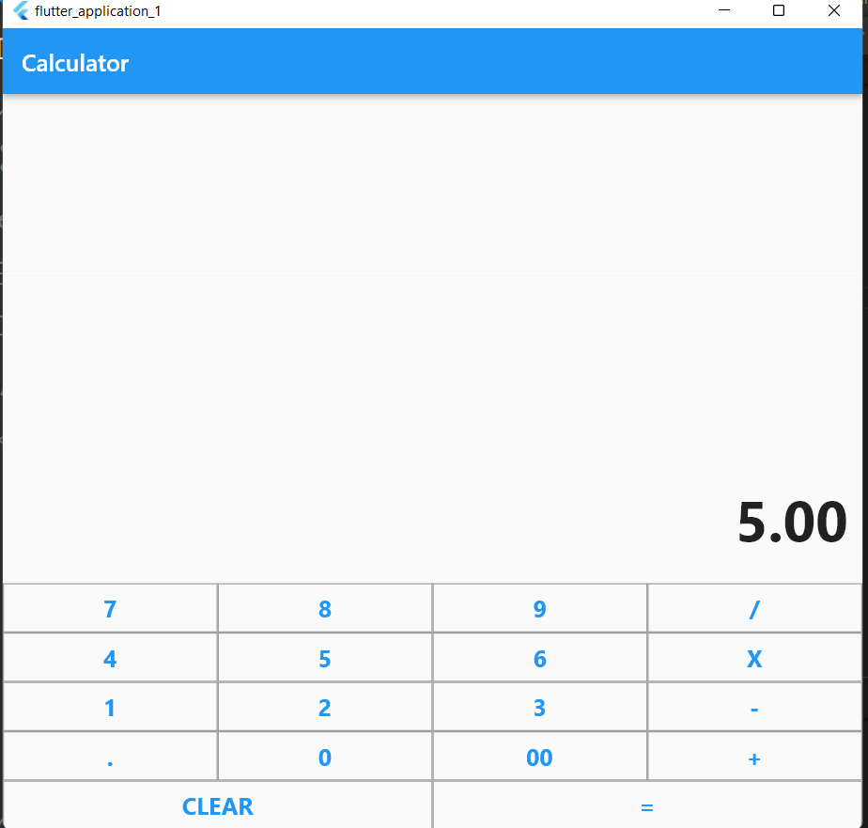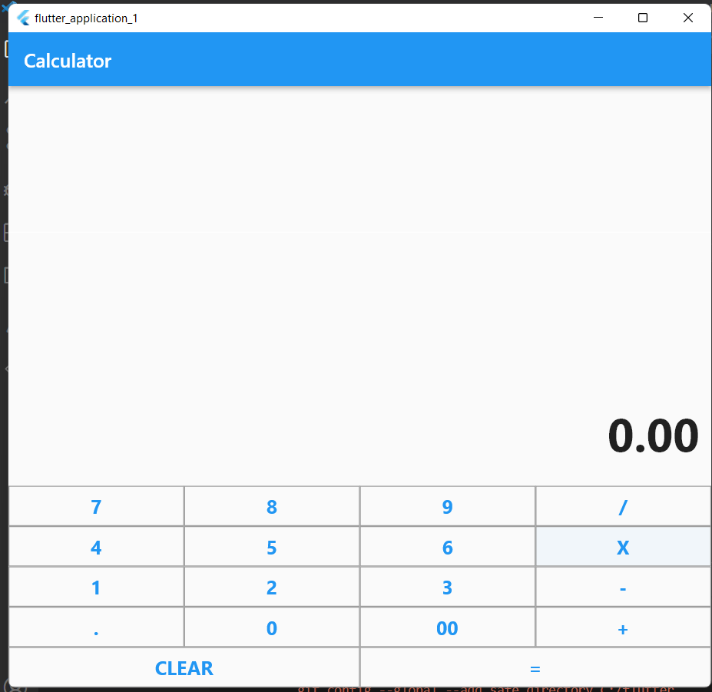

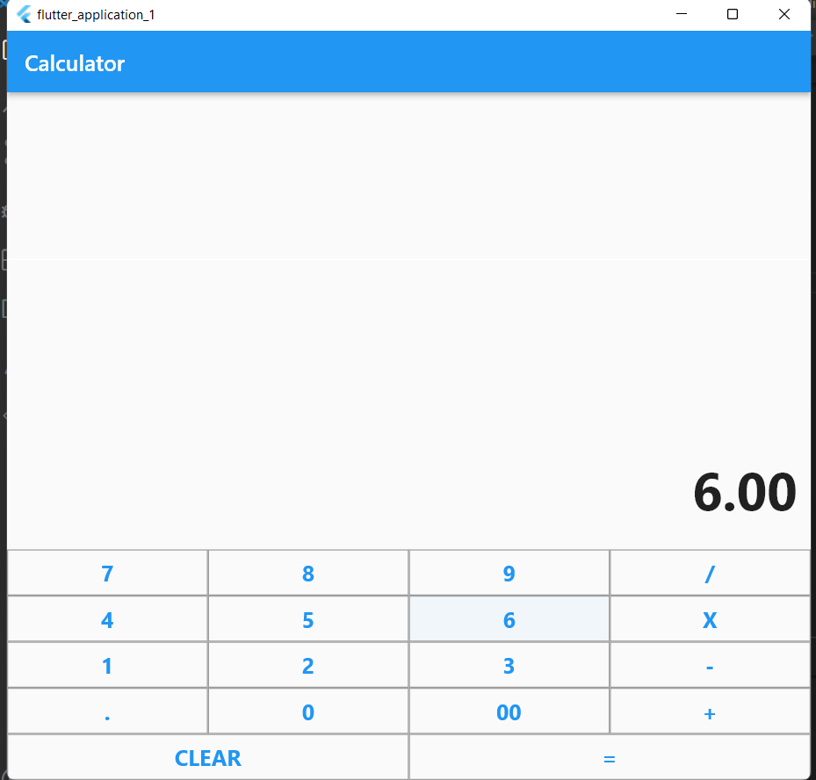

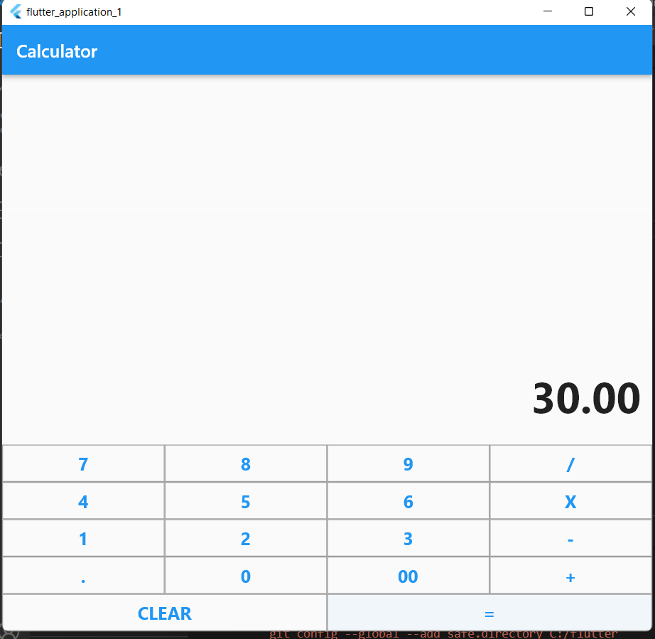

**Result:**

A calculator application for mobiles has been implemented successfully.

# Ex: 4 An application that draws basic graphical primitives on screen Date: 08/09/2022

**Aim:**

To create a mobile application that draws basic graphical primitives on screen.

# Code:

import 'package:flutter/material.dart';

final Color darkBlue = Color.fromARGB(255, 18, 32, 47);

void main() {

  runApp(MyApp());

}

class MyApp extends StatelessWidget {

  @override

  Widget build(BuildContext context) {

    return MaterialApp(

      theme: ThemeData.dark().copyWith(scaffoldBackgroundColor: darkBlue),

      debugShowCheckedModeBanner: false,

      home: Scaffold(

// Outer white container with padding

        body: Container(

          color: Colors.black,

          padding: EdgeInsets.symmetric(horizontal: 40, vertical: 80),

// Inner yellow container

          child: Container(

// pass double.infinity to prevent shrinking of the painter area to 0.

            width: double.infinity,

            height: double.infinity,

            color: Color.fromARGB(255, 126, 125, 125),

            child: CustomPaint(painter: FaceOutlinePainter()),

          ),

        ),

      ),

    );

  }

}

class FaceOutlinePainter extends CustomPainter {

  @override

  void paint(Canvas canvas, Size size) {

    final paint = Paint();

    paint.style = PaintingStyle.stroke;

    paint.strokeWidth = 4.0;

    paint.color = Color.fromARGB(255, 244, 67, 54);

    canvas.drawOval(

      Rect.fromLTWH(size.width - 120, 40, 100, 100),

      paint,

    );

    canvas.drawRect(

      Rect.fromLTWH(20, 40, 100, 100),

      paint,

    );

    final mouth = Path();

    mouth.moveTo(size.width * 0.8, size.height * 0.6);

    mouth.arcToPoint(

      Offset(size.width * 0.2, size.height * 0.6),

      radius: Radius.circular(150),

    );

    canvas.drawPath(mouth, paint);

  }

  bool shouldRepaint(FaceOutlinePainter oldDelegate) => false;

}

# Output:

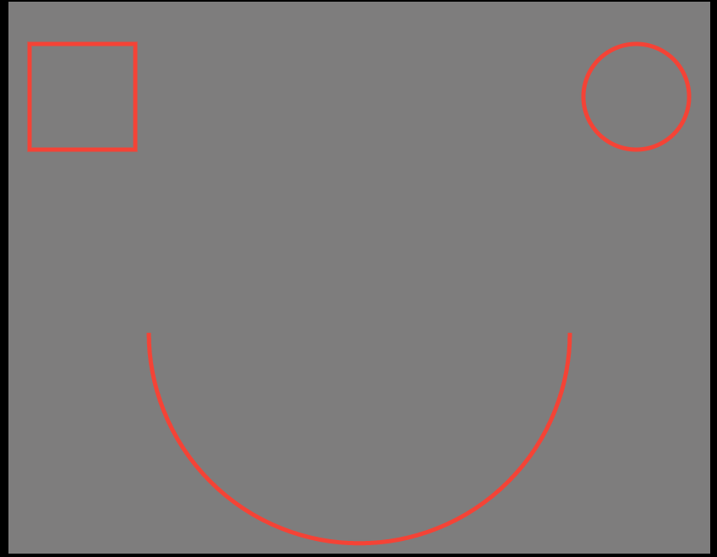

**Result:**

A mobile application that draws basic graphical primitives on screen has been implemented successfully.

# Ex.5 An application that uses database for persistent storage Date: 15/09/2022

**Aim:**

To create a mobile application that draws basic graphical primitives on screen.

# Code:

import 'package:flutter/material.dart';

import 'package:cloud_firestore/cloud_firestore.dart'; void main() => runApp(

MaterialApp(

theme: ThemeData( brightness: Brightness.light, primaryColor: Colors.blue, accentColor: Colors.orange),

home: MyApp(),

),

);

class MyApp extends StatefulWidget { @override

_MyAppState createState() => _MyAppState();

}

class _MyAppState extends State<MyApp> { List todos = List();

String input = ''; createTodos() {

DocumentReference documentReference = Firestore.instance.collection('MyTodos').document(input);

Map<String, String> todos = {'todoTitle': input}; documentReference.setData(todos).whenComplete(() { print('$input created');

});

}

deleteTodos() {} @override

Widget build(BuildContext context) { return Scaffold(

appBar: AppBar(

title: Text('To-Do List'),

),

floatingActionButton: FloatingActionButton( child: Icon(Icons.add),

onPressed: () { showDialog( context: context,

builder: (BuildContext context) { return AlertDialog(

title: Text('Add To-Do'), content: TextField( onChanged: (String value) {

input = value;

},

),

actions: <Widget>[ FlatButton( onPressed: () {

createTodos(); Navigator.of(context).pop();

},

child: Text('Add'),

),

],

);

},

);

},

),

body: StreamBuilder(

stream: Firestore.instance.collection('MyTodos').snapshots(), builder: (context, snapshots) {

return ListView.builder( shrinkWrap: true,

itemCount: snapshots.data.documents.length, itemBuilder: (BuildContext context, int index) { DocumentSnapshot documentSnapshot =

snapshots.data.documents[index]; return Dismissible(

key: Key(index.toString()), child: Card(

elevation: 4.0,

margin: EdgeInsets.all(8.0), shape: RoundedRectangleBorder(

borderRadius: BorderRadius.circular(8),

),

child: ListTile(

title: Text(documentSnapshot['todoTitle']), trailing: IconButton(

icon: Icon( Icons.delete, color: Colors.red,

),

onPressed: () {

setState(() { todos.removeAt(index);

});

},

);

}));

}

}

),

));

}),

**Output:**

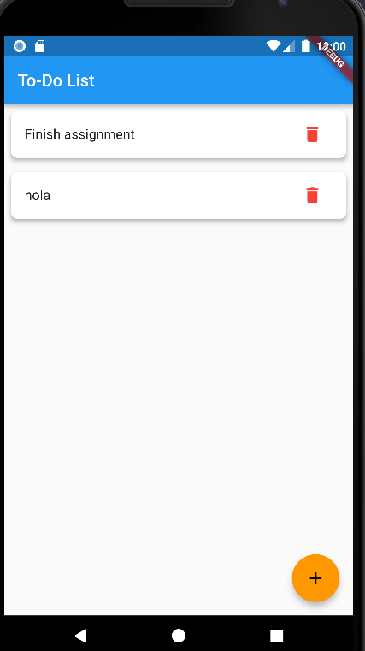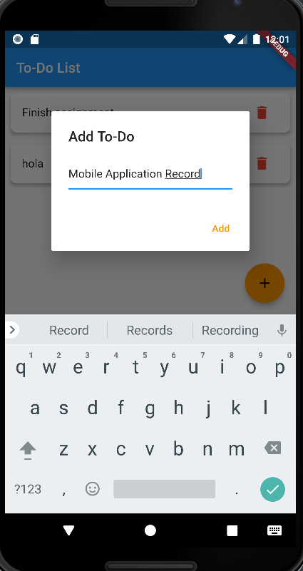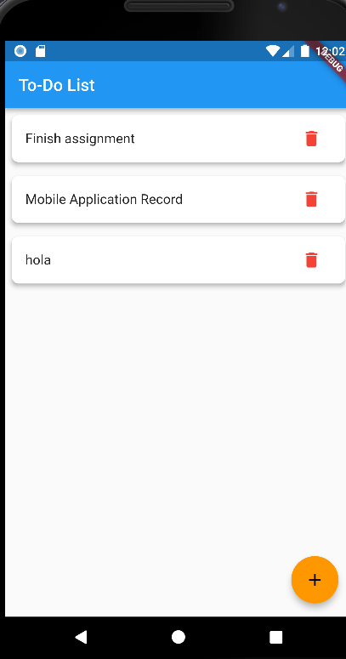

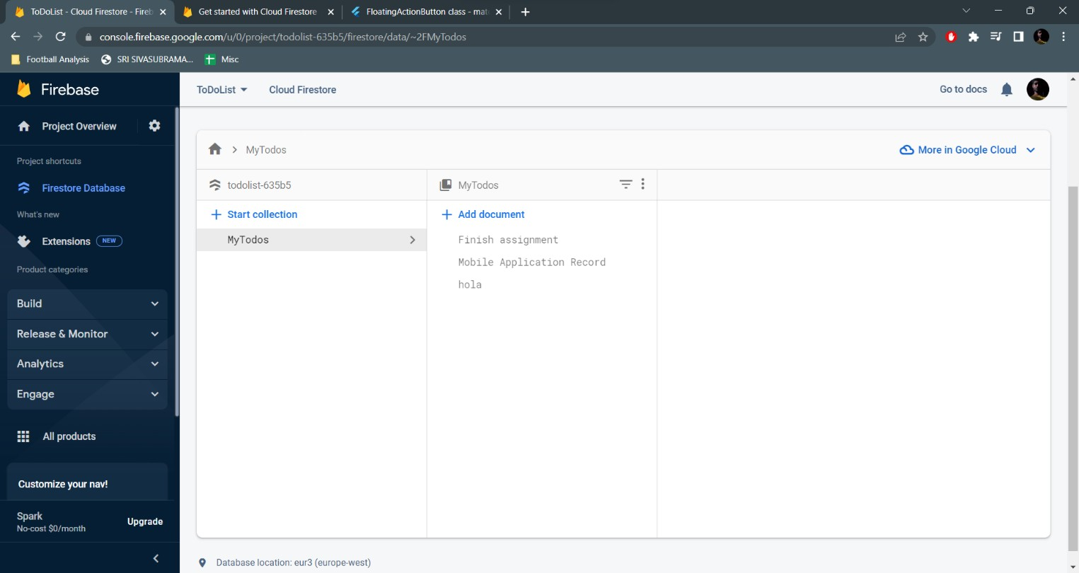

**Result:**

A mobile application that draws uses databases has been implemented successfully.

**Ex: 6 An application that makes use of RSS feed**

**Date: 13/10/2022**

**Aim:**

To create a mobile application that uses RSS feed.

**Code:**

**Main.dart**

import 'package:flutter/foundation.dart';

import 'package:flutter/material.dart';

import 'package:webfeed/webfeed.dart';

import 'package:http/http.dart' as http;

import 'package:url_launcher/url_launcher.dart';

void main() {

  runApp(const RSSDemo());

}

class RSSDemo extends StatelessWidget {

  const RSSDemo({Key? key}) : super(key: key);

  @override

  Widget build(BuildContext context) {

    return const MaterialApp(title: "RSS Feed", home: RSSMainPicture());

  }

}

class RSSMainPicture extends StatefulWidget {

  const RSSMainPicture({Key? key}) : super(key: key);

  @override

  State<RSSMainPicture> createState() => _RSSMainPictureState();

}

class _RSSMainPictureState extends State<RSSMainPicture> {

  late Future<RssFeed> result;

  Future<RssFeed> giver() async {

    var response = await http.get(Uri.parse(

        "https://www.espncricinfo.com/rss/content/story/feeds/0.xml"));

    var channel = RssFeed.parse(response.body);

    return channel;

  }

  @override

  void initState() {

    super.initState();

    result = giver();

  }

  @override

  Widget build(BuildContext context) {

    return Scaffold(

      appBar: AppBar(

        title: const Text("News"),

        actions: [

          IconButton(

              onPressed: () => result = giver(),

              icon: const Icon(Icons.refresh_rounded)),

        ],

      ),

      body: FutureBuilder<RssFeed?>(

        future: result,

        builder: (context, snapshot) {

          if (snapshot.hasError) {

            if (kDebugMode) {

              print("Error");

            }

            return Container();

          } else if (snapshot.connectionState == ConnectionState.waiting) {

            return const Center(

              child: CircularProgressIndicator(),

            );

          } else if (snapshot.hasData) {

            var feed = snapshot.data!;

            var items = feed.items;

            return ListView.builder(

              itemCount: items?.length,

              itemBuilder: (context, index) {

                var item = items![index];

                return GestureDetector(

                  onTap: () async {

                    if (!await launchUrl(Uri.parse(item.link!))) {

                      throw 'Could not launch ${item.link}';

                    }

                  },

                  child: ListTile(

                    // leading: CachedNetworkImage(

                    //   imageUrl: mediaImage!,

                    //   progressIndicatorBuilder: (context, url, downloadProgress) =>

                    //       CircularProgressIndicator(value: downloadProgress.progress),

                    //   errorWidget: (context, url, error) => const Icon(Icons.error),

                    // ),

                    title: Text(item.title!),

                    subtitle: Text("${item.pubDate!}"),

                  ),

                );

              },

            );

          }

          return Container();

        },

      ),

    );

  }

}

**Output:**

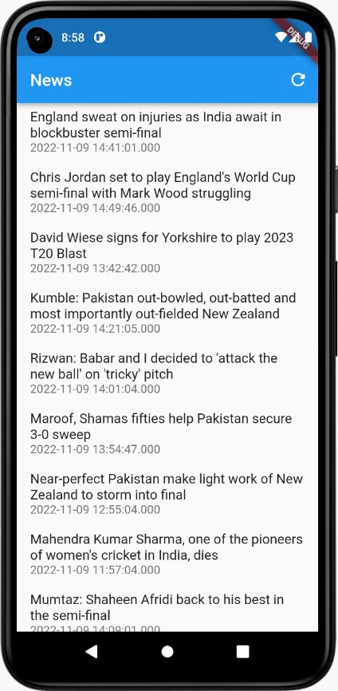

**Result:**

RSS feed has been successfully integrated with the mobile app.

**Ex: 7 An application that implements multithreading**

**Date: 20/10/2022**

**Aim:**

To create a mobile application that implements multithreading.

**Code:**

***main.dart***

import 'package:expt7/pages/home.dart';

import 'package:flutter/material.dart';

void main() {

runApp(const MyApp());

}

class MyApp extends StatelessWidget {

const MyApp({super.key});

// This widget is the root of your application.

@override

Widget build(BuildContext context) {

return MaterialApp(

title: 'Flutter Demo',

theme: ThemeData(

primarySwatch: Colors.blue,

brightness: Brightness.dark,

),

home: const Home(),

);

}

}

***home.dart***

import 'dart:async';

import 'dart:math';

import 'package:flutter/foundation.dart';

import 'package:flutter/material.dart';

class Home extends StatefulWidget {

const Home({Key? key}) : super(key: key);

@override

State<Home> createState() => _HomeState();

}

class _HomeState extends State<Home> {

int randint=99;

static FutureOr<int> randGen(int cal){

var rng = Random();

return rng.nextInt(100);

}

@override

Widget build(BuildContext context) {

return Scaffold(

appBar: AppBar(

title: Text(

"Multithreading App",

),

centerTitle: true,

),

body: Column(

mainAxisAlignment: MainAxisAlignment.spaceEvenly,

children: <Widget>[

Row(

mainAxisAlignment: MainAxisAlignment.spaceAround,

children: [

Text(

"Random Number: ",

style: TextStyle(

fontSize: 20.0,

),

),

Text(

"${randint}",

style: TextStyle(

fontSize: 20.0,

),

),

],

),

SizedBox(

height: 20.0,

),

TextButton(

onPressed: () async{

int result = await compute(randGen,randint);

setState(() {

randint = result;

});

},

child: Text(

"Press Me!",

style: TextStyle(

fontSize: 20.0,

),

),

),

],

),

);

}

}

**Output:**

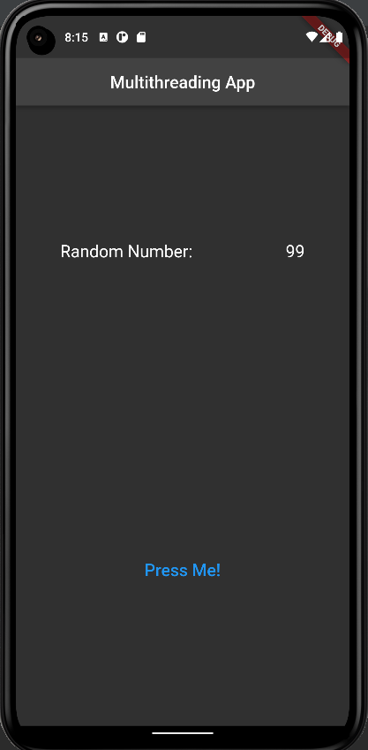 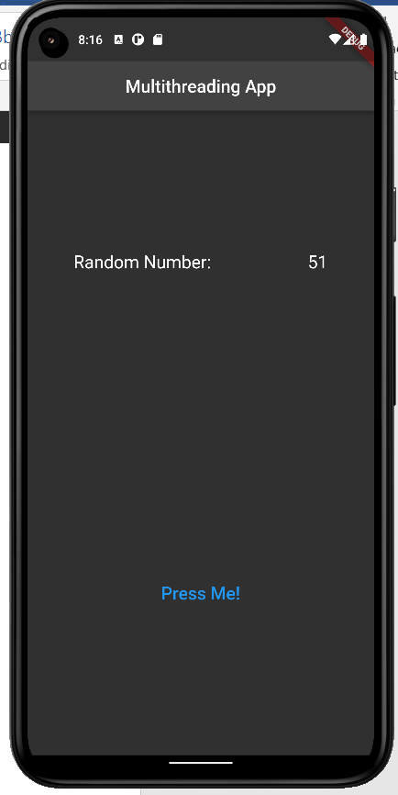

**Result:**

An android application that implements multithreading has been developed and executed successfully.

**Ex: 8 An application that uses GPS location information**

**Date: 27/10/2022**

**Aim:**

To create a mobile application that uses GPS location information.

**Code:**

import 'package:flutter/material.dart';

import 'package:location/location.dart';

void main() {

runApp(const MyApp());

}

class MyApp extends StatelessWidget {

const MyApp({Key? key}) : super(key: key);

// This widget is the root of your application.

@override

Widget build(BuildContext context) {

return MaterialApp(

title: 'Flutter Demo',

theme: ThemeData(

primarySwatch: Colors.pink,

),

home: const Home(),

);

}

}

class Home extends StatelessWidget {

const Home({Key? key}) : super(key: key);

@override

Widget build(BuildContext context) {

return Scaffold(

appBar: AppBar(

title: const Text(

"My Location"

),

centerTitle: true,

),

body: const LocationInfo(

),

floatingActionButtonLocation: FloatingActionButtonLocation.centerDocked,

);

}

}

class LocationInfo extends StatefulWidget {

const LocationInfo({Key? key}) : super(key: key);

@override

State<LocationInfo> createState() => _LocationInfoState();

}

class _LocationInfoState extends State<LocationInfo> {

String _myLoc ="My Location";

Location location=new Location();

late bool _serviceEnabled;

late PermissionStatus _permissionGranted;

late LocationData _locationData;

bool _isListenLocation =false, _isGetLocation = false;

@override

Widget build(BuildContext context) {

return Column(

crossAxisAlignment: CrossAxisAlignment.stretch,

children: <Widget>[

const SizedBox(

height: 20.0,

),

const Icon(

Icons.location_pin,

),

const SizedBox(

height: 20.0,

),

Center(

child: Text(

"$_myLoc",

style: TextStyle(

fontSize: 20.0,

),

),

),

const SizedBox(

height: 20.0,

),

FloatingActionButton(

child: Icon(

Icons.location_on_sharp,

),

onPressed: updateLoc,

),

],

);

}

void updateLoc() async{

_serviceEnabled = await location.serviceEnabled();

if(!_serviceEnabled){

_serviceEnabled = await location.requestService();

if(_serviceEnabled)

return;

}

_permissionGranted = await location.hasPermission();

if(_permissionGranted == PermissionStatus.denied){

_permissionGranted = await location.requestPermission();

if(_permissionGranted != PermissionStatus.granted)

return;

}

_locationData = await location.getLocation();

setState(() {

_isGetLocation = true;

});

if(_isGetLocation){

_myLoc="${_locationData.latitude} / ${_locationData.longitude}";

}

}

}

**Output:**

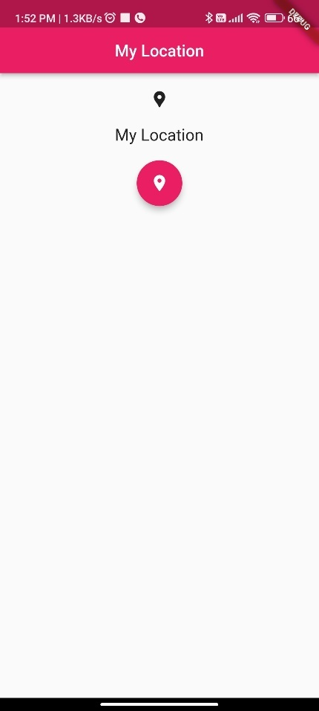 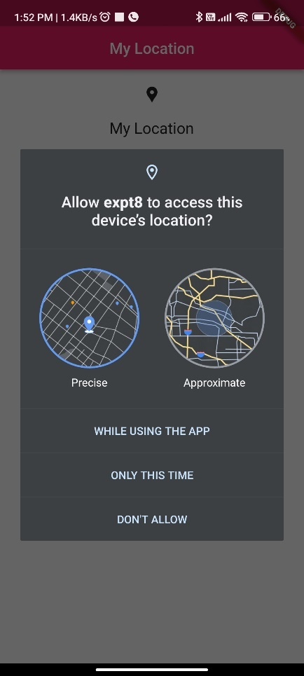 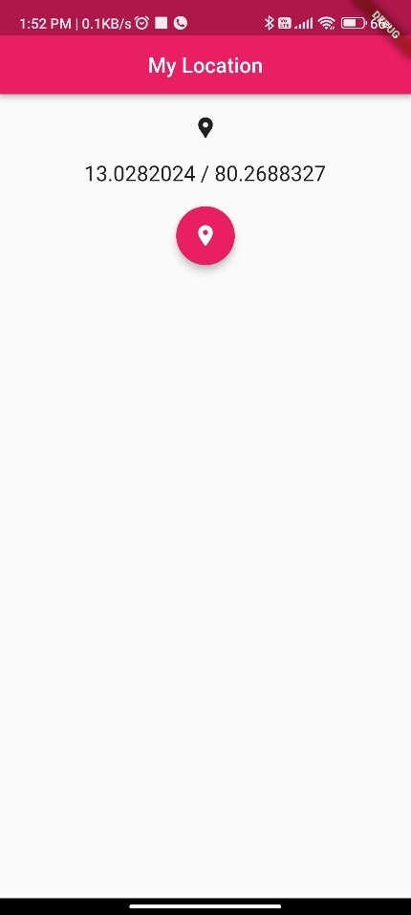

**Result:**

A native application that uses GPS location has been developed and executed successfully.

**Ex: 9 An application that takes advantage of rich gesture-based UI handling**

**Date: 3/11/2022**

**Aim:**

To create a mobile application that will take advantage of underlying phone functionality including rich gesture-based UI handling

**Code:**

import 'dart:math';

import 'package:flutter/material.dart';

import 'package:sensors_plus/sensors_plus.dart';

void main() {

runApp(const MyApp());

}

class MyApp extends StatelessWidget {

const MyApp({super.key});

// This widget is the root of your application.

@override

Widget build(BuildContext context) {

return MaterialApp(

title: 'Flutter Demo',

theme: ThemeData(

// This is the theme of your application.

//

// Try running your application with "flutter run". You'll see the

// application has a blue toolbar. Then, without quitting the app, try

// changing the primarySwatch below to Colors.green and then invoke

// "hot reload" (press "r" in the console where you ran "flutter run",

// or simply save your changes to "hot reload" in a Flutter IDE).

// Notice that the counter didn't reset back to zero; the application

// is not restarted.

primarySwatch: Colors.blue,

),

home: const MyHomePage(title: 'Gyroscope and ui'),

);

}

}

class MyHomePage extends StatefulWidget {

const MyHomePage({super.key, required this.title});

// This widget is the home page of your application. It is stateful, meaning

// that it has a State object (defined below) that contains fields that affect

// how it looks.

// This class is the configuration for the state. It holds the values (in this

// case the title) provided by the parent (in this case the App widget) and

// used by the build method of the State. Fields in a Widget subclass are

// always marked "final".

final String title;

@override

State<MyHomePage> createState() => _MyHomePageState();

}

class _MyHomePageState extends State<MyHomePage> {

double _dx = 0,

_dy = 0;

@override

Widget build(BuildContext context) {

return Scaffold(

appBar: AppBar(

title: Text(widget.title),

),

body: StreamBuilder<GyroscopeEvent>(

stream: SensorsPlatform.instance.gyroscopeEvents,

builder: (context, snapshot) {

if (snapshot.hasData) {

_dy = _dy + snapshot.data!.y * 10;

_dx = _dx + snapshot.data!.x * 10;

}

return Stack(

children: [

Positioned(

top: _dy,

left: _dx,

child: GestureDetector(

onPanUpdate: (details) {

setState(() {

_dy = max(0, _dy + details.delta.dy);

_dx = max(0, _dx + details.delta.dx);

});

},

child: const CircleAvatar(),

),

)

],

);

},

),

);

}

}

**Output:**

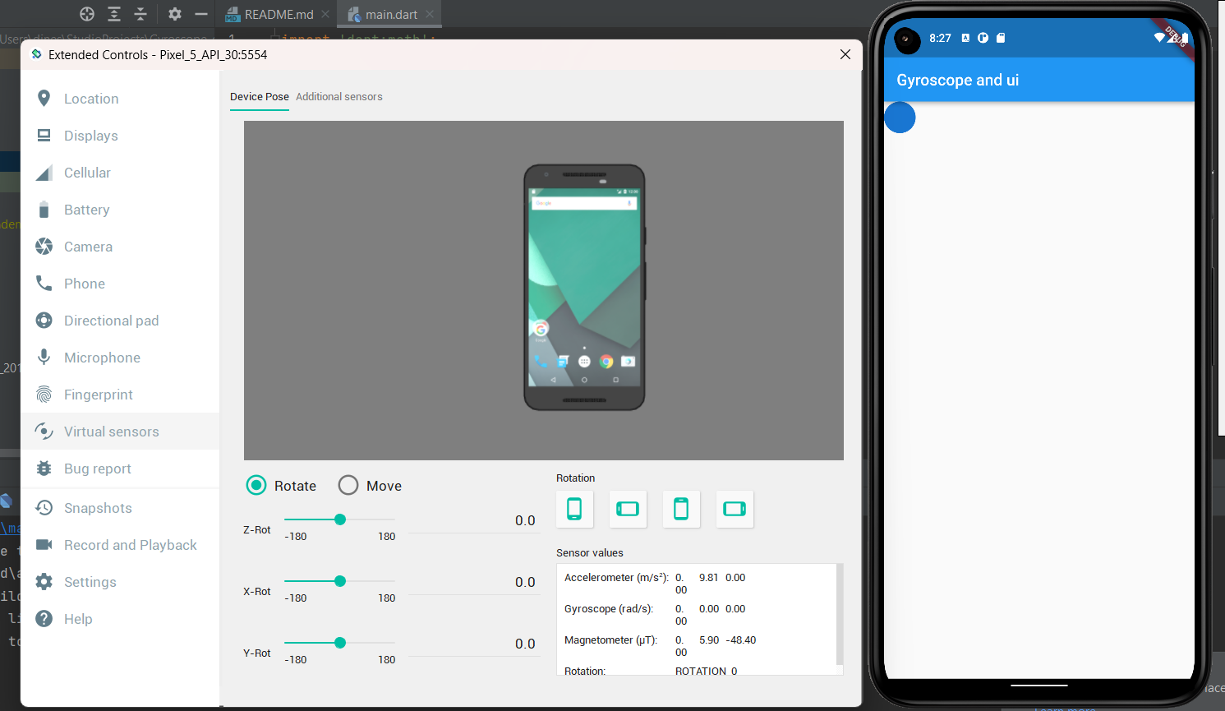

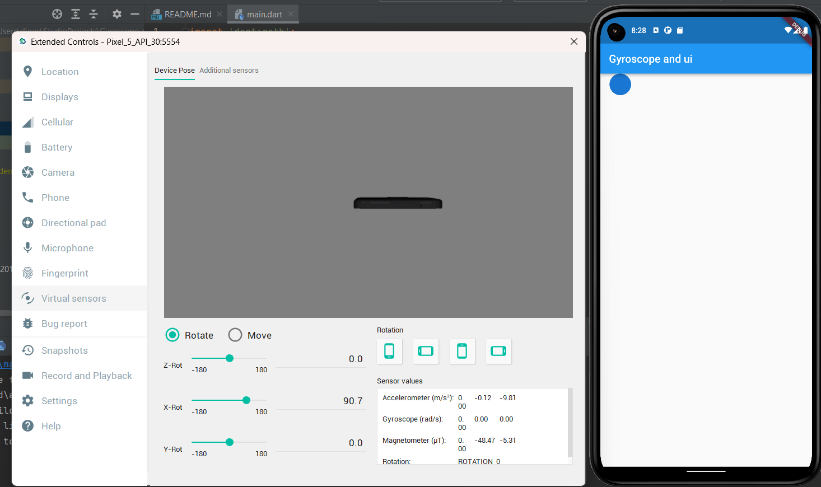

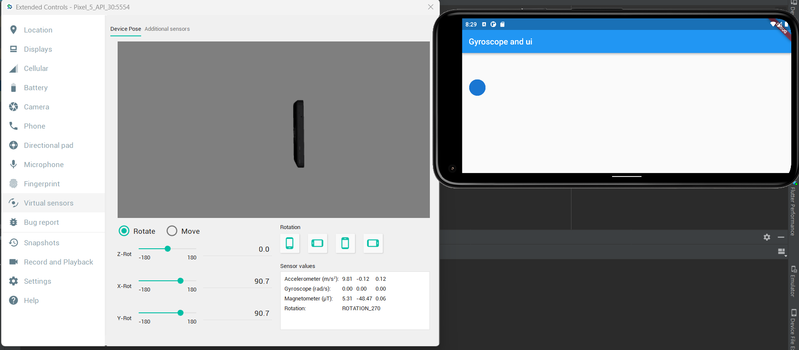

**Result:**

A mobile application that uses rich gestures to handle UI was developed and executed successfully.

**Ex: 10 An application that creates an alert upon user action**

**Date: 17/11/2022**

**Aim:**

To create an application that sends an alert upon user action.

**Code:**

**main.dart**

import 'package:expt10/pages/home.dart';

import 'package:flutter/material.dart';

void main() {

runApp(const MyApp());

}

class MyApp extends StatelessWidget {

const MyApp({Key? key}) : super(key: key);

// This widget is the root of your application.

@override

Widget build(BuildContext context) {

return MaterialApp(

title: 'Experiment 10',

theme: ThemeData.dark(),

home: const Home(),

);

}

}

home.dart

import 'package:expt10/services/local_notification_service.dart';

import 'package:flutter/material.dart';

class Home extends StatefulWidget {

const Home({Key? key}) : super(key: key);

@override

State<Home> createState() => _HomeState();

}

class _HomeState extends State<Home> {

late final LocalNotificationService service;

@override

void initState(){

service = LocalNotificationService();

service.initialize();

super.initState();

}

@override

Widget build(BuildContext context) {

return Scaffold(

appBar: AppBar(

title: const Text(

"Local Notifications Expt"

),

backgroundColor: const Color(0xff006473),

centerTitle: true,

),

body: Padding(

padding: EdgeInsets.all(MediaQuery.of(context).size.width*0.25),

child: Column(

children: <Widget>[

TextButton(

onPressed: () async {

await service.showNotification(

id: 0,

title: "Sample Notification",

body: "Sample Body"

);

},

child: const Text(

"Get an instant Notification"

),

),

TextButton(

onPressed: () async {

await service.showScheduledNotification(

id: 0,

title: "Sample Notification",

body: "Sample Body",

seconds: 4,

);

},

child: const Text(

"Get a delayed Notification"

),

),

],

),

),

);

}

}

local_notification_service.dart

import 'package:flutter_local_notifications/flutter_local_notifications.dart';

import 'package:timezone/timezone.dart' as tz;

import 'package:timezone/data/latest.dart' as tz;

class LocalNotificationService {

LocalNotificationService();

final _localNotificationService = FlutterLocalNotificationsPlugin();

Future<void> initialize() async{

tz.initializeTimeZones();

const AndroidInitializationSettings androidInitializationSettings =

AndroidInitializationSettings('ic_stat_assistant_navigation');

const DarwinInitializationSettings iosInitializationSettings =

DarwinInitializationSettings(

requestAlertPermission: true,

requestBadgePermission: true,

requestSoundPermission: true,

);

const InitializationSettings settings = InitializationSettings(

android: androidInitializationSettings,

iOS: iosInitializationSettings

);

await _localNotificationService.initialize(settings);

}

Future<NotificationDetails> _notificationDetails() async{

const AndroidNotificationDetails androidNotificationDetails = AndroidNotificationDetails(

"channel_id", "channel_name",

channelDescription: "Description",

importance: Importance.max,

priority: Priority.max,

playSound: true,

);

const DarwinNotificationDetails darwinNotificationDetails = DarwinNotificationDetails();

return const NotificationDetails(android: androidNotificationDetails,iOS: darwinNotificationDetails);

}

Future<void> showNotification({

required int id,

required String title,

required String body}) async{

final details = await _notificationDetails();

await _localNotificationService.show(id, title, body, details);

}

Future<void> showScheduledNotification({

required int id,

required String title,

required String body,

required int seconds

}) async{

final details = await _notificationDetails();

await _localNotificationService.zonedSchedule(

id,

title,

body,

tz.TZDateTime.from(DateTime.now().add(Duration(seconds: seconds)), tz.local,),

details,

androidAllowWhileIdle: true,

uiLocalNotificationDateInterpretation: UILocalNotificationDateInterpretation.absoluteTime

);

}

}

**Output:**

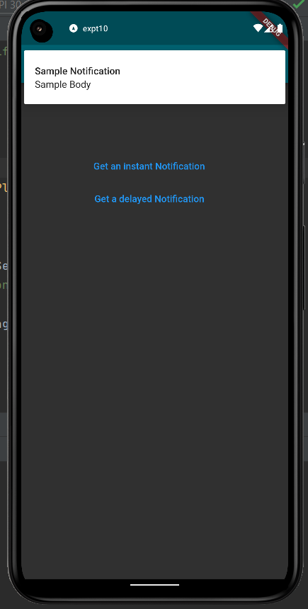 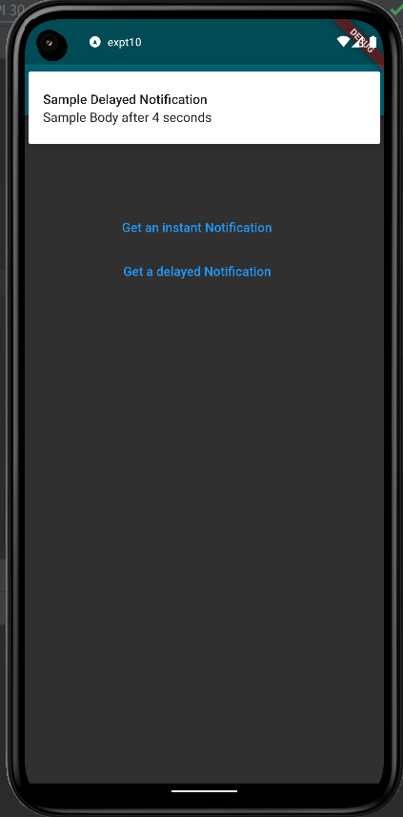

**Result:**

An application that sends an alert upon user action was developed and executed successfully.

**Ex:11 An application that creates an alarm clock**

**Date: 26/11/2022**

**Aim:**

To create an application that creates an alarm clock.

**Code:**

**main.dart**

import 'package:flutter/material.dart';

import 'pages/home.dart';

void main() {

runApp(const MyApp());

}

class MyApp extends StatelessWidget {

const MyApp({super.key});

// This widget is the root of your application.

@override

Widget build(BuildContext context) {

return MaterialApp(

title: 'Flutter Demo',

theme: ThemeData(

primarySwatch: Colors.cyan,

brightness: Brightness.dark,

),

home: const Home(),

);

}

}

home.dart

import 'package:flutter/material.dart';

import 'package:flutter_alarm_clock/flutter_alarm_clock.dart';

class Home extends StatefulWidget {

const Home({Key? key}) : super(key: key);

@override

State<Home> createState() => _HomeState();

}

class _HomeState extends State<Home> {

TimeOfDay time= TimeOfDay(hour: 23, minute: 59);

@override

Widget build(BuildContext context) {

return Scaffold(

appBar: AppBar(

title: Text(

"Alarm Clock",

),

centerTitle: true,

elevation: 0.0,

backgroundColor: Colors.cyan,

),

body: Padding(

padding: EdgeInsets.all(20),

child: Center(

child: Column(

mainAxisAlignment: MainAxisAlignment.center,

children: [

Row(

mainAxisAlignment: MainAxisAlignment.spaceEvenly,

children: [

Text(

"Time set: ",

style: TextStyle(

fontSize: 30.0,

),

),

Text(

"${time.hour.toString().padLeft(2,'0')}:${time.minute.toString().padLeft(2,'0')}",

style: TextStyle(

fontSize: 30.0,

color: Colors.cyan,

),

)

],

),

SizedBox(

height: 30.0,

),

Row(

mainAxisAlignment: MainAxisAlignment.spaceAround,

children: [

TextButton(

onPressed: () async{

TimeOfDay? newTime = await showTimePicker(

context: context,

initialTime: time,

);

if(newTime == null) return;

setState(() {

time = newTime;

});

},

child: Text(

"Edit Time",

style: TextStyle(

fontSize: 17.0,

),

),

),

TextButton(

onPressed: () {

FlutterAlarmClock.createAlarm(time.hour,time.minute);

},

child: Text(

"Set Alarm",

style: TextStyle(

fontSize: 17.0,

),

),

),

],

),

],

),

),

),

);

}

}

**Output:**

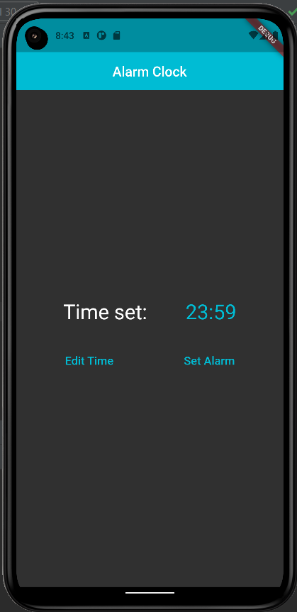 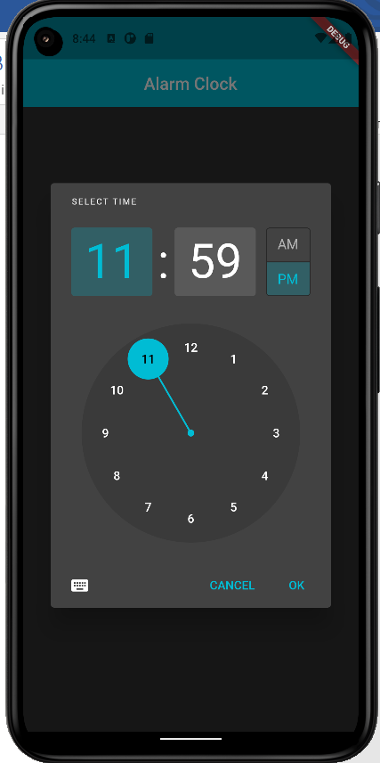

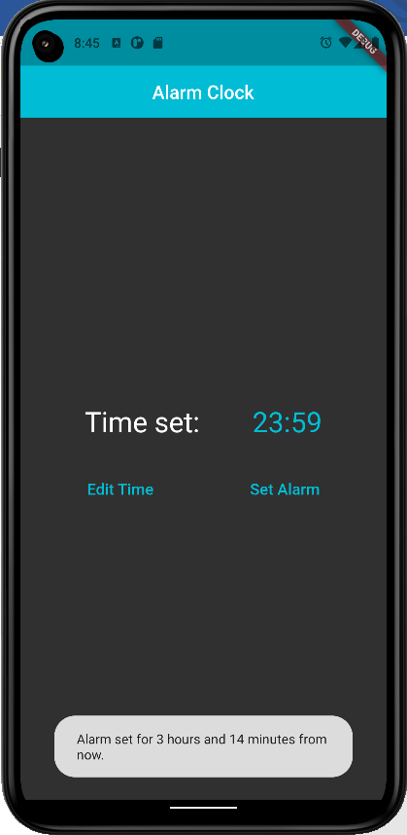 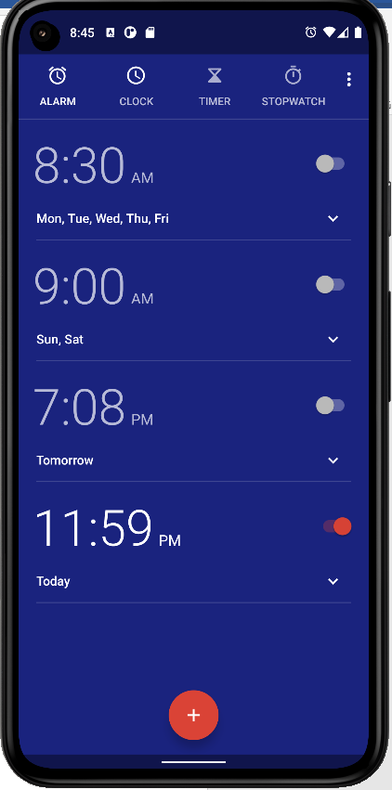

**Result:**

An application that creates an alarm clock is developed and tested successfully.

**Ex: 12 An application that performs REST-based API calls**

**Date: 26/11/2022**

**Aim:**

To create an application that performs REST-based API calls.

**Code:**

**main.dart**

import 'dart:convert';

import 'package:flutter/material.dart';

import 'package:http/http.dart' as http;

void main() {

runApp(const MyApp());

}

class MyApp extends StatelessWidget {

const MyApp({super.key});

// This widget is the root of your application.

@override

Widget build(BuildContext context) {

return MaterialApp(

title: 'Api Calls',

theme: ThemeData(

// This is the theme of your application.

//

// Try running your application with "flutter run". You'll see the

// application has a blue toolbar. Then, without quitting the app, try

// changing the primarySwatch below to Colors.green and then invoke

// "hot reload" (press "r" in the console where you ran "flutter run",

// or simply save your changes to "hot reload" in a Flutter IDE).

// Notice that the counter didn't reset back to zero; the application

// is not restarted.

primarySwatch: Colors.blue,

),

home: const MyHomePage(title: 'Codeforces Problem Set'),

);

}

}

class MyHomePage extends StatefulWidget {

const MyHomePage({super.key, required this.title});

// This widget is the home page of your application. It is stateful, meaning

// that it has a State object (defined below) that contains fields that affect

// how it looks.

// This class is the configuration for the state. It holds the values (in this

// case the title) provided by the parent (in this case the App widget) and

// used by the build method of the State. Fields in a Widget subclass are

// always marked "final".

final String title;

@override

State<MyHomePage> createState() => _MyHomePageState();

}

class _MyHomePageState extends State<MyHomePage> {

late Future<Map<String,dynamic>> info;

@override

void initState(){

info=giver();

super.initState();

}

Future<Map<String,dynamic>> giver() async{

var response = await http.get(Uri.parse("https://www.boredapi.com/api/activity"));

Map<String,dynamic> result=json.decode(response.body);

//print(result);

return result;

}

@override

Widget build(BuildContext context){

return Scaffold(

appBar: AppBar(

title: const Text("Bored API"),

actions: [

IconButton(onPressed: ()=>setState(() {

info=giver();

}), icon: const Icon(Icons.refresh_rounded))

],

),

body: FutureBuilder<Map<String,dynamic>>(

future: info,

builder: (context,snapshot){

if(snapshot.connectionState==ConnectionState.waiting){

return const Center(child: CircularProgressIndicator());

}

Map<String,dynamic> data={};

if(snapshot.hasData){

data=snapshot.data!;

return Center(

child: Column(

mainAxisAlignment: MainAxisAlignment.center,

children: [

Text("Activity: ${data["activity"]}"),

Text("Type: ${data["type"]}"),

Text("Participants: ${data["participants"]}"),

Text("Price: \$${data["price"]}"),

],

),

);

}

return Container();

},

),

);

}

}

**Output:**

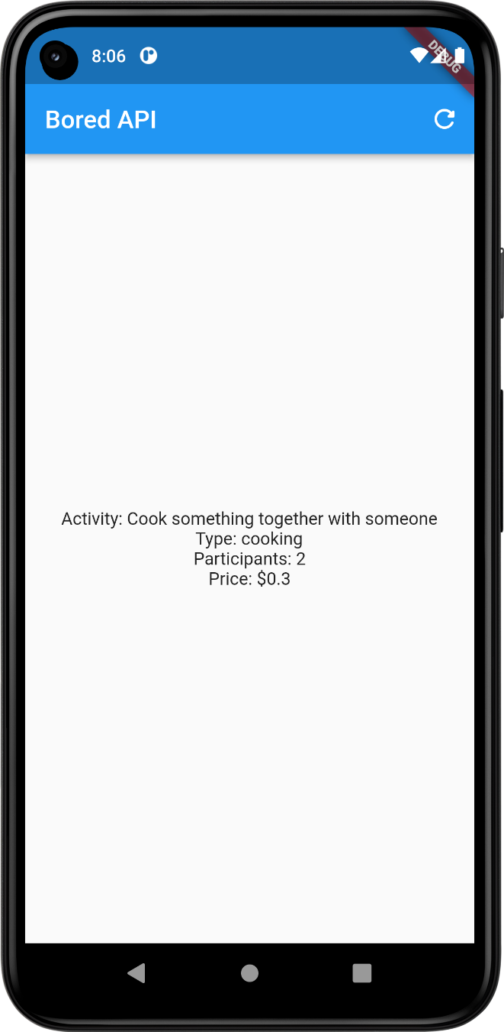

**Result:**

An application that performs REST-based API calls is developed and tested successfully.